Grade 7 Examination November
2023
SOCIAL SCIENCE

Discipline | - HISTORY
Duration | - 60 MINUTES
Marks | - 50
Date | - ….. November 2023

Name:………………………………………….
Surname:………………………………………
Educator:………………………………………

INSTRUCTIONS:
- Answer ALL the questions in the spaces provided on this question paper.
- Write neatly and legibly.

|

SECTION A: COLONISATION OF THE CAPE 17TH – 18TH CENTURIES

QUESTION 1 [5]

Choose the correct answer from the four and CIRCLE only the letter representing the correct answer.
1.1 In which year did Jan van Riebeeck arrive at the Cape? (1)

- 1550
- 1652
- 1777
- 1552

1. 2 Which of the following people were good wine farmers and helped set up the wine industry in South Africa? (1)

- The San
- Free burgers
- French Huguenots
- None of the above

1. 3 Before the arrival of Europeans in the 17th century, there were already ____________ groups of people living in the Cape. (1)

- Two
- More than ten
- Five
- Three
1.4 Slaves came from the following country ______________________ (1)

- Windhoek
- Madagascar
- Egypt
- Uganda
1.5 Which disease did sailors suffer from? (1)

- Influenza
- Malaria
- Scurvy
- Malnutrition

QUESTION 2:

DUTCH SETTLEMENT [10]
- Study the Source below and answer the questions that follow:
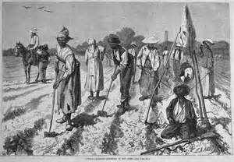

The VOC brought many people from Europe to settle at the Cape, mostly Dutch and French, and as a result, settlement grew, and new towns such as Stellenbosch were built.
  - Define the following concepts.
    - Settlement (1)
____________________________________________________________
____________________________________________________________
____________________________________________________________

    - Free burgher (1) ____________________________________________________________
____________________________________________________________
____________________________________________________________

    - Illiterate (1) ____________________________________________________________ _____________________________________________________________
____________________________________________________________

  - Why did the VOC release some of their workers to be free burghers? (1)
__________________________________________________________________
__________________________________________________________________
__________________________________________________________________
__________________________________________________________________

  - List 2 conditions from VOC that the free burghers had to follow. (1)

__________________________________________________________________
__________________________________________________________________
__________________________________________________________________

QUESTION 3:

LIFESTYLES AND STORIES OF TREKBOERS

Trekboers had their own lifestyle, write a paragraph of 7-8 sentences where you explain what their lifestyle included. The following rubric will be used in the assessment of this paragraph: [5x1=5]
Level | Criteria | Marks
1 | - Paragraph not structured as prescribed.  - Cannot answer question.  - Inadequate and only two facts given to answer the question | 0-2
2 | - Paragraph is structured as prescribed  - Use relevant facts to answer the question.  - Able to give 3-4 relevant facts | 3-4
3 | - Paragraph is well structured as prescribed  - Excellent use of 5 or more relevant facts to answer the question.  - Able to make excellent explanation | 5
 | TOTAL | 5

__________________________________________________________________________________ __________________________________________________________________________________
__________________________________________________________________________________
__________________________________________________________________________________
__________________________________________________________________________________
__________________________________________________________________________________
__________________________________________________________________________________
__________________________________________________________________________________
__________________________________________________________________________________
__________________________________________________________________________________
__________________________________________________________________________________

SECTION A TOTAL: 20 MARKS

SECTION B
QUESTION 4:
CO-OPERATION AND CONFLICT ON THE FRONTIERS OF THE

CAPE COLONY IN THE 19TH CENTURY [5]
Look at Source A and answer the following questions.
Source A: Trade between the Dutch and the Khoi-Khoi.
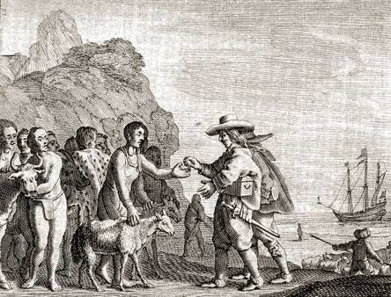

4.1 What form of transport did the Dutch settlers use to arrive at the Cape? (1)
____________________________________________________________
4.2 Use two sentences to explain what you think is happening in the picture from Source A.
(i)______________________________________________________________ (1)
(ii)______________________________________________________________ (1)
4.3 Mention one item that was used for trading from Source A.
_______________________________________________________________ (1)
4.4 What impression do you get from the interaction between the Dutch and Khoi-Khoi in Source A? Write a sentence to show your answer.
______________________________________________________________
______________________________________________________________ (1)

QUESTION 5:
ARRIVAL OF THE BRITISH AND THE EXPANDING FRONTIERS OF EUROPEAN SETTLEMENT [10]

5.1 Match column B with column A. Write the correct alphabet letter next to the number in column C.
COLUMN A | COLUMN B | COLUMN C
5.1.1 Settler | A An area of land where two different groups meet, and fight for control of the land. | 5.1.1
5.12. Frontier | B The process or action of settling amongst and establishing control over the indigenous people of an area. | 5.1.2
5.1.3 Colonisation | C The process of coming to live permanently in a foreign country. | 5.1.3
5.1.4 Indigenous people | D A person who moves with a group of others to live in a new country or area. | 5.1.4
5.1.5 Immigration | E The first occupants of an area or the land. | 5.1.5
(5)
5.2 Refer to Source 2B to answer the questions that follow.
Before the arrival of the British in 1795, the Dutch proclaimed the Fish River the frontier between the Cape Colony and the Xhosa. They did this without consulting the Xhosa. A frontier is not just a border or boundary, it is an area of land where two different groups meet, and fight for control of the land. An expanding frontier is when one group begins to control more of the land. The frontier between European settlers and Xhosa inhabitants expanded as
European settlers took control of most of the land. For the settlers, this was their eastern frontier, and for the Xhosa, the same frontier was their western frontier.
The timeline shows all the wars that were fought between 1779 and 1806.

Source 2B: The British at the Cape 1795

5.2.1 During which years were the wars fought? From __________ to___________(1)
5.2.2 Why did the groups of people who lived in the Cape from 1795 to 1806 experience clashes/wars?
____________________________________________________________________
____________________________________________________________________
______________________________________________________________ (1)
5.2.3. Which group of people first settled at the Cape between these two groups? (Dutch/British)
___________________________________________________ (1)
5.2.4. The first frontier war took place in 1779, which two groups fought during this frontier war?
__________________________ and _______________________ (1)
5.2.5 According to you which group of people had the rightful claim for the land in the Cape, choose from the groups in Source 2B.
___________________________ (1)

QUESTION 6: THE EASTERN FRONTIER OF EUROPEAN SETTLEMENT
FOURTH BORDER WAR (1811 – 1812)
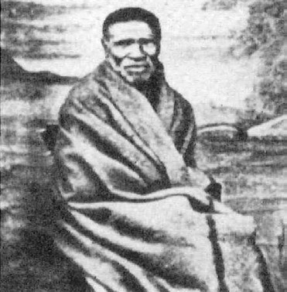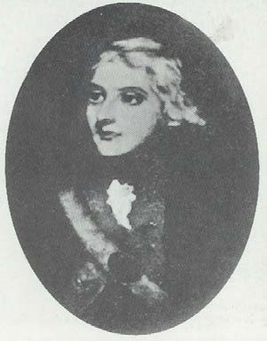

Chief Ndlambe Colonel John Graham
- Use the word bank to answer the questions.
Xhosa |  | British Griquas
Maqoma |  | sir Harry Smith
Ngqika |  | Colonel John Graham
Fish |  | Kei
Ndlambe |  | Dutch
  - What is the name of the Chief who played a big role in the fourth border
war? ______________________
(1)
  - Which tribe was barbarously robbed of their land by the British?
________________________ (1)
  - Who waged an army against the Xhosa during the fourth border war?
_________________________________________________________________(1)
  - The Xhosa were driven back across the ___________ river and ____________
forts which were built to guard the borders. (2)

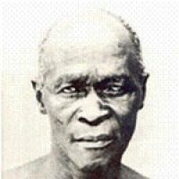
CASE STUDY
Read the case study on Chief Maqoma to
answer the questions

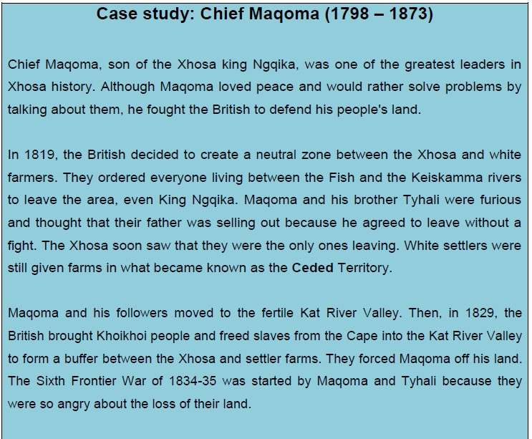

  - Who is Chief Maqoma?
_________________________________________________________________(1)
  - State why you think some people referred to Chief Maqoma as a great warrior.
____________________________________________________________________ ____________________________________________________________________
__________________________________________________________________(2)

  - Define the following terms:
- Military commander_______________________________________________________
______________________________________________________________________(1)
- Dispossessed_____________________________________________________________________________________________________________________________________(1)
- Savage__________________________________________________________________________________________________________________________________________(1)

  - How would you describe Chief Maqoma in reference to the source? Is it representing Chief Maqoma negatively/positively?
_______________________________________________________________________________
_______________________________________________________________________________
_______________________________________________________________________________ _______________________________________________________________________________
_____________________________________________________________________________________________________________________________________________________________________________________________________________________________________________(3)
6.9 In which year did the British decided to create a neutral zone between the Xhosa and white farmers? (1)
__________________________________

QUESTION 7:
ABOLITION OF SLAVERY IN 1836
Paragraph Writing
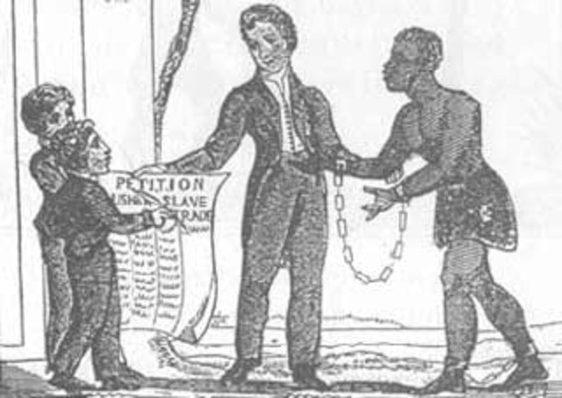

Write a paragraph on abolition of slavery referring to the following factors: Humanitarian reasons, economic reasons, and slave rebellions. Your paragraph should entail the introduction which will be one mark, the body (three marks) and concluding remarks (one mark). [5]
RUBRIC for marking paragraph writing
Assessment Criteria | Expected mark
Introduction at the beginning of the paragraph, which explains the intention clearly. | 1 mark
The body should entail factors related to abolition of slavery.  The learner should present the enriched knowledge, in regard with the topic | 3 marks
The conclusion remarks are included.  The learner was able to sequence his/her paragraph factually and strategically | 1 mark

________________________________________________________________________________
________________________________________________________________________________
________________________________________________________________________________
________________________________________________________________________________ ________________________________________________________________________________
______________________________________________________________________________
______________________________________________________________________________
______________________________________________________________________________
______________________________________________________________________________
______________________________________________________________________________
______________________________________________________________________________
______________________________________________________________________________
______________________________________________________________________________
______________________________________________________________________________
______________________________________________________________________________

SECTION B TOTAL: 30 MARKS
GRAND TOTAL 50 MARKS

GOOD LUCK!!

