50

SOCIAL SCIENCE
GRADE 7
TERM 3: HISTORY TEST
2022

LEARNER NAME: __________________________________________ GRADE: 7____
INSTRUCTIONS:
- Read each question carefully.
- Answer all questions on this question paper.
________________________________________________________________________________
Question 1:
Choose the correct terms from the table below. Write the answers in the spaces provided. (5)
Indigenous | Colonisation | Settlers | Slaves | Traders

1.1 Inhabitants of the Cape in the 17th Century. (1)
________________________________________________________________________________
1.2 The expanding frontiers of the Dutch settlements. (1)
________________________________________________________________________________
1.3 A person who moves with a group to live in a new country or area. (1)
________________________________________________________________________________
1.4 A person who is the legal property of another and is forced to obey them. (1)
________________________________________________________________________________
1.5 A person who buys and sells goods. (1)
________________________________________________________________________________

Question 2:
Place the following statements in the correct columns below. (10)

- People different from ourselves.
- Men among men.
- Hunter-gatherers.
- Herders.
- Nomadic.
- Pastoralists.
- Made tools from wood and stone.
- Made tools from copper and iron.
- Were called Bushmen by the Dutch.
- Were called Hottentots by the Dutch.

SAN | KHOIKHOI

Question 3:
Study SOURCE A and answer the following questions (12)
SOURCE A

3.1 What does DEIC stand for? (2)
________________________________________________________________________________
3.2 Complete the following sentence.
Jan Van Riebeeck arrived at the Cape in _______________________. (1)
3.3 Write down 3 reasons why the DEIC permanently settled at the Cape. (3)
________________________________________________________________________________
________________________________________________________________________________
________________________________________________________________________________
3.4 Who provided fresh meat to the Dutch people? Mention two kinds of people. (2)
________________________________________________________________________________
________________________________________________________________________________
3.5 Name the disease that many sailors died from. (1)
________________________________________________________________________________
3.6 What caused this disease? (1)
________________________________________________________________________________

3.7 Describe the relationship between the Indigenous people and Dutch. (2)
________________________________________________________________________________
________________________________________________________________________________
________________________________________________________________________________
Question 4:
Fill in the missing words from the table below: (8)
Cape | Controlled | Strictly | Harsh | Whipping | Starving | Caught | Chains

4.1 ____________________________ slave owners 4.2 ______________________their slaves
very 4.3 ___________________________. Slave owners could use 4.4 _______________________
punishments like 4.5 _____________________________, 4.6 _______________________________
and forcing slaves to work long hours. If slaves ran away, they would be 4.7 ____________________
and put in 4.8 ________________________________.

Question 5:
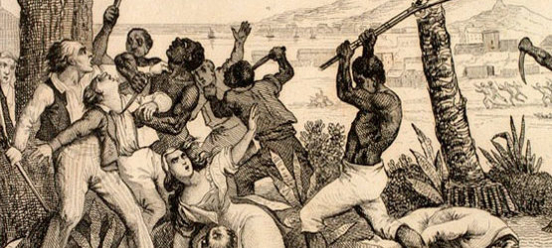
5.1 List FIVE ways slaves showed resistance. (5)
________________________________________________________________________________
________________________________________________________________________________
________________________________________________________________________________
________________________________________________________________________________
________________________________________________________________________________
TOTAL: 50 MARKS

