MOPANI EAST DISTRICT

GRADE 7
2023 FINAL EXAMINATION

SOCIAL SCIENCES

GEOGRAPHY

OCTOBER / NOVEMBER 2023

ar

MARKS: 50 TIME: 1 hour

QUESTION PAPER

This question paper consists of 8 pages including the cover page.

Name____________________________________
School____________________________________
DATE_____________________________________

INSTRUCTIONS AND INFORMATION
1. Answer all questions.
2. Write your answers on the spaces provided in the question paper.
2. Write neatly and legibly

SECTCTION A: POPULATION GROWTH AND CHANGE (15)
 | QUESTION 1
1.1. | Choose the correct answer from the four possible answers. Circle only the correct answer. | (3)
1.1.1. | Birth rate means:  - The number of infants born in an area  - The number of babies who are in a city per year  - The number of live babies born per one thousand people per year in a country.  - The number of people who die per year | [1x1] 1
1.1.2 | Population growth rate:  - Refers to an increase in number of people in a country in one year.  - Refers to people who move from rural to urban areas  - Refers to people who live in farms  - Refers to increase in number of people who live in a city | [1x1] 1
1.1.3. | Number of deaths per one thousand people per year in a country.  - Birth rate.  - Death rate.  - Life expectancy.  - Population rate | [1x1] 1
1.2. | Study the table below and answer the questions that follow:
  Country | Birth rate | Death rate | Population growth rate
  Zimbabwe | 17 | 13
  India | 29 | 38
  Niger | 51 | 14
1.2.1. | Identify the country with the highest death rate.  ___________________________________________________ | [1x1] 1
1.2.2. | What is the growing population rate of Niger?  ___________________________________________________ | [1x1] 1
1.2.3. | Explain why India has a negative population growth rate.  ___________________________________________________  1.3 study the case study below and answer the following questions | [1x2] 2
The main diseases in Africa that kill people are Malaria, TB, Diarrhoea, HIV and AIDS. These diseases are more common in poorer countries. Countries where these diseases are common have a much lower life expectancy than wealthier countries which have medicines, hospitals and good doctors. In wealthier countries diseases such as TB and diarrhea are controlled by medicines and good hygiene. Heart disease and cancer are the main killer diseases in wealthier countries. South Africa, Botswana, Mozambique, Malawi and Namibia are the countries with the highest infection of HIV & AIDS.

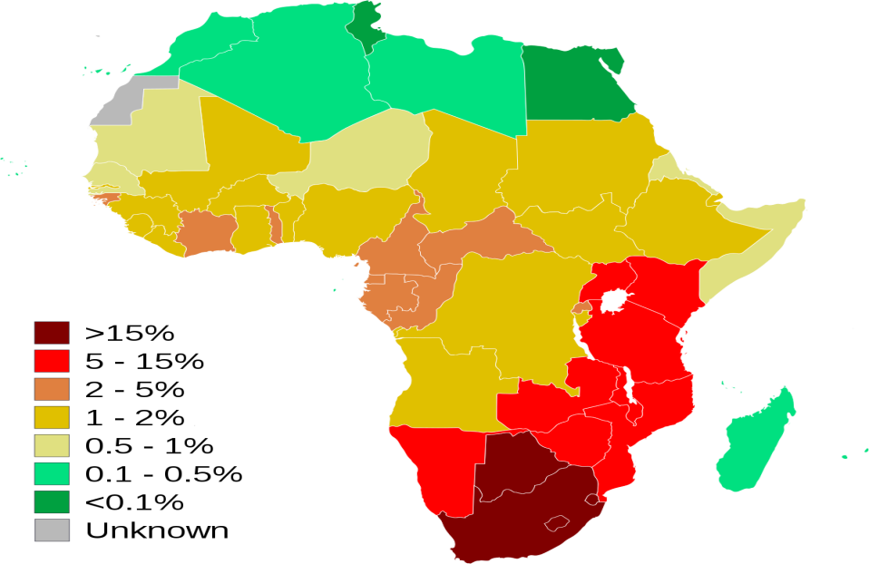
Adapted from: Social Sciences Solutions for all grade 7 learners book

1.3.1 | Explain how HIV and AIDS is spread.  _______________________________________________________  _______________________________________________________ | [1x2] 2
1.3.2 | Give ONE way to prevent the spread of HIV/AIDS.  _______________________________________________________ | [1x2] 2
1.3.3. | Name TWO main killer diseases in Africa?  ________________________________________________________  ________________________________________________________ | [2x1] 2
1.3.4 | Write TWO countries that have the highest rate of HIV and AIDS in Africa  ________________________________________________________  ________________________________________________________ | [2x1] 2
 | ________________________________________________________  ________________________________________________________ | 15

[15]

SECTION B: NATURAL RESOURCES AND CONSERVATION IN SOUTH AFRICA (35)
 | QUESTION 2
2.1 | Study the table below showing some natural resources that people use. Match each suitable use in column A with the resource in column B | [4x1]
   | Suitable use | Natural resource | answers
  2..1.1 | Growing crops | - coal | 2.1.1________________ | (1x1) (1)
  2.1.2 | Fishing / drinking water | - Trees/ wood | 2.1.2________________ | (1x1) (1)
  2.1.3 | Building / furniture making | - Rivers and oceans | 2.1.3_______________ | (1x1) (1)
  2.1.4 | Making electricity | - soil | 2.1.4_______________ | (1x1) (1)
2.2. | Define the term resource.  ______________________________________________________  ______________________________________________________ | [1x2] 2
2.3. | Name THREE natural resources that South Africa is rich in.  __________________________________  __________________________________  __________________________________ | [3x1] 3
2.4. | Read the Case Study below and answer the questions that follow. | (10)
  Case Study: Dwesa and Cwebe Nature Reserve, Eastern Cape
  Dwesa and Cwebe are two small nature reserves next to each other in the Eastern Cape. They protect a large area of indigenous coastal forest. The reserves also include a sensitive marine environment that has become a marine protected area. Dwesa offers a range of activities that follow conservation and eco-tourism policy, such as bird watching, game viewing and swimming. Fishing is only allowed in the areas where the rivers meet the sea
2.4.1. | Define the concept Conservation  _____________________________________________________  _____________________________________________________ | [1x2] 2
2.4.2. | What is the purpose of the Dwasa and Cwebe Nature Reserves?  ______________________________________________________  ______________________________________________________ | [1x2] 2
2.4.3. | In which province is Dwesa and Cwebe Nature Reserve located?  _____________________________________________________ | [1x1] 1
2.4.4. | What is eco-tourism?  _____________________________________________________  _____________________________________________________ | [1x2] 2

2.4.5. | Describe Three eco-tourism activities visitors can do in the Dwesa reserve.  _____________________________________________________  _____________________________________________________  _____________________________________________________ |  | [3x1] 3
 | (11)
Question3

3.1. | Use the pie chart and your own knowledge to answer the questions that follow.  FIGURE A pie chart showing the main water users in South Africa. |  | (10)

WHO USES SOUTH AFRICA’S WATER?

3.1.1. | List the water-use activities indicated in the diagram, in order from the biggest uses to the smallest uses.  _______________________________________________  ________________________________________________  ________________________________________________  ________________________________________________  ________________________________________________  ________________________________________________  ________________________________________________ | [6x1] 6
3.1.2. | Which sector uses the most water?  ________________________________________________ | [1x1] 1
3.1.3. | Explain why water is a scarce resource in South Africa  __________________________________________________  __________________________________________________ | [1x2] 2
3.1.4. | Explain ONE use of water by people  ___________________________________________________ | [1x2] 2
3.2. | In a paragraph of about 5-6 lines, explain what people ca do to use water more responsibly.  _____________________________________________________  _____________________________________________________  _____________________________________________________  _____________________________________________________  _____________________________________________________  _____________________________________________________  _____________________________________________________  _____________________________________________________  _____________________________________________________  _____________________________________________________  _____________________________________________________  _____________________________________________________ | (5)

TOTAL: 50 MARKS

