
INSTRUCTIONS AND INFORMATION

S
ENIOR PHASE

GRADE 7

NOVEMBER 2024

CREATIVE ARTS
)

(

THIS QUESTION PAPER CONSISTS OF 25 PAGES

MARKS:50 MARKS PER ART FORM

TIME:

21
hour

Read the instructions carefully before answering the questions.

- Answer ONLY 2 OF THE 4 SECTIONS. Choose TWO sections in relation
. to your selected pathways.

PATHWAY
SECTION A: DANCE
SECTION B: DRAMA
SECTION C: MUSIC
SECTION D: VISUAL ARTS

- Number your answers exactly as questions are numbered.
- Write NEATLY and LEGIBLY.
- All answers should be written on the ANSWER SHEET and NOT on the question paper.

SECTION A: DANCE

QUESTION 1
Choose the correct answer from the possible answers given in each question written below. Write only the letter (A-D) of the correct answer next to the number (1.1-1.10) of the question, for example 1.11. D
  - The speed of the movements or music
- Tempo
- Shape
- Levels
- Axial
  - The Code of conduct in a dance class:
- Rules
- Dance conventions
- Floorwork
- Space

  - Arrangement steps into a dance sequence is called:
- Locomotor
- Choreograph
- Accompaniment
- Elements of dance

  - How you hold your body when you stand and move:
- Alignment
- Locomotion
- Levels
- Flexibility

  - The ability to bend and stretch your muscles easily:
- flexibility
- Sensitivity
- Core stability
- Spiral

  - Positioning body parts in relation to each other:
- Posture
- Alignment
- Levels
- Negative space

  - A dance that originates from cultural tribe/from a cultural group:
- Indigenous dance
- Spotting
- Pantsula dance
- Gumboot dance

1.8 Movements that take you from one place to another:
- Non-locomotor
- Locomotor
- Aerial
- Plie

  - The highly controlled movement where only one part of the body is moving while the rest of the body is still and aligned:

- Neutral positioning
- Body part isolations
- Relationships
- Physical attributes

  - Exercises being done on the floor:
- Knee bend
- Floorwork
- Articulation
- Posture
[1x10=10]

QUESTION 2
Give one word for the following statements:
2.1. A dance in overalls and rubber boots. (1)
2.2 Finding an area to focus your eyes on when turning to avoid dizziness or losing your balance. (1)
2.3. To create movement on spot without any planning. (1)
2.4. Agreements and rules that we make and follow in a class (1)
2.5. People who are watching a dance performance. (1)
2.6 Shape, dimension, level, direction and pathways are collectively called. (1)
2.7 Duration, tempo, accent, phrase using rhythm. (1)
2.8 Skipping, hopping, jumping are examples of-------------movements. (1)
2.9 Curling, uncurling, twisting and bending are examples of---------------movement. (1)
2.10 Relaxation and stretching after warm-up activities. (1)
[1X10=10]

QUESTION 3
Study the following pictures and answer the following questions:
DANCE: A
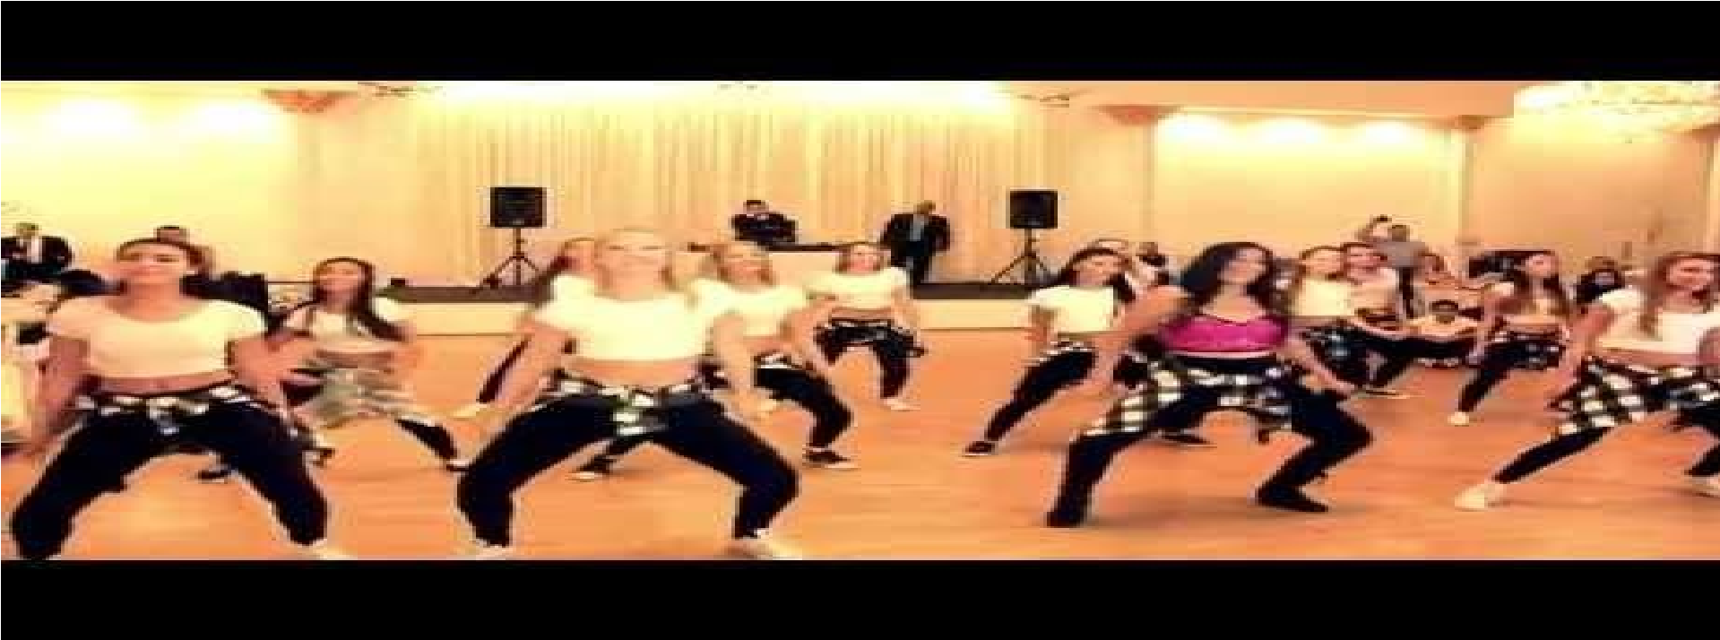

DANCE: B

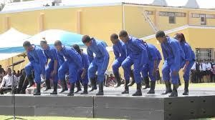

DANCE: C
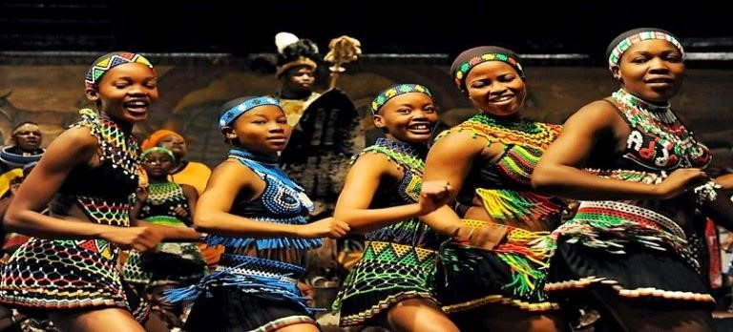

Questions:
3.1 Which dance type is a traditional dance in the above dance types? (1)
3.2 Where did Dance B originate? (1)
3.3 Under which mood is dance C performed? (1)
3.4 Is Dance B performed in low, middle or higher level? (1)
3.5 Dancers in Dance C are mainly -----------------------------? (1)
3.6 What brings about the production of sound in Dance B? (1)
3.7 In which level do dancers perform in Dance A? (1)
3.8 Which type of dance uses modern instruments? (2)
3.9 Which type of dancers use self – made instruments? (1)
[10]

QUESTION 4
Match the Concept in column A with the statement in column B

COLUMN A | COLUMN B
4.1 Personal space  4.2 Duet  4.3 Grace & Elegance  4.4 Dance Convention  4.5 Choreography  4.6 Axial movements  4.7 Technique  4.8 Sequence  4.9 Gumboot dance  4.10 Warm-up activities | - The art of creating steps for a dance.  - The way the movement is done to improve the quality of dance.  - A series of movement  - Spinal rolls and arm swings.  - A dance originated in the mines.  - Space within your area  - Move with pleasing style.  - Agreements & rules we make and follow in a dance class.  - A dance performed by two dancers.  - Twist and turn.
[10]

QUESTION5
Read the following passage about this South African Ballet dancer and Choreographer and answer the questions that will follow.

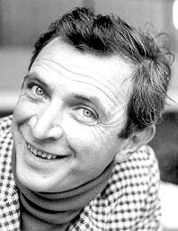

Cranko was born to Herbert and Grace Cranko in Rustenburg in the former province of Transvaal, Union of South Africa. As a child, he would put on puppet shows as a creative outlet. Cranko received his early ballet training in Cape Town under the leading South African ballet teacher and director, Dulcie Howes, of the University of Cape Town Ballet School. In 1945 he choreographed his first work (using Stravinsky's Suite from L'Histoire du soldat) for the Cape Town Ballet Club.
He moved to London, studying with the Sadler's Wells Ballet School (later called the Royal Ballet) in 1946 and dancing his first role with the Sadler's Wells Ballet in November 1947.
Cranko collaborated with the designer John Piper on Sea Change, performed at the Gaiety Theatre, Dublin, in July 1949. They created a season of ballet at the Kenton Theatre, Henley, in 1952 and collaborated again for Sadler's Wells Ballet on The Shadow, which opened on 3 March 1953. This period marked a transition in Cranko's career from dancer to full-time choreographer, with his last performance for the Sadler's Wells Ballet taking place in April 1950. At 23 years of age, he was appointed as resident choreographer for Sadler's Wells Theatre Ballet's 1950–51 season.
For the company's Festival of Britain season in 1951 Cranko choreographed Harlequin in April, a "pantomine [sic] with divertissements" to music by Richard Arnell, as well as the comic ballet Pineapple Poll, to the music of Arthur Sullivan (newly out of copyright) arranged by the conductor Charles Mackerras.^{[2]} Another collaboration with Mackerras followed in 1954 with The Lady and the Fool, to music by Verdi.
In January 1954, Sadler's Wells Ballet announced that Cranko was collaborating with Benjamin Britten to create a ballet. Cranko devised a draft scenario for a work he originally called The Green Serpent, fusing elements drawn from King Lear, Beauty and the Beast (a story he had choreographed for Sadler's Wells in 1948) and the oriental tale published by Madame d'Aulnoy as Serpentin Vert. Creating a list of dances, simply describing the action and giving a total timing for each, he passed this to Britten and left him to compose what eventually became The Prince of the Pagodas.
Cranko wrote and developed a musical revue Cranks, which opened in London in December 1955, moved to St Martin's Theatre in the West End the following March, and ran for 223 performances. With music by John Addison, its cast of four featured the singers Anthony Newley, Annie Ross, Hugh Bryant and the dancer Gilbert Vernon; it transferred to Broadway at the Bijou Theatre. An original cast CD has been released.^{[11]} Cranko followed the format of Cranks with a new revue New Cranks opening at the Lyric Theatre Hammersmith on 26 April 1960 with music by David Lee and a cast including Gillian Lynne, Carole Shelley and Bernard Cribbins, but it failed to have the same impact.
In 1960, Cranko directed the first production of Benjamin Britten's opera A Midsummer Night's Dream, at the Aldeburgh Festival. When the work had, its London premiere the following year at Covent Garden, Cranko was not invited to direct, and Sir John Gielgud was brought in.
Prosecuted for homosexual activity, Cranko left the UK for Stuttgart, and in 1961 was appointed director of the Stuttgart Ballet, where he assembled a group of talented performers such as Marcia Haydée, Egon Madsen, Richard Cragun, Birgit Keil and Susanne Hanke. Among his following choreographies were Romeo and Juliet by William Shakespeare in 1962, set to music by Prokofiev, Onegin in 1965, an adaptation of the verse novel Eugene Onegin by Alexander Pushkin, set to music by Tchaikovsky (mainly piano music, including The Seasons and music from lesser-known operas), orchestrated by Kurt-Heinz Stolze, The Taming of the Shrew by Shakespeare in 1969 using keyboard music by Domenico Scarlatti, Brouillards in 1970, Carmen in 1971 (music by Wolfgang Fortner and Wilfried Steinbrenner)' Initials R.B.M.E. (music by Johannes Brahms) in 1972 and Spuren (Traces) (music by Gustav Mahler) in 1973.
Cranko's work was a major contribution to the international success of German ballet beginning with a guest performance at the New York Metropolitan Opera in 1969. At Stuttgart, Cranko invited Kenneth MacMillan to work with the company, for whom MacMillan created four ballets in Cranko's lifetime and a fifth, Requiem, as a tribute after Cranko's death. At Cranko's instigation the company established its own ballet school in 1971; it was renamed the John Cranko Schule in his honour in 1974. His assistant and choreologist Georgette Tsinguirides preserved his works in Benesh Movement Notation.
In 1973, Cranko choked to death after suffering an allergic reaction to a sleeping pill he took during a transatlantic charter flight from Philadelphia to Stuttgart, two days after the company completed a successful tour of the United States at the Academy of Music in Philadelphia. The flight made an emergency landing in Dublin where Cranko was pronounced dead upon arrival at a hospital.^{[16]} His mother, Grace, who was divorced from Herbert and lived in what was then Rhodesia, learned of his death from a radio broadcast.
Cranko was buried at a small cemetery near Castle Solitude in Stuttgart.
In 2007, the Stuttgart Ballet celebrated what would have been Cranko's 80th birthday with the Cranko Festival.] The ballet Voluntaries by Glen Tetley was created in his memory. The John Cranko Society in Stuttgart, founded in 1975, promotes knowledge of ballet and Cranko's work, supports performances and talented dancers, and every year presents the John Cranko Award.

QUESTIONS
5.1 Who is John Cranko? (1)
5.2 At which age was he appointed as a choreographer? (1)
5.3 Whose company did Cranko joined when he was in Britain? (1)
5.4 Mention 3 additional ballets Cranko Choreographed in German. (3)
5.5 In which position was he appointed in 1961? (1)
5.6 What was established by the company after Cranko’s death? (1)
5.7 How many performances did he run in the West End (1)
5.8 What is a ballet dance? (1)
[1x10=10]

SECTION A 50 MARKS

SECTION B: DRAMA
QUESTION 1
Choose the correct answer from the possible answers given in each question written below. Write only the letter (A-D) of the correct answer next to the number (1.1-1.10) of the question, for example 1.11. D

  - A word or action which acts as a signal for an actor to start speaking:
- Cues
- Playwright
- Articulating
- Intonation
  - A person that recites a poem:
- Performer
- Actor
- Narrator
- Poet

1.3 When the whole group speaks together at the same time:
- Dialogue
- Unison
- Antiphone
- Cumulative
  - The way we use our mouths to speak clearly:
- Projection
- Narrator
- Resonance
- Tone
1.5 People who take part in a ritual or cultural event:
A. Spectators
B. Participants
C. Praise Singer
D. Composer
1.6 How fast and how slow a speech may flow:
A. Projection
B. Tension
C. Volume
D. Pace
1.7 A group of people who are moving forward:
A. Banquet
B. Crowd
C. Procession
D. Audience
1.8 The conversation between two people:
- Antiphon
- Dialogue
- Unison
- Dimension
1.9 Clothes that are worn by actors:
A. Props
B. Costume
C. Symbols
D. None of the above
1.10 These are noises that sound like thunder or gunshots used during a performance:
A. Thunderstorms
B. Sounds effects
C. Props
D. Costumes
[1X10=10]

QUESTION 2
State which type of characterisation is shown by each of the following scenarios (vocal characterization or physical characterization).
2.1 Use of gestures (1)
2.2 Change in voice (1)
2.3 showing a certain character through body movements. (1)
2.4 showing a certain character though imitating the voice of somebody else. (1)
2.5 A young girl wearing nurse’s uniform in a play performance. (1)
2.6 A boy talking like a policeman in a play. (1)
2.7 An emotional girl crying resembling a woman. (1)
2.8 A boy walking like an old man in a play. (1)
2.9 A man galloping like a horse. (1)
2.10 A woman crying like a chicken in the morning. (1)
[1x10=10]
QUESTION 3
Give one word for each of the following:
3.1 The objects that are used by the characters in a play or a film. (1)
3.2 The properties that are added to the final design of the set. (1)
3.3 People that take part in a play or drama. (1)
3.4 People that are watching the play or drama. (1)
3.5 Use of call and response. (1)
3.6 A person who makes sure that everything happens exactly on time during drama performance. (1)
3.7 A person who looks after the costumes in the wardrobe. (1)
3.8 Slapping your thighs with your hands. (1)
3.9 Letting one person speaks most of the lines or poem and the rest of the group speak the chorus.
3.10 How loudly or softly you speak.
[1X10]
QUESTION 4
Define the following technical elements in Drama.
3.1 Costumes (2)
3.2 Props (2)
3.3 Special effects (2)
3.4 Actors (2)
13.5 Audience (2)
[1x10=10]

QUESTION 5
Read the following extract and answer the questions below:

Chaelize Theron


Charlize Theron born 7 August 1975) is a South African and American actress and producer. One of the world's highest-paid actresses, she is the recipient of various accolades, including an Academy Award and a Golden Globe Award. In 2016, Time named her one of the 100 most influential people in the world.
Theron came to international prominence in the 1990s by playing the leading lady in the Hollywood films The Devil's Advocate (1997), Mighty Joe Young (1998), and The Cider House Rules (1999). She received critical acclaim for her portrayal of serial killer Aileen Wuornos in Monster (2003), for which she won the Silver Bear and Academy Award for Best Actress, becoming the first South African to win an acting Oscar. She received another Academy Award nomination for playing a sexually abused woman seeking justice in the drama North Country (2005).
Theron has starred in several commercially successful action films, including The Italian Job (2003), Hancock (2008), Snow White and the Huntsman (2012), Prometheus (2012), Mad Max: Fury Road (2015), The Fate of the Furious (2017), Atomic Blonde (2017), The Old Guard (2020), F9 (2021) and Fast X (2023). She received praise for playing troubled women in Jason Reitman's comedy-dramas Young Adult (2011) and Tully (2018), and for portraying Megyn Kelly in the biographical drama Bombshell (2019), for which she received her third Academy Award nomination.
Since the early 2000s, Theron has ventured into film production with her company Denver and Delilah Productions. She has produced numerous films, in many of which she had a starring role, including The Burning Plain (2008), Dark Places (2015), and Long Shot (2019). Theron became an American citizen in 2007, while retaining her South African citizenship. She has been honoured with a motion picture star on the Hollywood Walk of Fame.
Theron was born in Benoni, in Transvaal Province (Gauteng Province since 1994) of South Africa on 7 August 1975. She is the only child of road constructionists Gerda (née Maritz) and Charles Theron (27 November 1947 – 21 June 1991). ³⁴ The Second Boer War military leader Danie Theron was her great-granduncle. She is from an Afrikaner family, and her ancestry includes Dutch as well as French and German. Her French forebears were early Huguenots in South Africa.
She grew up on her parents' farm in Benoni, near Johannesburg. On 21 June 1991, Theron's father, an alcoholic, threatened both Charlize and her mother while drunk, physically attacking her mother and firing a gun at both of them. Theron's mother retrieved her own handgun, shot back and killed him. The shooting was legally adjudged to have been self-defense, and her mother faced no charges.
Theron attended Putfontein Primary School (Laerskool Putfontein), a period during which she has said she was not "fitting in". She was frequently unwell with jaundice throughout childhood and the antibiotics she was administered made her upper incisor milk teeth rot; they had to be surgically removed. Theron's permanent teeth did not grow until she was roughly ten years old. At 13, Theron was sent to boarding school and began her studies at the National School of the Arts in Johannesburg. About her early life in her home country, Theron has said: “I grew up as an only child in South Africa, and there was turmoil in my family, but the surroundings were so great. I was usually barefoot in the dirt: no Game Boys, no computers, and we had sanctions, so there were no concerts. This meant you had to entertain yourself.”
Although Theron is fluent in English, her first language is Afrikaans.
Although she saw herself as a dancer, Theron won a one-year modelling contract at age 16 at a local competition in Salerno, Italy and moved with her mother to Milan, Italy. After Theron spent a year modelling throughout Europe, she and her mother moved to the United States; they resided in New York City and Miami. In New York, she attended the Joffrey Ballet School, where she trained as a ballet dancer until a knee injury closed this career path. As Theron recalled in 2008:
I went to New York for three days to model, and then I spent a winter in New York in a friend's windowless basement apartment. I was broke, I was taking class at the Joffrey Ballet, and my knees gave out. I realized I couldn't dance anymore, and I went into a major depression. My mom came over from South Africa and said, "Either you figure out what to do next or you come home, because you can sulk in South Africa".
In 1994, Theron flew to Los Angeles on a one-way ticket her mother bought for her; she intended to work in the film industry. During her initial months there, she lived in a motel with the $300 budget that her mother had given her; she continued receiving cheques from New York and lived "from paycheck to paycheck". Theron stole bread from a basket in a restaurant to survive. One day, she went to a Hollywood Boulevard bank to cash a few cheques, including one her mother had sent to help with the rent; however; the check from her mother was rejected because it was out-of-state and she was not an American citizen. Theron argued and pleaded with the bank teller until talent agent John Crosby, who was the next customer behind her, cashed it for her and gave her his business card.
Crosby introduced Theron to an acting school In 1995, she played her first non-speaking film role in the horror film Children of the Corn III: Urban Harvest.^{[8]} In Theron's first speaking role, she portrayed hitwoman Helga Svelgen in 2 Days in the Valley (1996). Despite the film's mixed reviews, Theron drew attention due to her beauty and to a scene in which she fought Teri Hatcher's character. Theron feared being typecast as characters similar to Helga and recalled being asked to repeat her performance in the film during auditions: "A lot of people were saying, 'You should just hit while the iron's hot' [...] But playing the same part over and over doesn't leave you with any longevity. And I knew it was going to be harder for me, because of what I look like, to branch out to different kinds of roles".
When auditioning for Showgirls, Theron was introduced to talent agent J. J. Harris by co-casting director Johanna Ray. She recalled being surprised at how much faith Harris had in her potential. Theron has referred to Harris as her mentor. Harris found scripts and films for Theron in a variety of genres and encouraged her to become a producer. She served as Theron's agent for over 15 years.
Theron's career expanded by the end of the 1990s. In the horror drama The Devil's Advocate (1997), which is credited as her break-out film Theron starred alongside Keanu Reeves and Al Pacino as the haunted wife of an unusually successful lawyer. She subsequently starred in the adventure film Mighty Joe Young (1998) as the friend and protector of a giant mountain gorilla, and in the drama The Cider House Rules (1999), as a woman who seeks an abortion in World War II-era Maine. While Mighty Joe Young flopped at the box office, The Devil's Advocate and The Cider House Rules were commercially successful. She appeared on the cover of the January 1999 issue of Vanity Fair as the "White Hot Venus". The May 1999 issue of Playboy magazine also featured Theron on its cover; the photos of Theron used by Playboy had been taken several years earlier when she was an unknown model, and Theron unsuccessfully sued the magazine for publishing them without her consent.
By the early 2000s, Theron continued to steadily take on roles in films such as Reindeer Games (2000), The Yards (2000), The Legend of Bagger Vance (2000), Men of Honor (2000), Sweet November (2001), The Curse of the Jade Scorpion (2001), and Trapped (2002), all of which, despite achieving only limited commercial success, helped to establish her as an actress. On this period in her career, Theron remarked: "I kept finding myself in a place where directors would back me but studios didn't. [I began] a love affair with directors, the ones I really, truly admired. I found myself making really bad movies, too. Reindeer Games was not a good movie, but I did it because I loved [director] John Frankenheimer".

QUESTIONS
5.1 When did she start acting in films? (1)
5.2 Where was Charlize born? (1)
5.3 What was her first language? (1)
5.4 Mention two tragic fights that happened to her when she was only 15 years old. (2)
5.5 How did she get the opportunity to travel overseas? (1)
5.6 Why did she have to abandon her dance career? (1)
5.7 Mention 2 films she acted in. (2)
5.8 Charlize gave birth to two children of her own. Is the statement true or false? (1)
[10]

SECTION C:MUSIC
QUESTION 1
Choose the correct answer from the possible answers given in each question written below. Write only the letter (A-D) of the correct answer next to the number (1.1-1.5) of the question, for example 1.6. D
1.1 A basic unit of time, a musical pulse:
- Note
- Bar
- Beat
- Phrase
1.2 The series of five lines and four spaces in between, into which notes are written to compose music:
- Staff notation
- Stave
- Clef
- Symbols
1.3A person who writes and creates music:
A.Composer
B.Poet
C.Dramatist
D.Dancer
1.4 When naming the notes of music, we use the first --------- of alphabet:
- 11 letters
- 7 letters
- 8 letters
- 10 letters
1.5 The technique of singing with your mouth still closed:
A. Whispering
B. Humming
C. Improvising
D. Articulating

1.6 A person singing alone is called:
- Duet
- Soloist
- Quartet
D.None of the above
1.7 A musical composition in a written form:
A. Melody
B. Score
C. Note values
D. Song
1.8 A musical part (vocal or instrumental) that supports or provides background for other musical parts:
- Accompaniment
- Percussion
- Voice
- Music
1.9 Lines used to notate notes above or below the stave:
A. score
B. Parallel lines
C. Ledger lines
D. Octave
1.10 High and low notes together that create a musical phrase:
- Phrasing
- Melody
- Tune
- Articulation
[1x10=10]

QUESTION 2
Complete the following sentences. Only write the appropriate answer:
2.1 The longest note is called a -------------------- and it last for four counts, it looks like this--------------(draw a note). (2)
2.2 A minim looks like this --------(draw a note) and last for ---------- counts. (2)
2.3 Two minims equal to a --------------. (1)
2.4 A crotchet lasts for ---------- count and it looks like this ----------------. (2)
2.5 Four crotchets are equal to how many semibreves? (1)
2.6 Tempo has got to do with the ------------- of music. It tells you how fast or ------- a piece of music is. (2)
[10]
QUESTION 3
Redraw the following stave /staff and answer the following questions.

3.1 Draw the treble clef. (1)
3.2 Write a B note within a stave. (1)
3.3 Write a C note within a stave. (1)
3.4 Write a bass clef on fourth bar. (1)
3.5 Write a D note on bass clef. (1)
3.6 Write a quaver note at E note of treble clef. (1)
3.7 Name the second line in treble clef. (1)
3.8 Name line number four in bass clef (1)
3.9 Draw a double barline in a correct bar (1)
3.10 what is a series of five line with four spaces. (1)
[1x10=10]
QUESTION 4
Give one word for each of the following descriptions:

  - A person who directs a choir during music performance. (1)
  - A clef in spaces spell FACE. (1)
  - A note value with 4 counts. (1)
  - The high or low sounds in music. (1)
  - One word for indigenous songs & cultural songs. (1)
  - A note on the line below the stave. (1)
  - A note value of 3 counts. (1)
  - A note half of a crotchet. (1)
  - A clef which represents men’s low voices. (1)
  - A sign usually written in the beginning of a music score with two numbers.(1)
[1x10=10]
QUESTION 5

Read the article below and answer the questions that follow:

Zenzile Miriam Makeba

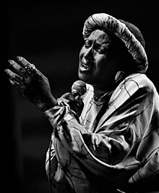
Zenzile Miriam Makeba 4 March 1932 – 9 November 2008), nicknamed Mama Africa, was a South African singer, songwriter, actress, and civil rights activist. Associated with musical genres including Afropop, jazz, and world music, she was an advocate against apartheid and white-minority government in South Africa.
Born in Johannesburg to Swazi and Xhosa parents, Makeba was forced to find employment as a child after the death of her father. She had a brief and allegedly abusive first marriage at the age of 17, gave birth to her only child in 1950, and survived breast cancer. Her vocal talent had been recognized when she was a child, and she began singing professionally in the 1950s, with the Cuban Brothers, the Manhattan Brothers, and an all-woman group, the Skylarks, performing a mixture of jazz, traditional African melodies, and Western popular music. In 1959, Makeba had a brief role in the anti-apartheid film Come Back, Africa, which brought her international attention, and led to her performing in Venice, London, and New York City. In London, she met the American singer Harry Belafonte, who became a mentor and colleague. She moved to New York City, where she became immediately popular, and recorded her first solo album in 1960. Her attempt to return to South Africa that year for her mother's funeral was prevented by the country's government.
Makeba's career flourished in the United States, and she released several albums and songs, her most popular being "Pata Pata" (1967). Along with Belafonte, she received a Grammy Award for Best Folk Recording for their 1965 album An Evening with Belafonte/Makeba. She testified against the South African government at the United Nations and became involved in the civil rights movement. She married Stokely Carmichael, a leader of the Black Panther Party, in 1968, and consequently lost support among white Americans. Her visa was revoked by the US government when she was traveling abroad, forcing her and Carmichael to relocate to Guinea. She continued to perform, mostly in African countries, including at several independence celebrations. She began to write and perform music more explicitly critical of apartheid; the 1977 song "Soweto Blues", written by her former husband Hugh Masekela, was about the Soweto uprising. After apartheid was dismantled in 1990, Makeba returned to South Africa. She continued recording and performing, including a 1991 album with Nina Simone and Dizzy Gillespie, and appeared in the 1992 film Sarafina!. She was named an FAO Goodwill Ambassador in 1999, and campaigned for humanitarian causes. She died of a heart attack during a 2008 concert in Italy.

QUESTIONS
5.1 When did Miriam Makeba start singing professionally? (1)
5.2 Which year did she record her first solo album? (1)
5.3 Where was Zenzile Mariam Makeba born? (1)
5.4 What was Miriam Makeba’s nickname? (1)
5.5 Where the Makeba’s career flourished? (1)
5.6 Mention two Professions of Miriam Makeba. (2)
5.7 Which album of Miriam Makeba was the most popular? (1)
5.8 What happened after death of her father? (2)
[10]
SECTION C 50 MARKS

SECTION D: VISUAL ARTS
QUESTION 1
Choose the correct answer from the possible answers given in each question written below. Write only the letter (A-D) of the correct answer next to the number (1.5) of the question, for example 1.1. D

1.1 This is one of the art elements:
- Blending
- Stippling
- Texture
- Media
1.2 The art elements are tools that the artist uses to create:
- Balance
- Image
- Design
- Proportion
1.3 Painting is when an artist creates an artwork using wet:
- Clay
- Media
- Texture
- Sand
1.4 Tone shows:
- Brightness & Lightness of an object
- Lightness & darkness of an object
- Coarseness or fineness of an object
- Size of an object
1.5 Shading techniques where short thin lines are used:
- Scribbling
- Blending
- Hatching
- Stepping

1.6 To be equal amounts of weight in a composition refers to:
A. Contrast
B. Repetition
C. Balance
D. Unity
1.7 When special importance is given to something in an artwork:
A. Variation
B. Emphasis
C. Rhythm
D. Proportion
1.8 This is one of the craftmanship techniques:
A. Wrapping
B. Blending
C. Stipping
D. Tone
1.9 When white is added to a colour, this is called:
A. Tint
B. Black
C. Moulding
D. Pasting
1.10 This is an example of a geometric shape:
A. Leaf shape
B. Perfect straight line
C. No shape
D. None of the above
[1x10=10]

QUESTION 2
Define the following terms:
3.1 Etching (2)
3.2 Monochromatic colour (2)
3.3 Collage (2)
3.4 Tone (2)
3.5 Proportion (2)
[2x5=10]

QUESTION 3
Give one word for each of the following:
3.1When something is flat and only has width and length. (1)
3.2The substances or materials an artist uses to make the artwork. (1)
  - A shading technique where lines are used without a specific direction . (1)
3.4 When something is found again and again in an artwork. (1)
3.5 The oldest form of printmaking that was used by the Ancient Greeks & Roman. (1)
3.6 Signs that are used to give us a message in an artwork. (1)
3.7 The type of colours that create a happy, inviting atmosphere. (1)
3.8 A technique or a method in which a soft material such as a clay or wax is built up around a wire armature. (1)
3.9 One colour mixed with white or black to create a tint or shade. (1)
3.10A design that is repeated to make a pattern. (1)
[1x10=10]

QUESTION 4
Study and observe a Lithograph done by Nelson Mandela on Robben Island (From My Robben Island: First Series) and answer questions that may follow:
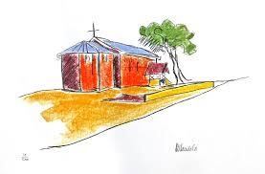
4.1 The above lithograph shows both art elements and design principles. Carefully look at the image and list at least 5 art elements & also 5 design principles that are shown in the image.
Draw the following table in your answer sheet as a guide.
ART ELEMENTS | DESIGN PRINCIPLES
(5) | (5)
[10]

QUESTION 5
Study the following extract and answer the following questions on it:
Irma Stern’s

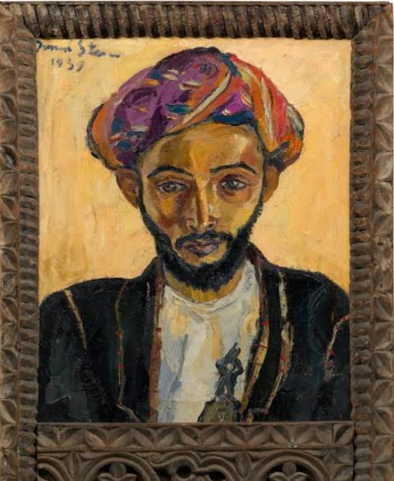
Irma Stern’s “The arab Priest” will be on show at the izolo South African Natinal Gallery (ISANG) until 28
July 2012, ahead of its export to the Qatar Orienalist Museum in Doha. The painting was sold to the Qatar Museum Authority (QAM) for a record breaking 3 million rands at the Bonhams South African sale on 23 March 2011.
In partnership with the department of Art and Culture, ISANG is hosting the painting for public view on its premises in the compan’s Gardens in Cape Town.
Sterns donated the piece of her work to a charity auction to help finance Nelson Mandela’s legal defence in the late 1950s. Mandela, along with other African national Congress activists at the time were on trial for treason and faced the death penalty.
Questions
5.1 What was Stern’s artwork called? (2)
5.2 To whom was the painting sold and how much did it cost? (2)
5.3 Where did the sale of the painting for public view take place? (2)
5.4 What does the word “ISANG” stands for? (2)
5.5 With whom did he face the death penalty? (2)
SECTION D 50 MARKS
GRAND TOTAL: 100

