GRADE: 7

SUBJECT: NATURAL SCIENCES

TERM TWO

FORMAL ASSESSMENT TASK (FAT) 2

Name: ________________________________________________________

Class: __________________________ Date: ________________________

School: _____________________ Teacher: _________________________

FAT | Activity / Form | Learner’s mark | Learner’s %
3. | PRACTICAL TASK
TOTAL |  | 20
It remains the responsibility of the teacher to do the final quality assurance of a FAT before it is used.

 | PRACTICAL TASK |  | Marks: 20
Knowledge Strands: __Matter and Materials

Topic: Properties of materials animal shelters

INVESTIGATION: Which type of paper is the strongest?

NOTE TO THE TEACHER
Learners can help you prepare for the activity by bringing different types of paper to school: newspaper, tissue paper, paper towel, or old magazines and gift wrap. Tell them to bring the biggest pieces they can find.

AIM: To compare the tearing strengths of different types of paper.

You could let the learners cut the paper into strips of 20 x 5 cm each, or you could do this beforehand to save time. Learners will compare the force required to tear the different types of paper. They have not yet encountered force as a concept (force is covered in Gr 9 Energy and Change) but you could encourage them to think about what they are doing when they hang the heavy marbles on the strip of paper. For example, ask learners: "What do more marbles in the yoghurt tub mean?" It means the yoghurt tub is heavier, and `pulls' harder on the strip of paper.
(If you cannot get hold of marbles you could try finding small stones or pebbles that are more or less the same size. You would just have to explain to the learners that the stones do not all have a mass of 5 grams, but you will imagine that they do to simplify the calculations.)

HYPOTHESIS:
When you write a hypothesis, you must state what you think will happen in your investigation.

Possible hypotheses are: 'The thicker and stronger the paper, the more marbles it can hold before breaking.', 'Paper X is the strongest', where X is one of the papers supplied.

MATERIALS AND APPARATUS:
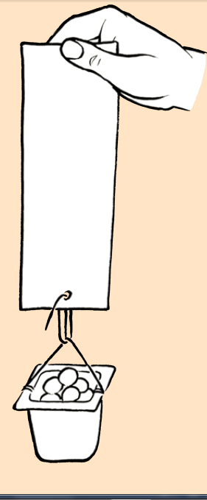
- Strips of different types of paper (20cm x 5cm) – photocopy paper, toilet paper, wax paper, aluminum foil and news paper
- Hole puncher
- Strong paper clips
- Yoghurt tub
- Marbles
- String

NOTE TO THE TEACHER
Make sure to use strong paper clips so that they do not bend under the strain of the marbles during the investigation. Make sure to use a range of papers, such as filter paper, tissue paper, crepe paper, wax paper, newspaper, normal white paper, harder card, etc. A suggestion is to also number the pieces of paper so that learners can easily reference them and then use the number to place them in order of strength later on in the questions. If you have time you can also test some other materials such as plastic shopping bags or aluminium foil.

METHOD:
NOTE TO THE TEACHER
You can introduce the idea of a fair test here. Ask learners why they think they should punch the holes the same distance from the edge in each type of paper. This is because you want it to be a fair test - each piece of paper must be tested fairly and equally. If the holes were punched at different distances from the edge, this might make some papers appear stronger or weaker than they actually are. You need to control all other variables so that the only thing you are changing is the type of paper.

- Punch a hole at both ends of each paper strip. This is so that you can test the paper twice on each side. Make sure that the holes are in the middle, and also at the same distance from the end of each strip. This will make it a fair test.
- Form the paper clip into an S-shape and hang it from the hole in the paper.
- Make a handle for the yoghurt tub, using the string.
- Hang the yoghurt tub from the paper clip and hold it in your hand.
- Add marbles one-by-one to the yoghurt tub until the paper tears. Count the number of marbles in the tub. (Tip: Place the marbles very gently into the yoghurt tub or the shock of dropping them in might tear the paper).
- Repeat steps 1 - 5 using the other end of the strip and count the marbles again. Take the average of the number of marbles.
- Repeat this using the other strips of paper, doing each twice and taking the averages.
- If each marble has a mass of 5 grams, work out the mass in grams that was needed to tear each strip of paper and write the number in the final column of your table.
- If you have time, you can also test different kinds of materials, such as a plastic shopping bag, aluminium foil or plastic wrap.
Tip: To calculate the average of a set of numbers, you add all the numbers together and then divide by how many numbers there were in the set.
In this investigation, you will add the number of marbles together for each time you tested the paper strength (this was twice for each strip of paper) and then divide by 2 to calculate the average number of marbles that each piece of paper can hold before it tears. For example, if you had 5 marbles in the first attempt, and 3 marbles in the second attempt, the average will be
calculated as follows:
5 + 3 = 8 marbles
8 ÷ 2 = 4 marbles on average
Therefore, the paper type could hold an average of 4 marbles.

RESULTS AND OBSERVATIONS:
Record your results in the table.
Type of  paper | Number of  marbles  (Trial 1) | Number of  marbles  (Trial 2) | Average  number of  marbles | Mass of the  marbles

MARK ALLOCATION
Number of marbles  (Trial 1) | 3 marks
Number of marbles  (Trial 2) | 3 marks
Average number of  marbles | 3 marks
Mass of the  marbles | 3 marks
(12)

Now answer the following questions:

- Which paper is the strongest?

Learner-dependent answer based on the evidence from the investigation.

- Which paper is the weakest?

Learner-dependent answer based on the evidence from the investigation.

ANALYSIS AND EVALUATION:

Let's now analyse and think about the results of the investigation.

- What do you think causes one paper to be stronger than another?
More than one factor play a role here, but generally paper that is thicker tends to be stronger. This is because the layer of fibres is thicker, so more fibres to cling to each other. Papers in which the fibres are longer and more tightly packed are also stronger, and coating the paper with a super thin layer of plastic also adds additional strength. Learners could be encouraged to look for signs of these treatments.

- What did you do to ensure fair testing?

Plastics are generally stronger than paper, so for a start, the testing method should allow for greater weights to be hung from the plastic strips. This is a good opportunity to introduce the notion of fair testing: As many variables as possible should be kept the same: length of the plastic strips, method of fastening the weight to the plastic strips, etc.

CONCLUSION:

What can you conclude from this investigation?
Possible conclusions include: 'The stronger the paper, the more marbles it can hold before tearing', or 'Paper X is the strongest as it can hold the most marbles before tearing and paper Y is the weakest', etc.

