

IBANGA LESI-6

ISITHILI:

EYENKANGA 2024

ISIXHOSA ULWIMI LWASEKHAYA
IPHEPHA LESI-2

IXESHA: 2 IIYURE
Umbuzo 1: Isicatshulwa (20)
Umbuzo 2: Itekisi ebonwayo (10)
Umbuzo 3: Isishwankathelo (05)
Umbuzo 4: Izakhi nemigaqo yokusetyenziswa kolwimi (15)

AMANQAKU: [50]

Eli phepha linamaphepha asi-8

IMIYALELO
- Eli phepha linamacandelo amaTHATHU:
ICANDELO A: Izicatshulwa
ICANDELO B: Isishwankathelo
ICANDELO C: Izakhi nemigaqo yokusetyenziswa kolwimi
- Fundisisa uze uphendule YONKE imibuzo ebuziweyo.
- Sebenzisa amagama amkelekileyo olwimi xa uphendula.
- Bhala ngokucacileyo nangokucocekileyo.
- Nombola imibuzo yakho kanye ngendlela ekunonjolwe ngayo kwiphepha lemibuzo.

ICANDELO A

UMBUZO 1

ISICATSHULWA

UVAVANYO LOKUQONDA
Funda eli bali, uze uphendule imibuzo elandelayo:

UKUZIMISELA EZIFUNDWENI KUNEZIPHUMO EZIHLE

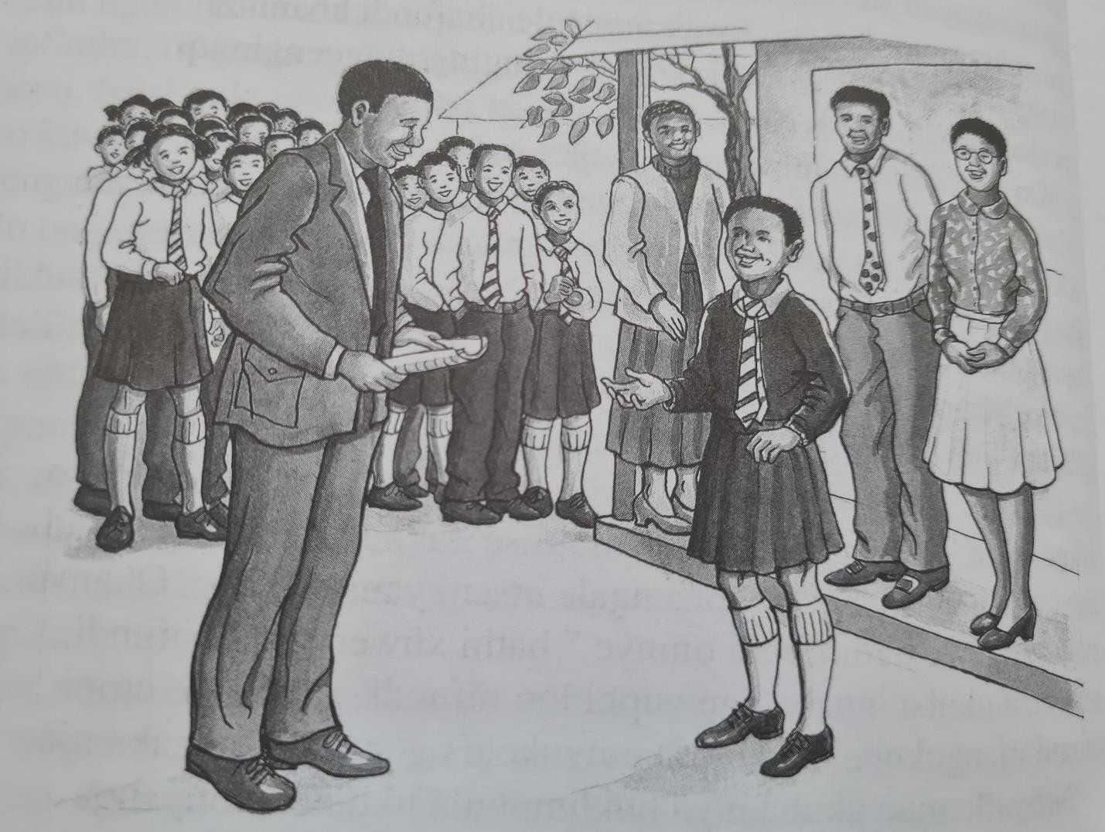

Kwilali yaseColana kwidolophu yaseMount Frere, kwakukho intombazana eyayikhuliswa nguninakhulu, igama lale ntokazi yayinguNtsiki. UNtsiki lo wayefunda kwisikolo iMfundo Secondary School. Le ntombazanana yayiphume izandla ngobukelekrele, ingqondo yayicwengile, izithanda iincwadi zayo, ingabaniki thuba bonke ababefunda nayo. Inqununu yesikolo yayibiza le ntwazana, yayikhuthaza ukuba ingenele ukhuphiswano lweMasifunde Scholarship.

UNtsiki wasithabatha isimemo senqununu ngezandla ezishushu, wancediswa yinqununu ukulungenela ukhuphiswano. Babebaninzi ke nabafundi bezinye izikolo ababelungenele olu khuphiswano bephuma kwiingingqi ngeengingqi kweli laseMpuma Koloni.

Zaqengqeleka iinyanga luqhubile ukhuphiswano, kwathuleka kwathi cwaka. UNtsiki yena wayelukhumbula usuku longenelo lwakhe ngathi yinto ayenze izolo, yayingumhla wama 21 kuCanzibe. Kwathi ngomhla wama 30 kweyeNkanga kwafika amagosa amabini esithi aphuma eMasifunde Scholarship Company. Anikwa ithuba lokuba athethe ngexesha lomthandazo wakusasa. Ngenene ke aluxela udaba lokuba abe lapho. Lathetha lenjenje elinye lala magosa:
“Mandibulise kwinqununu yesikolo, ndibulise kwisekela layo, kootitshala kunye nabafundi. Ndibulise ngokukhethekileyo kubafundi okanye kumfundi esize ngaye apha ngale ntseni yanamhlanje”. Bathi xhwenene abafundi bezibuza ukuba ingaba ngowuphi loo mfundi, yaye etye ntoni kabani njengokuba la magosa emvukele ngentseni kangaka nje.”Ndiyathemba ukuba niya kukhumbula ukuba kwiinyanga ezintlanu ezidlulileyo kwakukho ukhuphiswano, apho lowo uthe waphumelela wayeza kufumana isixa-mali esiza kumthatha ayokufunda kwidyunivesithi zaseRhawutini fele fele. Nisalukhumbula olo khuphiswano?” Bavuma abafundi, zaqala neentliziyo zabetha ngamandla bebuzana ukuba ingaba ngubani ke loo mfundi kuziwe ngaye namhlanje?
“Ngoku ke ndiza kucela uNtsiki Zibetho eze ngaphambili“. Wothuka uvalo lwaphantse lwaphuma ngomlomo” Ndinemincili yokukwazisa ukuba kuso sonke esi sithili sesi 8 kweli laseMpuma Koloni, nguwe ophume phambili. Kuza kufuneka uzilungiselele ukuya eRhawutini ekuqaleni kwenyanga yoMqungu.” Kwaqhwatywa izandla ngabantwana nootitshala. UNtsiki wema watyhafa, engayikholelwa yonke le nto. Ukuphuma kwesikolo wagoduka edloba okwetakane eya kuxelela uninakhulu, owathi xa ethetha,” ukusebenza nzima kuneziphumo ezihle”. Watsho emwola umzukulwana wakhe. Zanwena okomlilo wedobo iindaba ezimnandi zokuphumelela kukaNtsiki.

Phendula le mibuzo ingezantsi IMIBUZO
Khetha impendulo echanekileyo kwezo uzinikiweyo.
Bhala kuphela impendulo ecaleni kwenombolo. Umzekelo 1. A.
  - Liqhubeka kweyiphi ilali eli bali? (1)
A.KuGatyana B.EZibeleni
C. EColana D.Ecolosa

  - Yeyiphi le nyanga abafundi bebengenele ngayo ukhuphiswano? (1)
- NguCanzibe

- YeyeNkanga
- YeyeSilimela.
- YeyoMqungu.
  - UNtsiki xa echazwa kwesi sicatshulwa ,uchazwa njengomlinganiswa: (1)
- Othetha kamnandi noculayo.
- Omile kakuhle nojongekayo.
- Ongonqeniyo nothanda ucoceko.
- Okrelekrele nonengqondo ecwengileyo.
  - Wayekhuliswa ngubani uNtsiki? (1)
  - Nika intsingiselo yeli binzana, ‘‘Bathi xhwenene’’. (1)
  - Nika izizathu zibe ZIBINI ezabangela ukuba inqununu ikhuthaze le ntwazana kolu khuphiswano. (2)
  - Loluphi udidi lokhuphiswano olwalungenelwe nguNtsiki, wayeza kufumana sipho sini ? (2)
  - Sasiza kuba luncedo njani kuNtsiki esi sipho? (2)
  - Kwisicatshulwa caphula/ khetha isivakalisi esibonisa okokuba uNtsiki wayekuvuyela ukuphumelela kwakhe kukhuphiswano. (2)
  - Bhala isivakalisi esinye obunokusisebenzisa xa ubunguNtsiki ubulela kwinqununu nakubaphathi benkampani ekuwongileyo. (2)
  - Kuthetha ukuthini? (2)
Uvalo lwaphantse lwaphuma ngomlomo
Zanwenwa okomlilo wodobo iindaba
1.12 Lisifundisa ntoni eli bali? (2)
1.13 Ukuba ibinguwe obefundiswa yiMasifunde Scholarship, ubuzofundela ukuba yintoni? (1)

AMANQAKU: {20}

UMBUZO 2

ITEKISI EBONWAYO
Qwalasela lo mfanekiso ungezantsi uze uphendule imibuzo elandelayo

Umfanekiso othathwe kuGoogle .


  - Jongisisa umfanekiso ze uchaze ukuba ubona ntoni kuwo. ? (1)
  - Sizalana /sinxulumana njani isicatshulwa esikumbuzo 1 nomfanekiso okumbuzo 2? (1)
  - Chaza izinto zibe mbini aye umntu ofundileyo abonakale ngazo (2)
  - Ucinga ukuba ngowuphi umvuzo ofunyanwa ngulowo unyamezele imfundo? (2)
  - Ukungafundi kunobungozi. Zeziphi iingozi umntu anokugaxeleka kuzo xa engafundanga? (2)
  - Ingaba kunzima okanye kulula ukufunda. Xhasa impendulo yakho (2)

AMANQAKU: /10/

ICANDELO B
UMBUZO 3
ITEKISI YESISHWANKATHELO
Funda isicatshulwa esikumbuzo-1 esinesihloko esithi ‘ukuzimisela esifundweni kuneziphumo ezihle ngocoselelo uze usishwankathele usebenzisa awakho amazwi ukhuphe iingongoma eziNTLANU. Amagama owasebenzisileyo makangabikho ngaphantsi kwama -60 angadluli kuma -70 (60-70). Bhala inani lamagama owasebenzisileyo ekupheleni kwesishwankathelo.

Amanqaku : {05}

ICANDELO C
IZAKHII NEMIGAQO YOKUSETYENZISWA KOLWIMI
UMBUZO 4

  - Chaza ukuba sesiphi isixando sesenzi (1)
Zaqengqeleka iinyanga zonyaka
4.2 Khetha uchaze aza izihlomelo kwesi sivakalisi (4)
Zihambile inyanga weva kubuhlungu esifubeni .
  - Nika intsingiselo ethe gca yesaci neqhalo elibhalwe apha ngasezantsi. (1)
(a) UNozipho no Lungisani ngumtya nethunga.
  - Hlahlela esi sivakalisi ukhuphe intloko, isenzi nenjongosenzi. (3)
UNtsiki esikolweni uthabatha isimemo sakhe
  - Krwelela isivumelanisi senjongosenzi kwesi sivakalisi usinikiweyo. (1) UNtsiki wasithabatha isimemo.
  - Safobe sini esi sisetyenziswe kwesi sivakalisi singezantsi? (1) Wagoduka edloba okwetakane eya kuxelela uninakhulu.
  - Kwesi sivakalisi singezantsi khetha isichazi uze uxele udidi lwaso. (2) Zanwena okomlilo wedobo iindaba ezimnandi zokuphumelela kukaNtsiki.
  - Bhala esi sivakalisi sibe kwixesha eladlulayo (1)
UNtsiki uphumelele ukhuphiswano.
  - Chaza ukuba sesiphi isafobe (1)
Uvalo lwaphantse lwaphuma ngomlomo

AMANQAKU: /15/
AMANQAKU EWONKE: [50]

