NKANGALA DISTRICT

SOCIAL SCIENCES
GEOGRAPHY
GRADE 6
SEPTEMBER 2023

MARKS: 40
TIME: 1 HOUR

This question paper consists of 10 pages including cover page

Copyright reserved Please turn over

NAME AND SURNAME: ______________________________________
NAME OF SCHOOL: _________________________________________
INSTRUCTIONS
- Answer all the questions.
- Write your answers in the space provided.
- Write neatly and legibly.
QUESTION 1
Study the source and answer the questions that follow
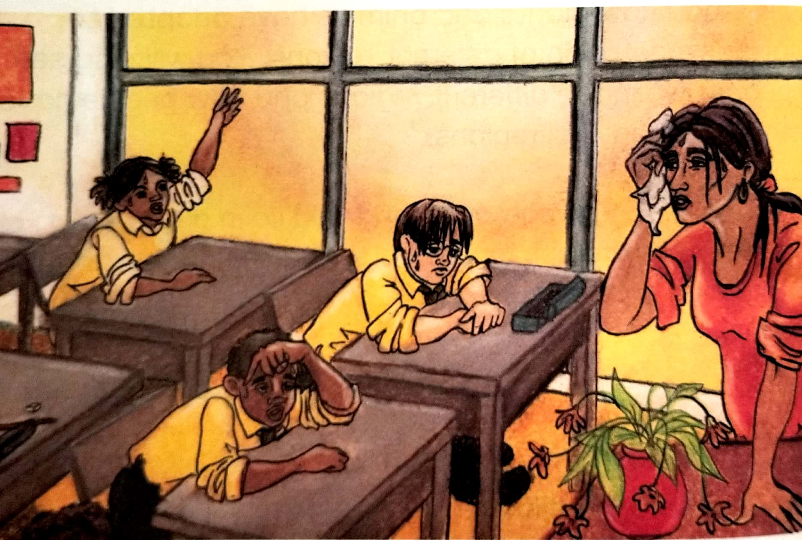
Adapted from: Our World , Our Society

State whether the following statements are TRUE or FALSE
  - Weather refers to the temperature, wind, cloud cover and rainfall on a particular day OR refers to the condition of a particular place over a short time.
  - Climate is the average weather conditions in a particular place/area over a long period of time.
  - Global warming is the increase in the earth’s surface temperature.
  - Current conditions are the way things were, in the past.
  - Polar regions are very cold areas close to the north or south poles.

(5)

QUESTION 2
Study the source and answer the questions below
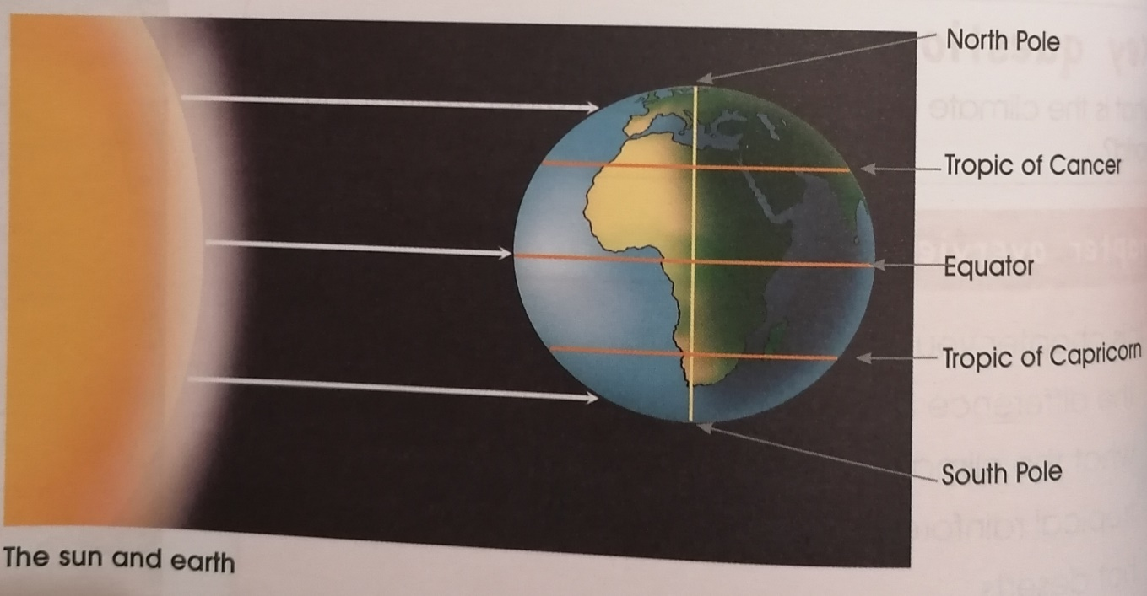 Adapted from VIVA SOCIAL SCIENCES

2.1 Which line of latitude is the hottest? (1)
___________________________________________________________________
2.2 Explain why the equator is the hottest. (2)
______________________________________________________________________________________________________________________________________
2.3 Where are the cold climate zones located? (2)
__________________
__________________
(5)

QUESTION 3
Study the source and answer the questions below
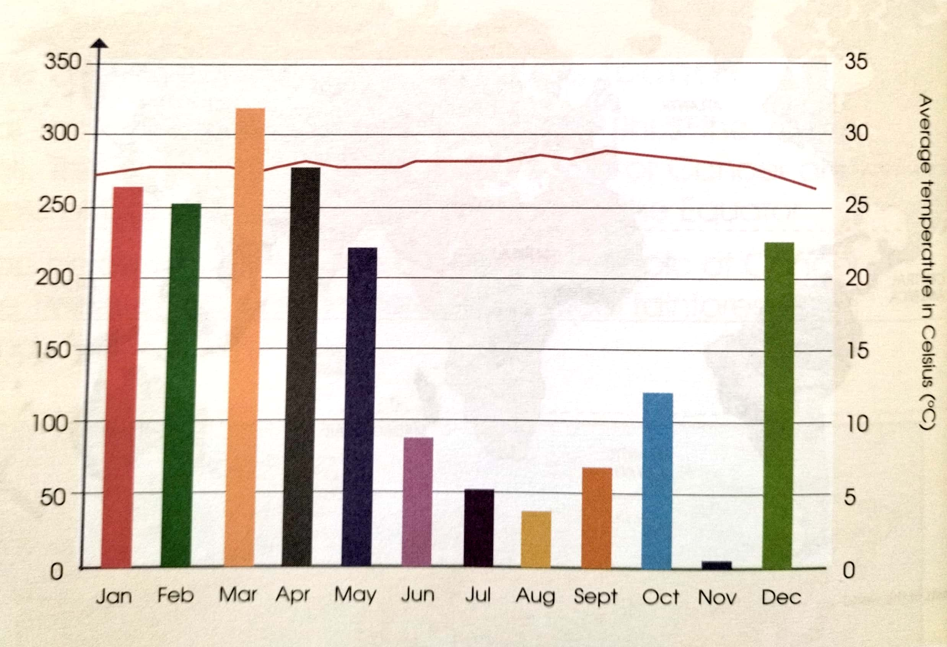
Adapted from Viva Social Sciences

3.1 Where are the tropical rainforests situated? (1)
___________________________________________________________________
3.2 Which month is having the highest rainfall? (1)
___________________________________________________________________
3.3 Which month is having the lowest rainfall? (1)
___________________________________________________________________
3.4 How many months of the year is the rainfall high (over 200mm)? (1)
___________________________________________________________________
3.5 Why tropical rainforests have lot of rain? (1)
______________________________________________________________________________________________________________________________________
(5)

QUESTION 4
Read the CASE STUDY and answer the questions below
Ivory Coast used to be covered in tropical rainforests. In only 25 years 12 million hectares of rainforest shrunk to 4 Million hectares. Now there are hardly any trees left. Forestry companies cut down more and more trees but did not replace them. Famers cleared land for crops like coffee and cocoa. Losing their forests has affected the economy, the climate and soil of ivory coast:
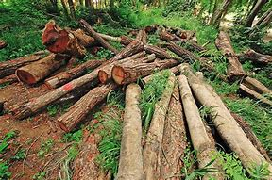
- The fail in timber sales caused the country to get less money from exports
- In the timber industry 30 000 workers have lost their jobs.
- As the forest was cleared, the rainwater either dried up in the hot sun or ran off the land instead of seeping into the soil.
- There was no longer a carpet of leaves rotting to form compost, so the soil became infertile.
- The drier savannah vegetation took over from the forest.
Adapted from Oxford successful and Internet

4.1 What is deforestation? (1)
________________________________________________________________
________________________________________________________________
4.2 Describe reasons of deforestation. (3)
________________________________________________________________
________________________________________________________________
________________________________________________________________
4.3 How did the soil get infertile (1)
________________________________________________________________
________________________________________________________________

(5)
QUESTION 5
Study the source and answer the questions below
ANIMALS AND PLANTS IN A HOT DESERT

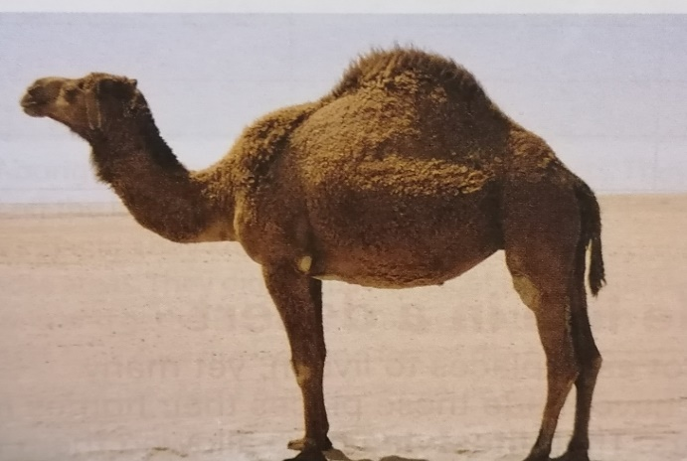

Downloaded from Internet

5.1 Choose the correct answer from the alternatives given below. Write only the
correct letter in the spaces provided. E.g. 8.1.4 A.
5.1.1 The animals in the hot desert hunt _____________ (1)
- In the morning
- In the afternoon
- At night
5.1.2 Plants adapted to the heat and dryness by ________________ (1)
A. short roots.
B. storing water on the leaves and stems.
C. having many leaves.
5.2 How is the condition in the Sahara Desert? (2)
________________________________________________________________
________________________________________________________________
5.3 Explain ONE (1) way on how plants adapt in the desert. (1)
_________________________________________________________________
_________________________________________________________________
(5)

QUESTION 6
Study the source and answer the questions below
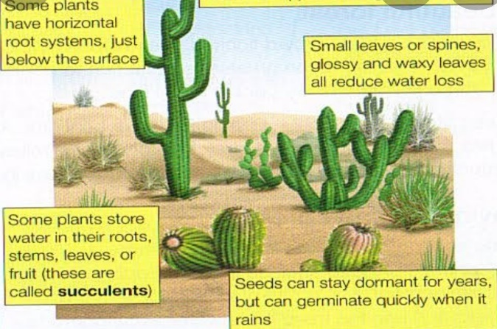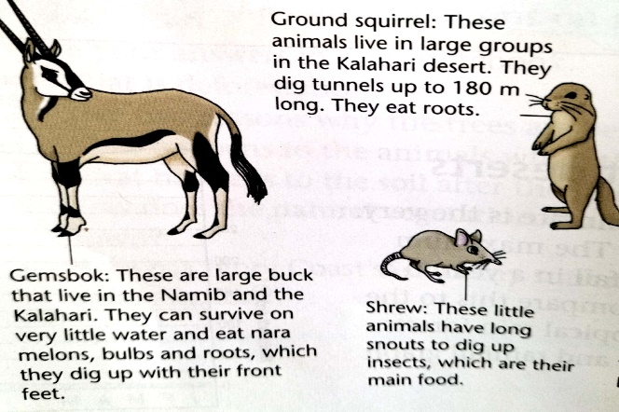

Downloaded from Internet

6.1 Mention TWO (2) plants growing in hot desert. (2)
______________________________________________________________
6.2 Where do most animal live in hot desert during the day? (1)
______________________________________________________________
6.3 How do the plants adapt themselves in hot desert? (2)
______________________________________________________________
(5)

QUESTION 7
Study the source and answer the questions below
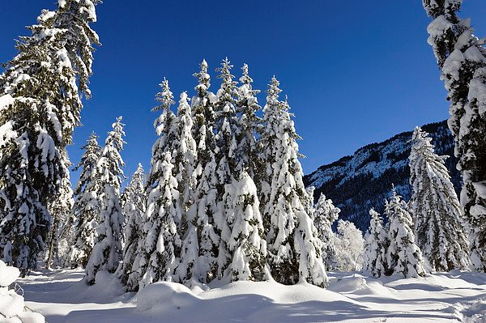
Downloaded from Internet
Choose the correct answer from the alternatives given below. Write only the correct letter in the spaces provided. Eg 11.1 C
7.1 Temperate coniferous are situated in _____________
A. Along the low-lying areas of the equator
B. Near the equator
C. Close to cool oceans, inland and on high lying areas.

  - Temperate coniferous forests have______________
- Warm summers and cold winters
- Cold summers and cold winters
- None of the above
  - The vegetation of temperate coniferous forests has to cope with_________
- Cold summers and poor soils
- Warm summers and fertile soils
- Cold winters and thin poor soils
  - The most common trees in coniferous trees are _________________
- Fir tree
- Fig tree
- Cactus
(4)

QUESTION 8
Study the source and answer the questions below
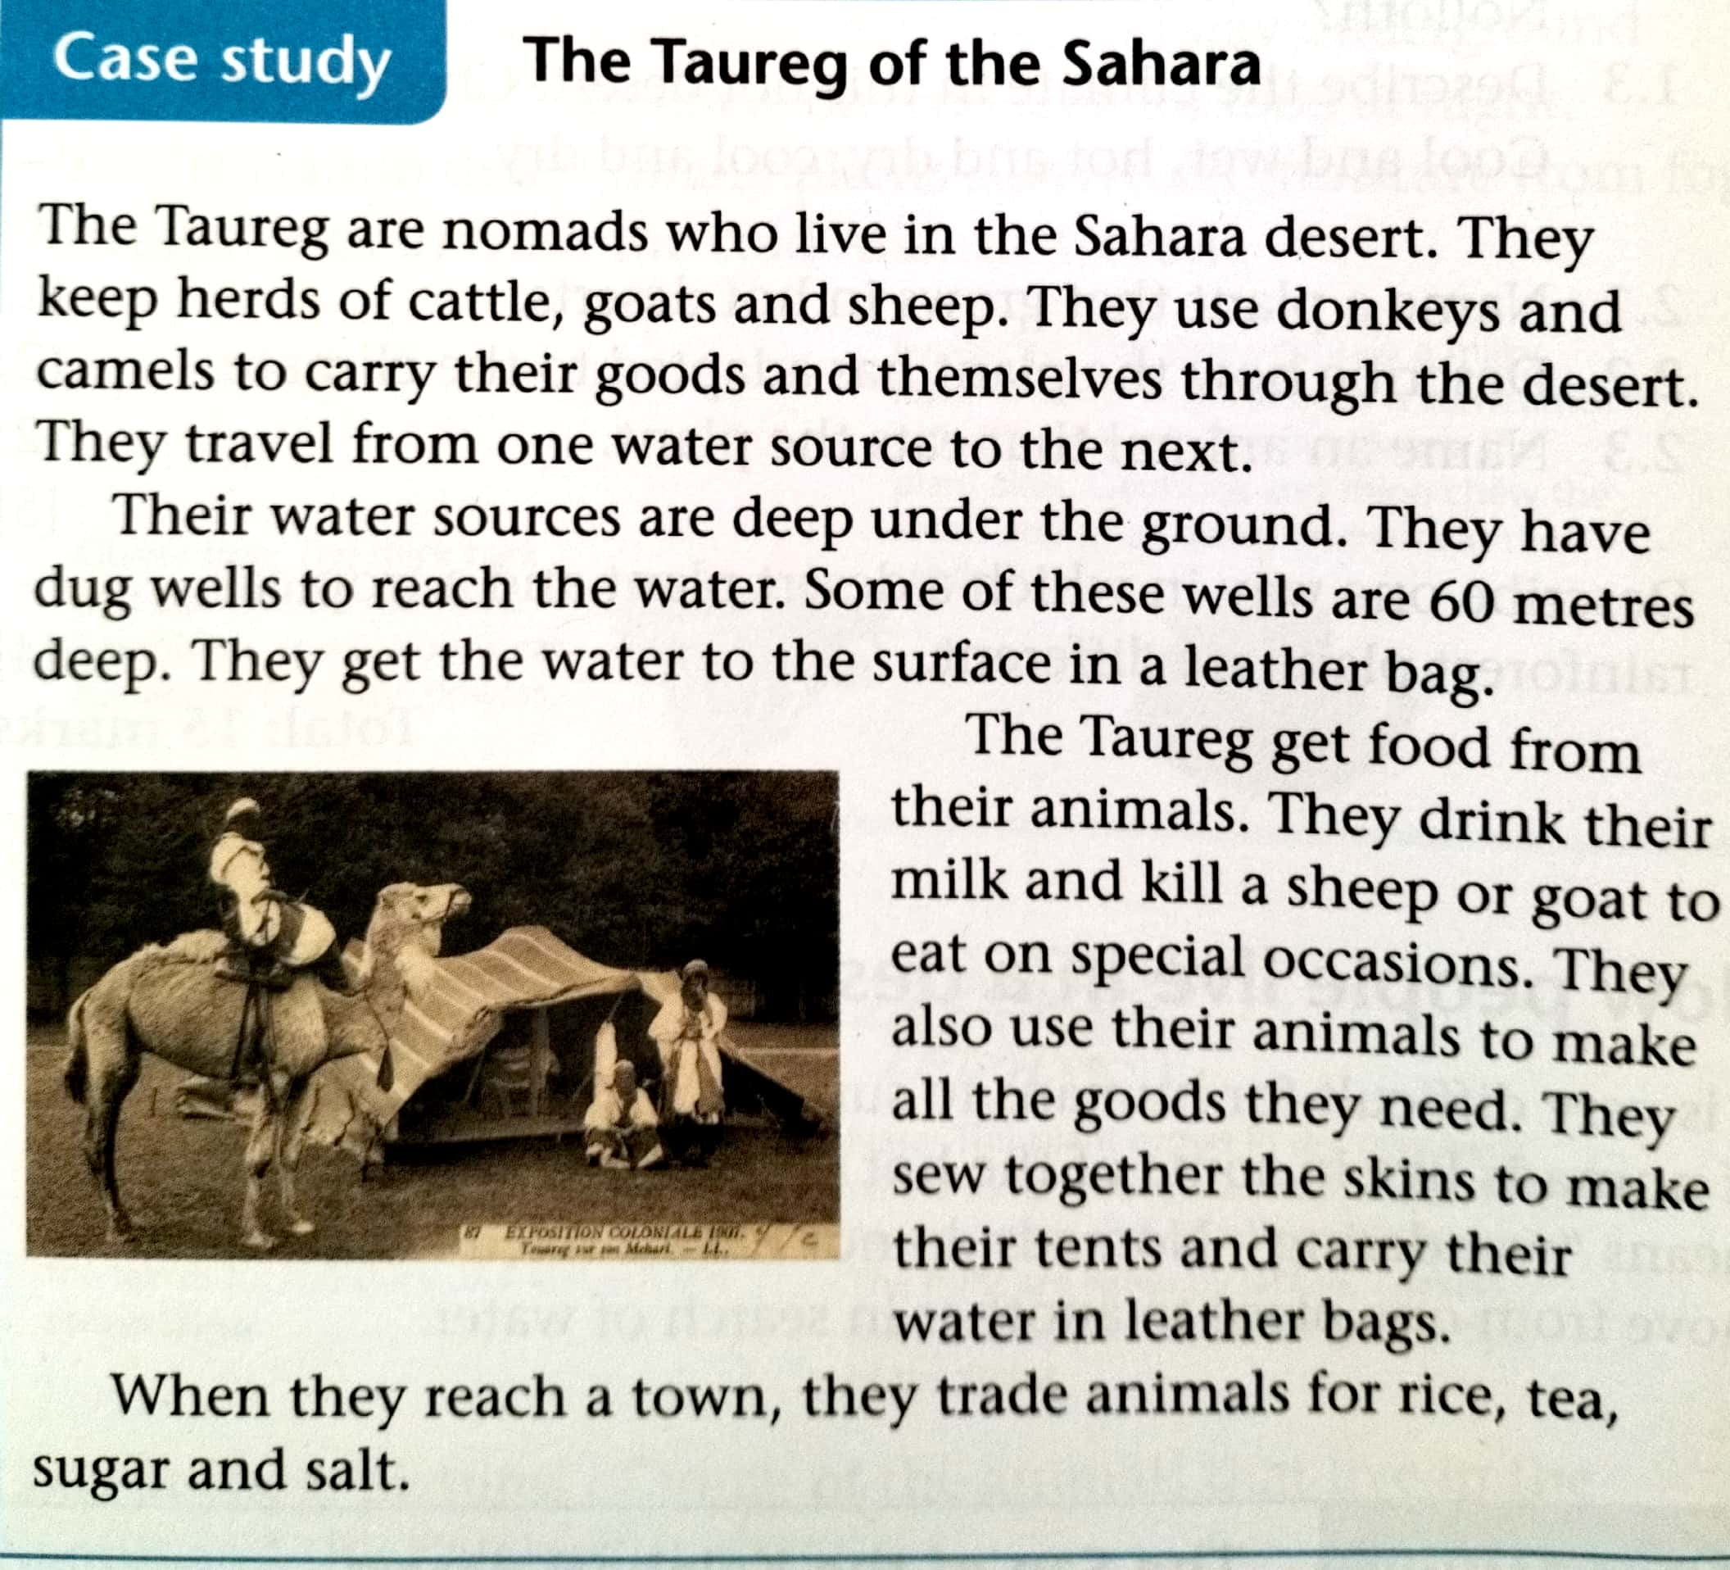
Adapted from the Oxford Successful

8.1 Where are the nomads living? (1)
8.2 In a paragraph of FIVE (5) sentences, explain how the Tuareg get water.
The paragraph should consist of a topic sentence, supporting sentences and a
concluding sentence. (5)
________________________________________________________________
________________________________________________________________
________________________________________________________________
________________________________________________________________
________________________________________________________________
Rubric for marking the paragraph (5 marks)
Level 1 | - Uses evidence in an elementary manner e.g. shows little or no understanding. Uses evidence partially to report on topic or cannot report on topic. | Marks: 0-1
Level 2 | - Evidence is mostly relevant and relates to a great extent to the topic. Uses evidence in a very basic manner. | Marks: 2-3
Level 3 | - Uses relevant evidence e.g. demonstrates a thorough understanding.  - Uses evidence very effectively in an organised paragraph that shows an understanding of the topic. | Marks: 4-5

