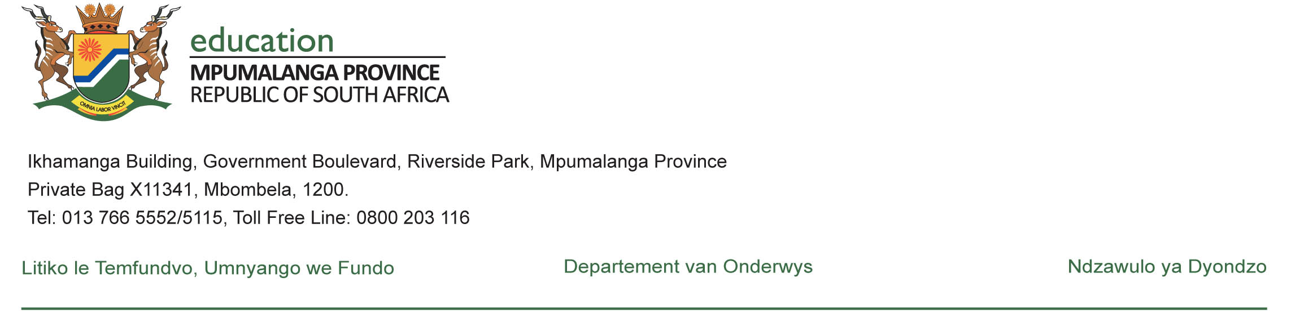
SOCIAL SCIENCES – GRADE 4

TERM 4- LESSON PLAN:

HISTORY

TOPIC:COMMUNICATION THROUGH TIME

SOCIAL SCIENCES – INTERMEDIATE PHASE

LESSON PLAN : HISTORY
TOPIC: COMMUNICATION THROUGH TIME  DATE FROM ____________ TO ___________ DURATION : 9 HOURS |  |  | GRADE | 4
 |  |  | TERM | 4  Week 2
CONTENT: CHANGE IN MODERN FORMS OF HUMAN COMMUNICATION |  | ASSESSMENT
 |  | Indicate with an x)  Formal assessment:  - Test  - Exam  - Data - handling  - Contextual - analysis  - Investigation/Research  - Case Study  - Creative Response | - Map skills  Informal assessment:  - Classroom activities  - Homework  - Worksheet  Assessment Tools:  Memorandum Rubric
CONCEPTS:
- Postal system  - Radio  - Television  - Early typewriters before electricity  - Telegraph  - Telephone | - Cell phone  - Cameras  - Computer  - Internet
WORDBANK:
Invented, Postal system, Wireless, Keyboard, Digital, Revolution,
 |  | The History curriculum aims to develop learners who:  AIMS | SKILLS
1.X |  | Finding a variety of kinds of information about the past. | -Being able to bring together information, from visual material including pictures.
2.X |  | Selecting relevant information. | -Being able to decide about what important information to use.
3. |  | Deciding about whether information can be trusted.
4.X |  | Seeing something that happened in the past from more than one point of view. | -Being able to contrast what information would be like if it was seen or used from another point of view.
5. | Explaining why events in the past are often interpreted differently.
6.X | Debating about what happened in the past on the basis of the available evidence |  | -Being able to take part in discussions or debates and developing points of view.
7. | Writing history in an organised way, with a logical line of argument.
8. | Understanding the importance of heritage and conservation.
RESOURCES REQUIRED: Relevant pictures of different forms of communication, Internet sources

KEY QUESTION:
- Is there a post office around your settlement?
- What can you do with your computer?
- Mention what can you use your cell phone for.

Teacher activities  (The teacher gives a detailed explanation of what will be done in class)  Date: ……... / ……… /20………. To ………. /………/20……… (3 HOURS)  -Postal system, Radio, Television |  |  | Learner activities
- Introduction to the topic.  - Explain new terminology to the learners, ie. Improving, Invented  - Inform them that methods of communicating have improved and new ways of sending messages are invented all the time.  - Display to the learners some pictures of these ways of communicating.  - Explain in detail the following ways that were used in the past, ie. Postal system (writing letters where postal stamps were used), Radios as the most common form of communication that are made up of transmitters and a receiver, Television (the 1st television set was invented in 1936 by a Scottish inventor known as John Logie Baird). Television is also a way of communicating information through pictures and sound to many people.  - Give them an activity about the above means of communicating. |  |  | - Listen attentively to the teacher.  - They listen and actively participate.  - Answer questions verbally as they are asked.  - They write the activity given
Teacher activities  (The teacher gives a detailed explanation of what will be done in class)  Date: ……. / …….. /20…….. TO …….. / ……../20……… (3 HOURS)  - Early typewriters before electricity, Telegraph, Telephone |  |  | Learner activities
- Explain new terminology to the learners  - Display to the learners some pictures of these ways of communicating.  - Explain in detail about the above forms of communicating, ie. Early typewriter as a small machine that was used by people to write printed words on a piece of paper, Telegraph was a way of sending messages along a wire, Telephone (is a Greek word which means ‘far sound’) which also allows people to send voice messages along wires. It was one of the greatest inventions of our time.  - Give them an activity about the above means of communication. |  |  | - Listen attentively to the teacher.  - They listen and actively participate.  - Answer questions verbally as they are asked.  - They write the activity given.
Teacher activities  (The teacher gives a detailed explanation of what will be done in class)  Date: …….. /…….. / 20……… TO ………/………/20……… (3 HOURS)  -Cell phones, Cameras, Computer and Internet |  |  | Learner activities
- Explain new terminology to the learners  - Display to the learners some pictures of the above ways of communicating.  - Explain in detail about the above forms of communicating, ie. A cellular phone or cell phone is a wireless phone that most people use these days to communicate with. They are small and easy to carry around. Talk about the benefits of using a cell phone. Cameras – the 1st camera was as big as a room, they will take pictures and store their own memories. Computers have become smaller over time; they can perform a number of things. Internet is a worldwide network that links millions of smaller computer networks to one another. People around the world can communicate with each other.  - Give them an activity about the above means of communication. |  |  | - Listen attentively to the teacher.  - Actively interacting with the sources displayed..  - Answer questions verbally as they are asked.  - They write the activity given.
ASSESSMENT ACTIVITIES (class or home activity):
Refer to the term 4 worksheets given.
Refer to the name of the textbook and page number, etc

EXPANDED OPPORTUNITIES /DIFFERENSIATION  - NB: Use the extra hours for revision.  - To be determined by the type of learners you have in the classroom.  - Revision and consolidation of the whole topic. |  |  | TEACHER REFLECTION:

