CREATIVE ARTS

VISUAL AND PERFORMING ARTS

MANUAL

GRADE: 5 TERM: 4

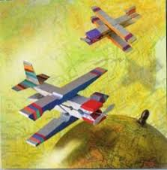

VISUAL ARTS

TERM 4: Grade 5 Visual Arts content is Mainly about:
Things that fly; Mechanical or Natural.

TEACHER’S NOTES:
● Visual Arts require learners to be observant, Critical and be able to INTERPRET WORKS of art.
● In order to develop that skill in learners, you have to collect, present and discuss a number of Artworks about the theme, both in 2D and in 3D.
● This compels the prioritisation of Visual literacy activities.
● NO VISUAL ART activity can be conducted BEFORE conducting visual literacy ASSESSMENT ACTIVITY.
● A Visual literacy activity serves as a process for teaching and learning in art.

VISUAL LITERACY

Visual literacy activities are the ONLY activities that are written down in learners’ books

ACTIVITY: CREATE IN 2D
Things that Fly (Natural or Mechanical)

INSTRUCTIONS:
● Observe the following picture /Artwork below and answer the questions that follows.
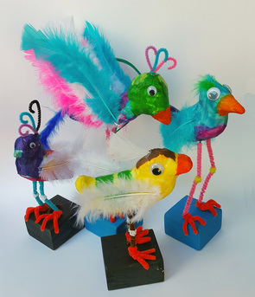

QUESTIONS:

- Is the above art work a depiction of Natural or Mechanical thing that fly?

YES |  | NO
(1)
- Is the above artwork in 2D or in 3D? CIRCLE the correct answer

2D / 3D (1)

    - Support your answer
__________________________________________________________________________________________________________________
(2)

- Identify CONTRASTING
SHAPES  3.1  3.2 | COLOURS  3.3  3.4
(4)

- Observe and identify the following

Media/materials used  4.1  4.2  4.3 | 4.4
(4)
5. Where is the emphasis of the Artwork?
_________________________________________________________
_________________________________________________________
(2)
TOTAL: (14)

VISUAL LITERACY

CREATE IN 2D
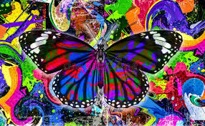

QUESTIONS
  - Observe the artwork above and mention all Art Elements used
1.1_________________________________________________
1.2_________________________________________________

1.3_________________________________________________

1.4 ________________________________________________

1.5 ________________________________________________

(5)
  - Is the above image in 2D OR in 3D?
YES /NO (1)
  - Observe and DRAW the following in the blocks below from the above artwork.
CONTRASTING SHAPES
3.1

3.2

3.3

(3)

  - Carefully observe and identify materials used and the technique applied in the above image.
.
MEDIA/MATERIALS USED
4.1__________________________________
4.2__________________________________
4.3__________________________________
TECHNIQUE APPLIED
4.4________________________________________
TOTAL: (13)
CREATE IN 2D
Things that Fly (Natural or Mechanical)

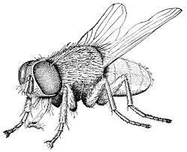

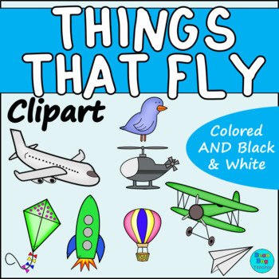

INSTRUCTIONS
● Choose anything that fly (Natural or Mechanical)
● Observe the image /model/ Artwork you have chosen
● Plan how you are to create in 2D in your drawing book.
● Manage balance in your drawing book.
● Have a strategy of infusing all Art elements.
(Form, Shape, Texture, Colour)
● Add design principles.
● Depict where there is an emphasis in your artwork.
● Cover the whole drawing book (All sides, top and bottom)

Was the learner able to --------------
SKILLS | 1----2 | 3---4 | TOTAL
Create in 2D things that fly | Create in 2D any image | Create in 2D  Things that fly. | 4
Manage balance in images created. | Manage balance one sided. | Apply design principles | 4
Apply all Art elements | Apply only form and shape  OR  Texture and colour | Creatively apply all Art elements | 4
Use selected media relevant | Used media with limited skill. | Applied media artistically. | 4
Depict an emphasis in the artwork. | Overlook an emphasis in the image created. | Present an image with an emphasis as a principle of design depicted. | 4

TOTAL: (20)

TEACHER’S NOTES

● PRESENT A NUMBER OF 3D ARTWORKS ON THINGS THAT FLY.
● ENCOURAGE THE COLLECTION OF DIFFERENT RECYCLABLE MATERIALS.
● MAKE USE OF YOUR CREATED RESOURCE CORNER TO ASSIST LEARNERS
WITH RECYCLABLE MATERIALS.
● ENCOURAGE LEARNERS TO PLAN THEIR MODELS BEFORE ACTUALLY
CREATING IT.

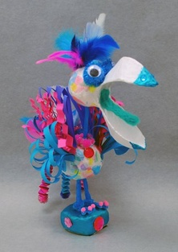

DEVELOP THE FOLLOWING SKILLS IN LEARNERS.

●● TOOL HANDLING SKILLS.
●● DESIGNING OF SHAPES, TEXTURE AND SIZES.
●● SPATIAL AWARENESS
CUTTING, WRAPING, TYING, JOINING, PASTING, etc.

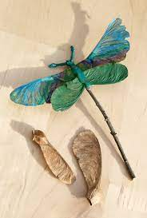
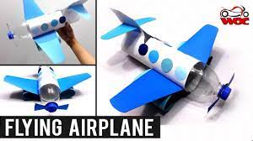
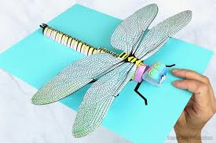
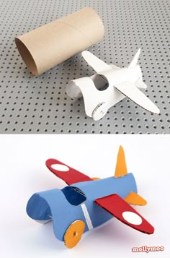

ACTIVITY: CREATE IN 3D
Things that fly
INSTRUCTIONS:
● use selected pictures, images or models of anything that flies.
● observe how all art elements were used.
● plan your own 2d model
● use recyclable materials in your creation.
● created model to be viewed back, front and all sides.
● use tools appropriately.

skills | 1-----2 | 3---4 | total
create in 3d  things that fly. | create in 3d  things that fly. | artistically create in  in 3d things that fly. | ----  4
construct an model from recyclable materials. | construct not only from recyclable materials | used recyclable materials | ----  4
apply art elements | apply only 2 or 3 art elements | apply all art elements | ----  4
use techniques  relevant | present, models with under developed  cutting, tying pasting and joining skills | present fully developed cutting ,tying pasting and joining skills | ----  4
present spatial awareness skills | model created viewed one sided only. | present a model that can extend to space and viewed from all sides. | ------  4
learner’s own
assessment

teacher’s comments

 |  | TOTAL = | -------  20

.

GRADE 5 - VISUAL ARTS FORMAL ASSESSMENT TASK: TERM 4
CREATE IN 2D – THINGS THAT FLY

INSTRUCTIONS:
- Choose a flying object:
Select one object that flies. It can be:
  - Airplane, bird, butterfly, drone, insect, hot air balloon, etc.

- Plan your artwork:
In your sketchbook or on scrap paper:
  - Sketch ideas
  - Decide what materials and colors you will use
  - Think about the setting (sky, clouds, space, etc.)

- Create your final artwork:
  - Use a A3 paper
  - Use 2D materials such as pencils, crayons, pastels, markers, or paint
  - Include background, details, and color
  - Focus on creativity, neatness, and clear representation

- Reflection (Written Component):
Answer the following in 3–5 sentences on the back of your page or a separate sheet:
  - What did you create?
  - What materials did you use?
  - What inspired your design?
  - What part of your artwork are you most proud of?

Materials needed:
- A4 or A3 paper
- Pencils, erasers
- Coloring materials (crayons, markers, colored pencils, or paints)
- Ruler (if needed for shapes or mechanical objects)

Assessment Rubric
Criteria | Excellent (7-8) | Good  (5-6) | Satisfactory (3-4) | Needs improvement (1-2)
Creativity & Originality | Highly imaginative and original idea | Creative with some original features | Some creativity shown | Limited originality
Use of Art Materials | Excellent control and application | Good control with minor errors | Some difficulty using materials | Poor use of materials
Detail & Effort | Artwork is detailed and complete | Good detail, mostly complete | Some detail, rushed areas | Lacks detail and effort
Neatness & Presentation | Very neat, well-presented | Mostly neat and clear | Somewhat messy | Very messy or incomplete
Written Reflection | Insightful and complete | Clear and thoughtful | Basic effort | Incomplete or missing
 |  |  | TOTAL = | ------------  40

OR

GRADE 5 - VISUAL ARTS FORMAL ASSESSMENT TASK: TERM 4

CREATE IN 3D: THINGS THAT FLY

INSTRUCTIONS:

1. Choose your flying object:
Your object can be:
- Airplane, bird, insect, helicopter, rocket, drone, etc.

2. Create your 3D Artwork:
- Use materials such as cardboard, paper, sticks, plastic bottles, foil, fabric, string, etc.
- Use glue, tape, staples, or safe fasteners for assembly
- Make sure your structure is stable and can stand or hang

3. Decorate your model:
- Add color using paint, markers, paper, or fabric
- Make it visually appealing and detailed

4. Complete a written reflection:
On a separate sheet or template provided, answer the following questions:
- What flying object did you create?
- What materials and techniques did you use?
- What challenges did you face, and how did you solve them?
- What do you like most about your 3D artwork?

Materials Suggested:
- Recycled boxes, cardboard, bottles, tubes
- String, sticks, toothpicks, paper plates
- Scissors, glue, tape, stapler
- Paint, markers, crayons, coloured paper

Assessment Rubric
Criteria | Excellent  7-8 | Good  5-6 | Satisfactory  3-4 | Needs Improvement  1-2
Creativity & originality | Very original idea and design | Mostly original with thoughtful ideas | Some originality | Lacks creativity or copied idea
Construction technique | Very well-constructed, strong and neat | Good construction with minor issues | Some parts loose or unstable | Poorly constructed or unfinished
Use of materials | Excellent and imaginative use of materials | Good use of materials | Limited variety used | Poor or inappropriate use of materials
Visual appeal & detail | Highly detailed and well-decorated | Good detail and neatness | Some effort shown | Lacks effort or messy
Written reflection | Thoughtful and complete responses | Clear with some detail | Basic answers | Incomplete or missing
TOTAL = |  |  |  | _________  40

PERFORMING ARTS

TEACHER’S NOTES
●Always create an inviting classroom atmosphere by displaying Drama performances, Poems and dance presentations.
●The classroom or period for Performing Arts have to have print rich Elements of Dance; drama and Music.
●The previous Term examples of Elements of dance, Drama and Music must always be used in all Art activities.
●The first activities have infused both Drama and Dance elements
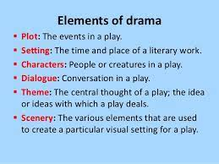

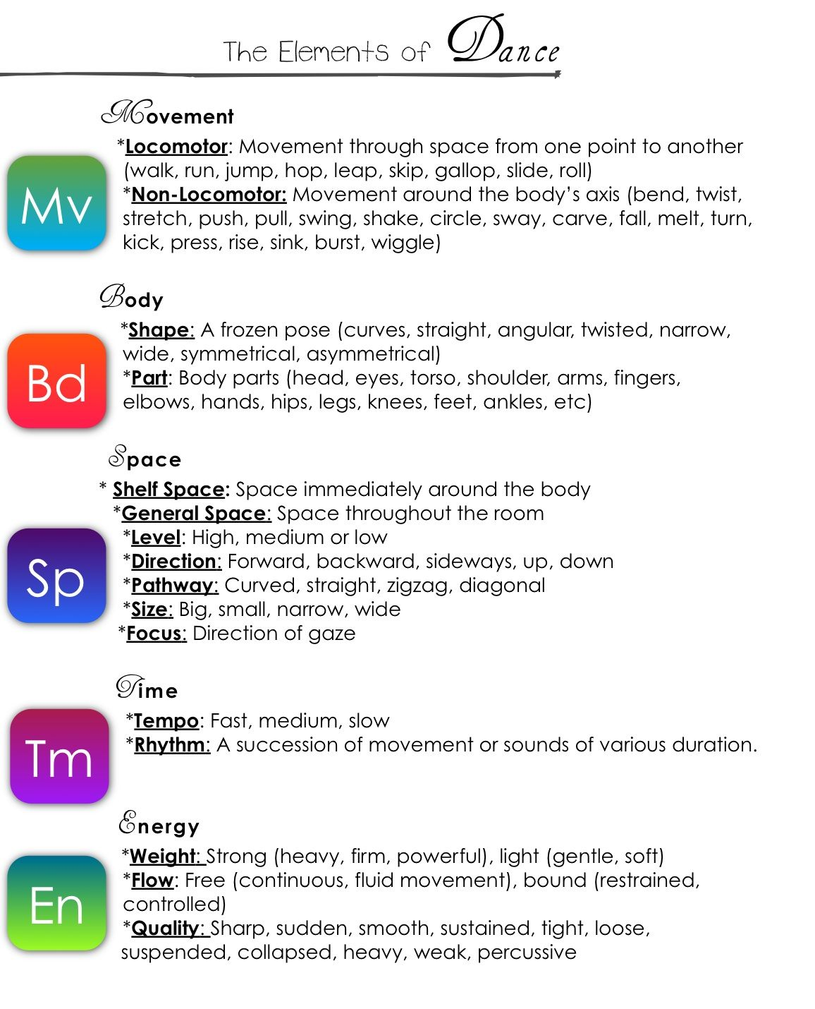

Term 4 content for Performing Arts emphasises the following themes:
● SOCIAL ISSUES
● CULTURAL ISSUES and
● ENVIRONMENTAL ISSUES

First brainstorm with learners issues around the above themes.

● Explain the meaning of the concepts first
Social
Environmental
Cultural

● Present different issues and provide learners to think out of the box as they engage about several issues they may think of:
● Dramatizing
●● Dancing or
●●● Writing POEMS about them.
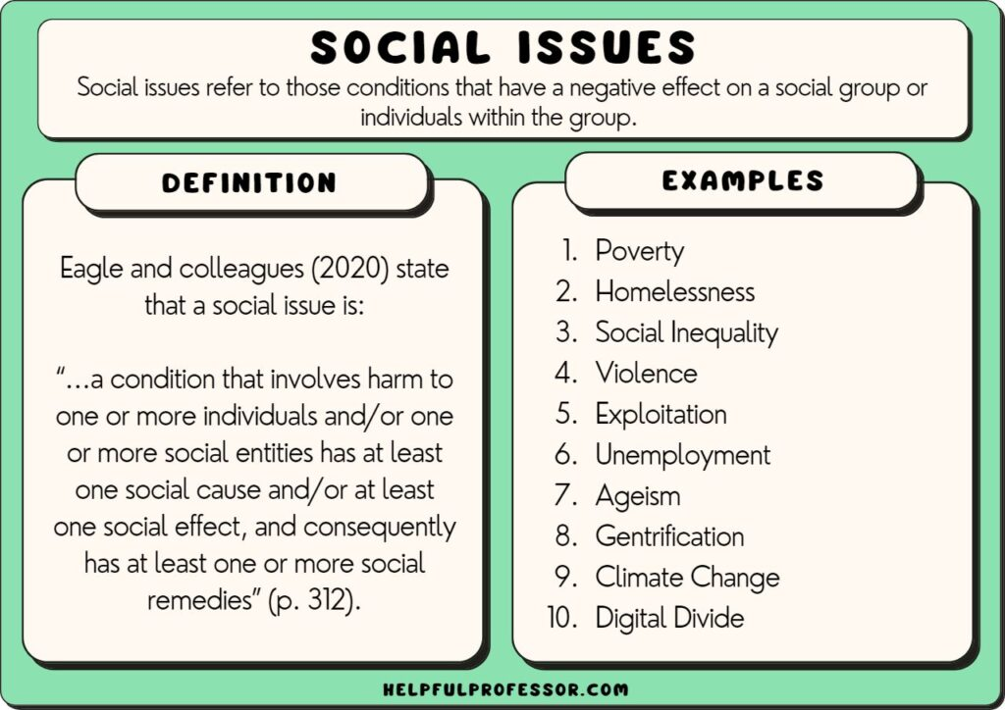

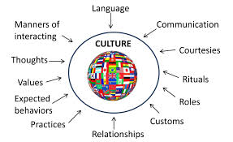

ENVIRONMENTAL ISSUES

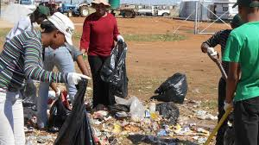

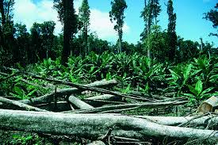

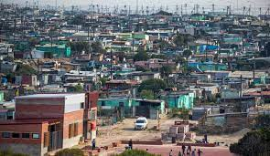

ACTIVITY: IMPROVISE AND CREATE / READ INTERPRET AND PERFORM
A Short Drama / Dance
(Reflecting Social /Cultural or Environmental issues)

INSTRUCTIONS:
● Choose members you will be performing together a drama or dance with.
● Think about what is happening around your community, school or family.
● Decide on any Social /Cultural or Environmental issue.
● Plan your drama or Dance looking at the Elements relevant the performance.
● Have the story line for the Drama or the lyrics for the Dance.
● The performance has to include TABLEAUX.

ACTIVITY: IMPROVISE AND CREATE
A Poem / Song
(Social, Cultural and Environmental)

INSTRUCTIONS:
● Choose any Social, Cultural or Environmental issue.
● Plan according to the message you want to convey.
● Add paragraphs for a Poem or Lyrics for the song.
● Compile the plan to a short composition.
● Present it in class for -------minutes.

Was the learner able to----------
SKILLS | 1---2 | 3 | TOTAL
Interpret a real Social, Cultural or Environmental issue. | Interpret any issue not specific to the identified issue | Realistically interpreted a selected issue | ___  3
Communicate a Social, Cultural or Environmental issue using a poem or a song | Use a Poem /song to communicate mixed issues. | Communicate a Social, Cultural or Environmental issue using a poem or a song | ___  3
Present a written plan of a Poem/Drama | Present a written plan of a Poem /Song | Present written situations around an issue using Poem/Song | ___  3
Present the composition. | Present ideas about the issues | Present a spiral composition about the selected issue. | ___  3
 |  | TOTAL | ___  12

TEACHER’S NOTES
● A reflection activity is an ORAL PRESENTATION by learners.
● Begin by reflecting with learners what you expect them to reflect on.
● Allow learners to reflect on issues of their choice if possible assist in approving whether issues are Social ,Cultural or Environmental
● Provide Sub –topics to guide their ORAL PRESENTATION.
● All the planned reflections have to be in the learner’s books as EVIDENCE of teaching and learning.

ACTIVITY: APPRECIATE AND REFLECT ON
A live or recorded Drama
Select a relevant introductory warm up activity

INSTRUCTIONS:
● Choose own or group Drama issue to reflect on
● Interpret how Elements of Drama were used.
● Communicate the most highlighted moments in the drama.
● Present the:
1. Theme through Drama
2. Ideas and moods used.
3. Character portrayal and costumes used
4. Body language and gestures used.

An Assessing Grid ( PRESENTING GUIDE TO LEARNERS)

1.1 The Drama Title /Theme -----------------------------------(1)

1.2 The type of the Drama -----------------------------------(2)

1.3 The type of an issue presented -------------------------------------(2)

1.4 The actual Key moment in the Drama ------------------------------(1)

1.5 What are ideas and moods that expressed in the Drama ---- 4)

1.6 Character Portrayal relevance to the Dance ---------------------(3)

1.7 What made the Social, Cultural or Environmental issue to be Dramatically expressed in the performance -------------------------(2)

1.8 Elements of Drama were creatively presented
-------------------------------------------------------------------------------(5)

TOTAL: (20)

ACTIVITY: IMPROVISE AND CREATE /
READ INTERPRET AND PERFORM
Short Drama

INSTRUCTIONS:
● Select any Social, Cultural or Environmental issue to be performed.
● Plan the Beiginning, Middle and End of the Drama.
● Allocate characters to chosen performers.
● In the Drama, include TABLEAUX during the performance.
● Add poetry and movements to the DRAMA.
● There must be singing individually or in unison as the performance
progresses.

Was the Drama presentation able to -------
SKILLS | 1 | 2-3 | TOTAL
Present a Social, Cultural or Environmental issue | Present issues with blockages | Present a realistic Social, Cultural or Environmental issue | ___  3
Present realistic characters | Characters without enrolment | Present realistic characters using body Language props and costumes. | ___  3
Perform a drama with Beiginning, Middle and the End | Perform a Drama as a linear presentation. | Perform a Drama with all phases for a presentation. | ___  3
Include TABLEAUX during the performance | Present still performers with no TABLEAUX | Synergise a Tableaux in the performance. | ___  3
Sing individually or in unison as the performance | Sing with no limitations in the performance | Selectively sing in line with the ideas expresses, individually and in unison | ___  3

TEACHER’S COMMMENT
___________________________________________________________________________________________________________________________________________________________________________
__________________________________________________________________________________________________________________

TOTAL: (15)

TEACHER’S NOTES

● Introduce and allow learners to explore a number of music
instruments:
Drums, Marimba, shakers, etc.
● Allow learners to be hands on and develop drumming techniques, such as:

Open slap
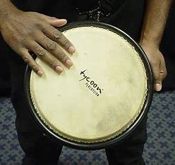

Base slap 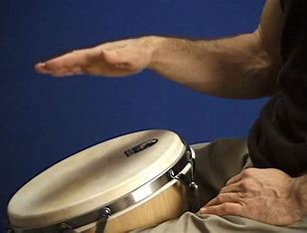

Muffled slap.
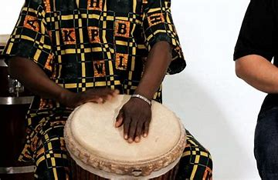
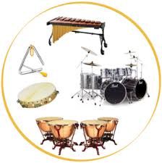

ACTIVITY: IMPROVISE AND CREATE
Short music piece

NB:
Learners have to observe music pieces combining a number
of music instruments.

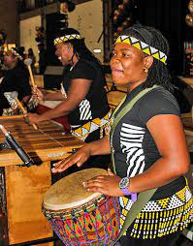

TEACHER’NOTES

Always present elements of an Art Form that will be taught

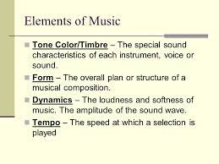

ACTIVITY: IMPROVISE AND CREATE
Short music piece
(Combining a number of instruments)
INSTRUCTIONS
● Choose own members for music performance.
● Discuss and bring different music instruments.
● Choose a common Social, cultural or an Environmental issue.
● Plan lyrics round the chosen issue.
● Include all elements of music in your music piece
● Use music instruments as accompaniments
● Express the actual moods through body movements.

Was the Music performance able to----------
SKILLS | 1---2 | 3---4 | TOTAL
Improvise and create a music piece on Social, cultural or an Environmental issue | Present music piece with no clear message | Improvise and create a music piece on Social, cultural or an Environmental issue | ------  4
Combine different music instruments | Present instruments not well played /heard. | Present the tone and timber of each instrument | ------  4
Include all elements of music in your music piece | include form and the dynamics unrelated to the music piece. | Present a spiral presentation of elements of music. | -----  4
Perform the selected issue using actual moods through body movements | Perform the music piece with uncommunicating  movements | Use body language and expressions to depict the moods of a song | -------  4
TEACHER’S  COMMENTS | _____________________

TOTAL: ( 16)

SELECT RELEVANT INTRODUCTORY WARM UP ACTIVITY

ACTIVITY: IMPROVISE AND CREATE
READ INTERPRET AND PERFORM
Short Drama or Dance improvisation

INSTRUCTIONS:
● Select a different Social, cultural or an Environmental issue from the previous lesson.
● Improvise and plan a Drama or a Dance.
● Reflect on Social, cultural or an Environmental issue through Drama or Dance.
● Include all elements of Drama and Dance.
● Manage Space appropriately.
● Present for --------minutes

Were learners able to--------
SKILLS | 1-----2 | 3---4 | TOTAL
Present a Drama/Dance | Present sequence of movements/ only(Dance)  OR  Present dialogues and movements | Present a realistic Drama/Dance  performance | ------  4
Communicate a different  Social /Cultural or Environmental issue | Communicate a repetition of a  Social /Cultural or Environmental issue | Communicate a different  Social /Cultural or Environmental issue | ------  4
Display understanding of  Drama/Dance elements | Display and interpret limited elements of Drama/dance | Communicate and express all elements of  Drama/dance | ------  4
Present Drama with a story line  OR  Dance with lyrics | Present Drama without a Storyline  OR  Dance with no meaning . | Present Drama with a story line  OR  Dance with lyrics | ------  4
Manage personal and general space effectively | Dramatize  OR  Dance all over the space | Manage both personal and general space during the performance. | ------  4
Teacher’s comments
 |  | TOTAL | ------  20

