2025 TERM 2 GRADE 5 HISTORY BASELINE ASSESSMENT
FIRST FARMERS IN SOUTHERN AFRICA
QUESTION 1
PICTURE A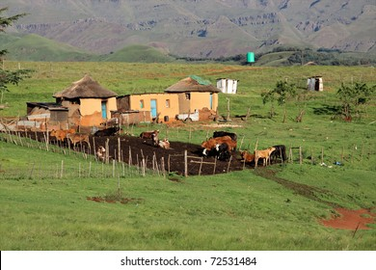 Downloaded from Internet | PICTURE B  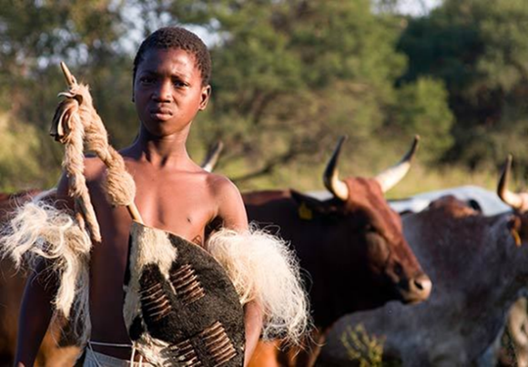

1.1 What is a farm? ___________________________________________________________
  - What is a farmer? ___________________________________________________________
  - What is a village? ___________________________________________________________
  - What is subsistence farming? ___________________________________________________________

2.1 People who live in farms and villages, what do they use cows for? Name 3 ______________________________, _______________________________, ______________________________
2.2 What do they use to build their houses? Name 2. _______________________, __________________________
2.3 What do boys who live in farms and villages expected to do? Name 2. ________________________________ and _______________________________
2.4 What do girls who live in farms and villages expected to do? Name 2. ________________________________ and _______________________________
(13)

