2025 TERM 2 GRADE 5 GEOGRAPHY BASELINE ASSESSMENT
QUESTION 1
Study the source and answer the questions below:


Downloaded from Internet

  - What does your local area look like? Is it a flat area OR a mountainous area? (1)________________________________________
1.2 Match Column A with the definition in Column B and indicate the correct answer in Column C (5)

COLUMN A | COLUMN B | COLUMN C
1.2.1 Coastal line | A. Is a flat lying land found high above sea level. | 1.1.1
1.2.2 Sea level | B. Is the line where the ocean meets the land. | 1.1.2
1.2.3 Interior | C. Is a number of mountains that are part of the same formation | 1.1.3
1.2.4 Mountain range | D. This means the inland area away from the sea | 1.1.4
1.2.5 A plateau | E. The height of the land at the coast | 1.1.5
(6)

QUESTION 2
Study the source and answer the questions below:
Location of the Highveld, Lowveld, Great Karoo, Little Karoo, Kalahari and Namaqualand
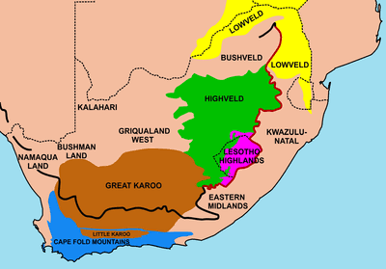
Downloaded from the internet
  - When do you get rainfall in your area? (1)
________________________________________________________________
  - Do plants grow very well in your location/area? (1)
________________________________________________________________
  - Is Mpumalanga located in the Lowveld region OR in the Highveld region. (1)
_______________________________________________________________

  - Refer to map above to identify the largest desert that is located in Botswana, Namibia and South Africa. (1)
_______________________________________________________________
(5)

QUESTION 3
RIVERS
Refer to the source below and answer the questions that follow:
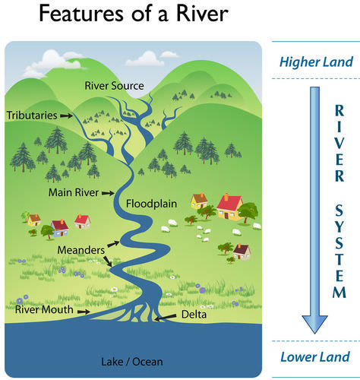
Downloaded from Internet
  - Where is the source of this river? (1)
________________________________________________________________
  - What do you call the small river that join the main river? (1)
________________________________________________________________
  - In which direction is the river flowing? (1)
_________________________________________________________________________
  - Name the river/s in your local area. (1)
________________________________________________________________
(4)
TOTAL MARKS: 15

