2025 TERM 2 GRADE 4 - HISTORY BASELINE ASSESSMENT
LEARNING FROM LEADERS
QUESTION 1
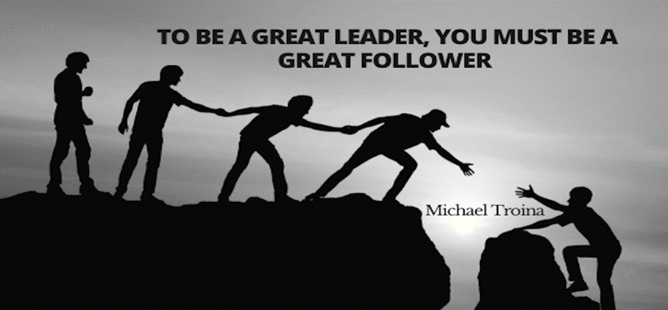
Downloaded from Internet
  - Who is the leader in your family? (1)
________________________________________________________________
  - Who is the leader of your church? (1)
________________________________________________________________
  - Who is the leader of your school? (1)
________________________________________________________________
2. Are leaders always good? Give a reason for your answer. (2)
______________________________________________________________________________________________________________________________________
3. Choose and circle the correct answer from the given options.
  - The president of South Africa is…. (1)
- DD Mabuza
- Cyril Ramaphosa
- Jacob Zuma
  - A good leader should: (1)
- Only care about his/her family
- Control everything
- Listen to people
  - This leader was imprisoned in Robben Island for 27 years. (1)
- Thabo Mbeki
- Nelson Mandela
- Cyril Ramaphosa

  - Nelson Mandela was released from jail in: (1)
- 1994
- 1992
- 1990
4. Nelson Mandela was the first black president. True/False (1)
___________________________________________________________________
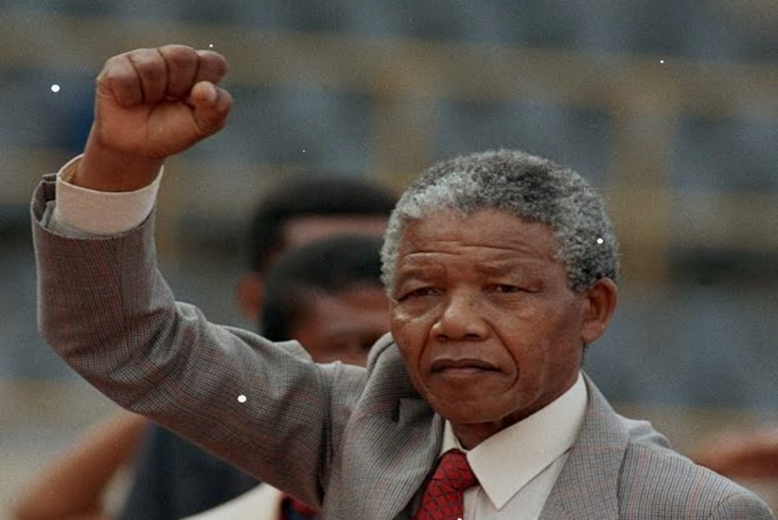
5. Write THREE (3) sentences about the person in the picture. (3)
___________________________________________________________________________________________________________________________________________________________________________________________________________________________
TOTAL MARKS: (13)

