2025 GRADE 4 GEOGRAPHY BASELINE ASSESSMENT
MAPSKILLS
QUESTION 1
Study the source to answer the questions below:
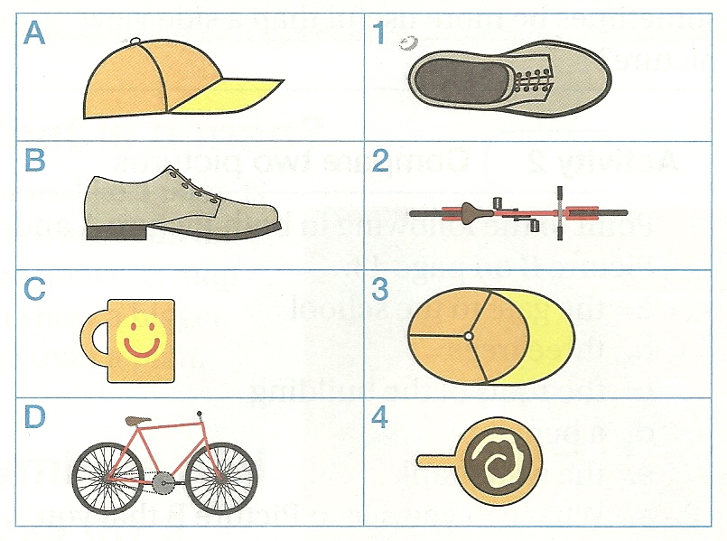
Adapted from Headstart Social Sciences

  - When using your cell phone or your parent’s cell phone to take photos or pictures. Do you take side view photos or plan view photos? (1)
_______________________________
  - Use the source above to match the side view photos with the plan view photos (eg. D2) (3)
_________________________
_________________________
_________________________
1.3Draw any THREE (3) items that you have in your bedroom OR kitchen and write their names opposite the drawing (symbol). (3)

    - ________________________________ =

    - ________________________________=

    - ________________________________=
1.4 Study the source below based on the FOUR (4) main cardinal points (points of direction) that we have. (4)
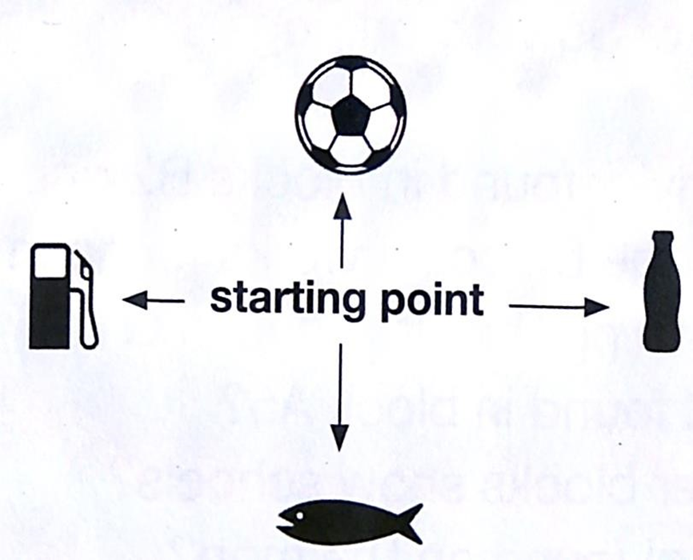
Downloaded from Internet
  - Use the compass points to answer the following questions:
    - Which direction do you move to reach the soccer field? (1)
__________________________________
    - Which direction do you move to reach the river? (1)
__________________________________
    - Which direction do you move to reach the petrol station? (1)
__________________________________
    - Which direction do you move to reach the café? (1)
__________________________________
    - What is the direction of the river from the soccer field? (1)
__________________________________
  - In which direction does the sun rise? (1)
____________________________________
  - Where does the sun set? (1)
____________________________________
  - What is the name of your town? (1)
____________________________________
  - In which province is your town located? (1)
____________________________________
1.10 What is the name of your country? (1)
____________________________________
1.11 How many provinces are found in your country? (1)
_____________________________________
1.12 Name any TWO (2) oceans that you know. (2)
__________________________ and ______________________________

TOTAL MARK: 24

