

KING CETSHWAYO DISTRICT

GENERAL EDUCATION AND TRAINING

GRADE 6

NATURAL SCIENCES AND TECHNOLOGY
JUNE PLC PRE-TEST
2025

Time: 70 Minutes
Marks: 40

Instructions and Information

- You must answer all the questions.
- Read the instructions carefully and answer questions as instructed.
- Number your answers exactly as the questions are numbered.
- For Question 4.1.5. a graph sheet is provided. Submit the graph sheet together with your answer sheet.
- Write neatly and legibly.

NB. This question paper consists of 6 pages and contains 6 questions.

Section A: Multiple Choice

Question 1
Various options are provided as possible answers to the following questions. Choose the most correct answer and write down only the letter next to the question number e.g. 1.1. D

  - Which properties of gases are correct?
- High compressibility.
- No fixed definite shape, spread out to occupy the entire available space.
- No fixed volume.

- I, II and III.
- I and II only.
- I and III only.
- II and III only. (1)

  - Which one of the following substances when mixed with water looks as though none of the substance has disappeared?
- Oil.
- Sugar.
- Copper sulfate.
- Salt. (1)

  - The effect of grain size, which is fine salt and coarse salt when dissolving in water. What is the independent variable in this practical?
- Grain size.
- Rate of reaction.
- Fine salt.
- Coarse salt. (1)

  - An area is not a wetland if it has one of the following factors.
- Low water table.
- High water table.
- Water-loving plants.
- Waterlogged soil. (1)

  - What does ‘clean water’ mean to Ziyanda who is a grade 6 learner?
- Oil, rubbish, and waste are in the water.
- Chemicals and poisons are in the water.
- Water is free of pollutants.
- Germs are in the water. (1)
[5]

Section B
Question 2
  - Study the diagrams showing the arrangement of particles below and answer the questions that follow.
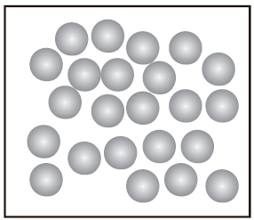  A | 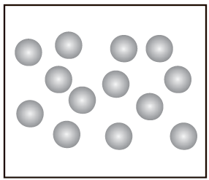  B | 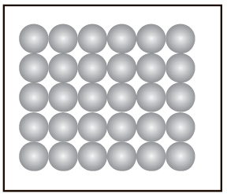  C

    - Which one of the above diagrams, A, B, or C represents the arrangements of particles in the liquids? Give a reason for your answer. (2)
    - If ice and liquid water have the same particles (ice is solid and water is liquid). Briefly discuss why do ice and liquid water have different properties. (3)
2.2. Did you know that the air we breathe is actually a mixture of many gases? Study the pie chart below that shows all the different gases in clean air and answer the questions that follow.
    - Which gas is the most abundant in air? (1)
    - What percentage of oxygen is present in air? (1)
    - If you had 5 000 air particles, calculate how many of these particles would be Argon particles? (3)
[10]
Question 3

  - Study the diagram of a mixture of sand and water poured through a filter below and answer the questions that follow.
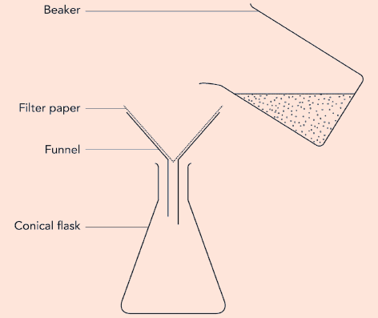
    - What is this process called? (1)
    - Why do the sand grains stay behind on the filter paper, but the water passes through it? (2)
  - Answer the following questions about the mixture of sugar and water.
    - What is the mixture of sugar and water called? (1)
    - What would happen if the mixture of sugar and water is poured through a filter? (1)
    - Why is it not possible to separate a solution of sugar and water through a filter? (2)
    - Describe how you can get the solid sugar back from the sugar solution. (2)
[9]
Question 4
  - Mariska and Thando from grade 6 investigate about dissolving salt in hot, tap (at room temperature) and ice water. They set up the apparatus as shown in the diagram below.
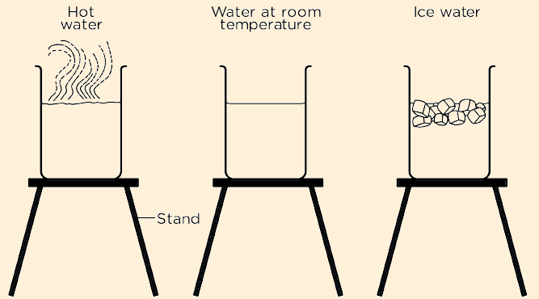
They obtained the results shown in the table below.

Situation | Time to dissolve (seconds) | Temperature (⁰C) | Amount of water (ml) | Mass of salt (g)
Salt in hot water | 5 | 70 | 100 | 2,5
Salt in tap water | 30 | 14 | 100 | 2.5
Salt in ice water | 48 | -10 | 100 | 2,5

    - What is the investigative question? (1)
    - Give one controlled variable shown in the table. (1)
    - Give an independent variable. (1)
    - Give a dependent variable. (1)
    - Use the information in the above table to draw a bar graph in the graph paper provided to show time taken to dissolve salt in hot, tap, and ice water. (5)
    - Which situation did the salt dissolve the fastest? (1)
[10]
Question 5
  - Study the picture of the bird covered in oil spilt in a river below and answer the following questions.
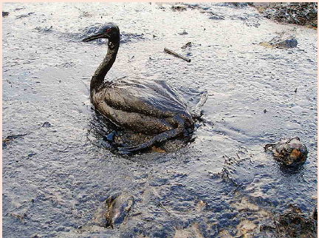

    - How do you think the oil got into the river that this bird lives in? (1)
    - Is oil a soluble or insoluble water pollutant? (1)
    - How will the oil damage this bird and other aquatic animals in this river? (1)
[3]

Question 6

  - Study the flow diagram for the process of cleaning water in a treatment plant below and answer the following questions.

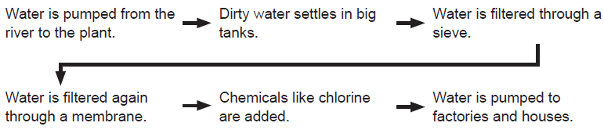

    - Where does a water treatment plant get its water from? (1)
    - What chemical is added to the water to kill germs? (1)
    - Name the wastewater that is piped away from homes. (1)

[3]

Total Marks: 40

Name: _______________________________________

Question 4.1.5.

