

KING CETSHWAYO DISTRICT

GENERAL EDUCATION AND TRAINING

GRADE 5

NATURAL SCIENCES AND TECHNOLOGY
JUNE PLC PRE-TEST
2025

Time: 70 Minutes
Marks: 40

Instructions and Information

- You must answer all the questions.
- Read the instructions carefully and answer questions as instructed.
- Number your answers exactly as the questions are numbered.
- For Question 5.1. a graph sheet is provided. Submit the graph sheet together with your answer sheet.
- Write neatly and legibly.

NB. This question paper consists of 5 pages and contains 5 questions.

Section A: Multiple Choice
Question 1
Four options are provided as possible answers to the following questions. Each question has only ONE correct answer. Write down only the letter to the question number e.g. (1.1. B).

  - Which one of the following is not a property of a metal?
- They are strong.
- They are shiny.
- They are dull.
- They are ductile.
(1)
  - Which metal is magnetic?
- Paper.
- Plastic cup.
- Chalk.
- Iron.
(1)
  - Which one of the following is the disadvantage of iron?
- Rust.
- It is shiny.
- It is soft metal.
- It is a polymer. (1)

  - Why would you not make a teaspoon from brass?
- It would be too soft.
- It would be too strong.
- It would be too heavy.
- It would be too light. (1)

  - Which one of the following objects is made from the wrong material?
- Wooden chair.
- Plastic chair.
- Glass chair.
- Aluminium chair. (1)
[5]
Section B
Question 2
  - Study the picture of a spanner below and answer the questions that follow.

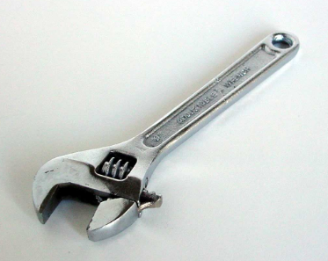
A spanner
    - Give two properties that a spanner needs to have to be used to tighten bolts. (2)
    - How do the properties of metal help the functioning of a spanner? (2)
    - If the spanner is made from plastic, do you think it would work as well? Give a reason for your answer. (2)
  - List 2 properties of non-metals. (2)
  - If a material is malleable, what does it mean? (1)
[9]

Question 3
Ronaldo and Kuhle who are grade 5 learners investigated about heat flow (thermal conductivity). They filled the container with warm water and placed the three spoons (metal, plastic, and wooden spoons) in the hot water for 30 seconds. The handles of the spoons were above the surface of the water as shown in the diagram below.
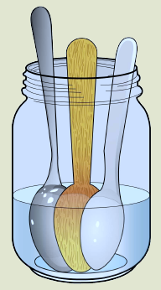
The three spoons in a container with warm water.
  - They felt the handles of each of the spoons in turn.
    - Which spoon felt the warmest? (1)
    - Give a reason for your answer in 3.1.1. above. (2)
  - If Ronaldo and Kuhle replaced warm water with ice cold water.
    - Did the metal spoon feel cold after it had been standing in the ice-cold water? Give a reason for your answer. (2)
[5]
Question 4
  - Study the picture of the pot below to answer the following questions.

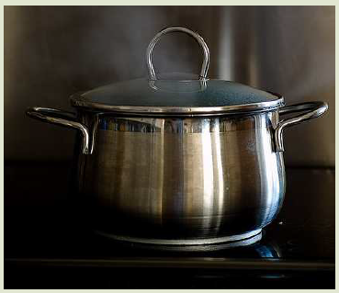

A pot

    - Why are most pots made of metal? (1)
    - Do you recommend metal handles of the pots? Give a reason for your answer. (2)
  - Some jewellery is made from metal.
    - Give one type of metal that makes jewellery. (1)
    - Why do you think some of these metals are so expensive? (1)
  - A group of learners from grade 5 left a piece of wire and a nail in a jar full of water.
Three days later they found that the nail had a reddish-brown powder on it. The wire did not change the colour.
    - What is the reddish-brown powder on the nail? (1)
    - Suggest a reason why the wire did not change colour? (1)
[7]
Question 5
Study the information provided in the table below regarding melting point of some metals and answer the following questions.
Metals | Melting Point (⁰C)
Gold | 852
Copper | 1085
Lead | 327
  - Use the information in the table to draw a bar graph in the graph paper provided to show a melting point of metals. (5)
  - You can melt lead in a copper spoon over a candle flame. Why does the copper spoon not melt? (1)
[6]
Question 5
  - Draw a flow diagram to show how concrete is made. (4)
  - Briefly explain why cement is used for laying of bricks. (1)
  - Read the following notes and study the diagrams below to help you answer the questions that follow.
- Since time memorial, people have always been able to use resources available to process materials to meet their needs.
- Materials were processed for houses, containers, and other useful resources.
- The pictures below show some of the materials which were designed for certain purposes.
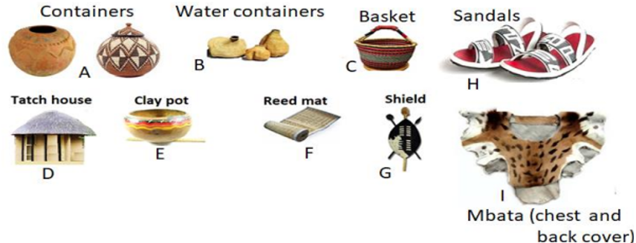

    - Describe how Xhosa people process clay to make bricks? (1)
    - Describe what raw materials (like clay) and processing is used to make and strengthen structures of people living in rural areas. (2)
[8]

Total Marks: 40

Name: _______________________________________

Question 5.1.

