

GENERAL EDUCATION AND TRAINING

GRADE 4
IBANGA LESI-4

NATURAL SCIENCES AND TECHNOLOGY
ISAYENSI YEMVELO KANYE NE THEKHNOLOJI
JUNE PLC PRE-TEST MEMORANDUM
IMEMORANDAMU YOKUHLOLWA KUKA-JUNE KWANGAPHAMBI YE-PLC
2025 TERM 2
2025 ITHEMU YESI-2

Time: 80 Minutes / Isikhathi: 80 Amaminithi

Marks: 40/ Amamaki: 40

Section A/ Isigaba A
Question 1/ Umbuzo 1

  - B√ (1)
  - B√ (1)
  - C√ (1)
  - A√ (1)
  - D√ (1)
[5]
Section B/ Isigaba B
Question 2/ Umbuzo 2
2.1 Solid√ – the particles in a solid are packed together as tight as possible√ / the particles are held together too strongly. (2)
I-Solid√ - izinhlayiya eziqinile zipakishwe ndawonye ziqine ngangokunokwenzeka√ / izinhlayiya zibanjwe ndawonye ngamandla kakhulu.
2.2.1 Liquid./ Uketshezi√ (1)
2.2.2 Gas/ igesi.√ (1)
2.2.3 Solid/ Iqinile.√ (1)
[5]
Question 3/ Umbuzo 3
3.1 No, √ because the clothes of material A dried at 30 minutes which is the fastest time compared to clothes of material B which dried at 35 minutes.√ or it took longer time which is 35 minutes to dry clothes of material B compared to the clothes of material A which took lesser time which is 30 minutes. (2)
Cha, √ ngoba izingubo ze-material A zomiswa ngemizuzu engu-30 okuyisikhathi esisheshayo uma siqhathaniswa nempahla engu-B eyomiswa ngemizuzu engu-35.√ noma kuthathe isikhathi eside okuyimizuzu engama-35 ukomisa izingubo ze-material B uma kuqhathaniswa nezingubo ze-material A okuthatha isikhathi esincane okuyimizuzu engama-30.
3.2 Temperature (30°C)./ Izinga lokushisa (30°C)./ √ (1)
3.3 Drying time of clothes./ Isikhathi sokomiswa kwezingubo √ (1)
3.4 Material of the clothes./ Impahla yezingubo √ (1)
3.5
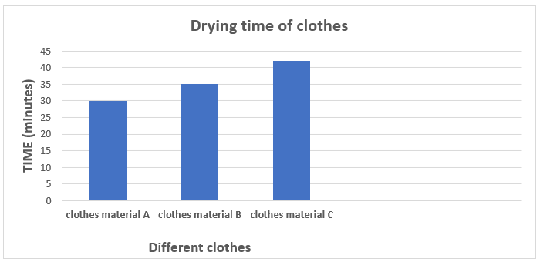

MARKING CRITERIAL FOR QUESTION 3.5.
- Labelling both axes correctly√
- caption√
- Correct plotting of:

- Clothes Material A√
- Clothes Material B√
- Clothes Material C√
INDLELA YOKUMAKA UMBUZO 3.5.
- Ukulebula zombili izimbazo ngendlela efanele√
- amazwibela√
- Ukuhlelwa kahle kwe:
- Izimpahla Zezingubo A√
- Impahla Yezingubo B√
- Impahla Yezingubo C√

(5)
[10]

Question 4/ Umbuzo 4

    - Wood is a raw material√ and paper is a manufactured material. √ (2)
Izinkuni ziyimpahla eluhlaza√ kanti iphepha liyimpahla ekhiqizwayo. √
    - Because wood is in its natural state√/ it has not been processed yet and paper has been made from wood and plant fibre√/ it has been processed. (2)
Ngoba ukhuni lusesimweni salo semvelo√/ alukalungiswa futhi iphepha lenziwe ngokhuni nemicu yezitshalo√/ selicutshunguliwe.

    - Leather boots, √ leather belt√ / leather shoes, etc. (2)
Amabhuzu esikhumba, √ ibhande lesikhumba√ / izicathulo zesikhumba, njll.
    - We make clothes. √ (1)
Senza izingubo. √

    - Hard√ material, because you cannot scratch it√ / you cannot cut it / you cannot dent it.
Hard√ impahla, ngoba awukwazi ukuyiklwebha√ / awukwazi ukuyisika / awukwazi ukuyiboleka.(2)

Question 5/ Umbuzo 5
  - Roof√, Pylon√, Crane√ /bridge, etc. (3)
Uphahla√, Pylon√, Crane√ /ibhuloho, njll.
  - A. √ (1)
  - The joints are the weakness part of structure, if they are not strengthened the structure can collapse.√ (1)
Amalunga ayingxenye ebuthakathaka yesakhiwo, uma engaqinisiwe isakhiwo singabhidlika.√

    - A – Brace/ Ukuqina √
B – Gusset/ I-Gusset √ (2)

- Triangulation./ Unxantathu√
- Davide structure into triangle/ ukuhlukanisa unxantathu √
Or/ noma
- Stop structure from bending out of shape./ Misa isakhiwo ukuthi singagobi
- Strengthen structure by pushing it. / Qinisa isakhiwo ngokusidudula (2)
[9]

Question 6/ Umbuzo 6
  - Branches/ Amagatsha √ / Mats/ . (1)
  - From the environment / kusukela endaweni√ / place in which they live/ indawo abahlala kuyo (1)
[2]

Total Marks: 40/ Amaphuzu Aphelele: 40

