NATURAL SCIENCE AND TECHNOLOGY MEMORANDUM
TERM 4 GRADE 6
MARKS: 60

Topic | Question | Expected answer | Marks
SECTION A : ENERGY AND CHANGE
 | 1
Electric circuits |  | C√ | 1
Electric circuits |  | B√ | 1
Electric circuits |  | A√ | 1
Electric circuits |  | A√ | 1
Electric circuits |  | B√ | 1
 | 2
Energy and electricity |  | Potential energy√ | 1
Conductors and insulators |  | Conductor √ | 1
Electric circuit |  | Switch √ | 1
Energy and electricity |  | Kinetic energy √ | 1
Conductors and insulators |  | insulator√ | 1
 | 3
Energy around us |  | F√ | 1
Energy around us |  | A√ | 1
Energy around us |  | B √ | 1
Conductors and insulators |  | D√ | 1
Electric circuit |  | C√ | 1
 | 4
Electric circuit | 4.1. | - A source of electrical energy – battery. √  - Conducting material – electric wire √  - A device that transfers energy for a useful purpose- bulb/buzzer/motor √ | 3
Electric circuit |  | A circuit is a complete √ path√ around which electricity can flow √ | 3
 | 5
Electric circuit | 5.1. | Light energy √ | 1
Electric circuit | 5.2. | Movement energy √ | 1
Electric circuit | 5.3. | Sound energy√ | 1
Electric circuit | 5.4. | Heat energy √ | 1
 | 6
Electric circuit | 6.1. | .  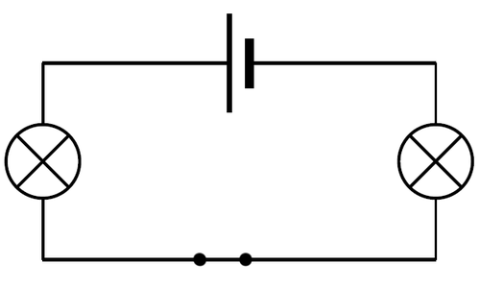 | 5
SECTION B: PLANET EARTH AND BEYOND
 | 1
The solar system |  | D√ | 1
The solar system |  | B√ | 1
The solar system |  | A√ | 1
The solar system |  | C√ | 1
The solar system |  | A√ | 1
The solar system |  | Asteroids √ | 1
The solar system |  | Gravity √ | 1
The solar system |  | Craters √ | 1
The solar system |  | Axis √ | 1
The solar system |  | Gaseous √ | 1
 | 3
The solar system |  | The sun √ | 1
The solar system |  | - Rotation : the Earth rotates on its axis which takes 24 hours √ √  - Revolution : the Earth revolves around the sun which takes 365$1/4$ √ √ | 4
The solar system |  | - There is no wind to blow the footprint away. √ √  - There is no water to wash the footprint away. √ √ | 4
 |  | 4
The solar system |  | Mercury √ | 1
The solar system |  | Saturn √ | 1
The solar system |  | Neptune √ | 1
The solar system |  | Earth √ | 1
The solar system |  | Jupiter √ | 1
 | 5
Dissolving | 5.1. | - Sun √  - Light rays √  - Earth √  - Day√  - Night √  - Diagram to show day and night √ | 6
SECTION A : 30 marks
SECTION B : 30 marks
TOTAL MARKS : 60

