

INSUZE PLC

MATHEMATICS PAPER 2023
GRADE 5 TEST
TERM 4

MARKS: 60 TASK 2 TEST TIME: $1$ HOUR

NAME & SURMANE

BOY | GIRL
GENDER ($√)$

Instructions to learners:
- Read all instructions carefully.
- Question 1 consists of multiple choice questions. Circle the letter next to the correct answer.
- Show all working (where necessary).
- The use of calculators is not allowed.
- Write neatly and legibly.

QUESTION: 1 MULTIPLE CHOICE QUESTIONS |  |  | [10]
Circle the letter of the correct answer
1.1. | The place value of the underlined digit in 3 256 is ………… |  | (1)
  A | Ten | B | 20
  C | Hundreds | D | Units/ Ones
1.2. | Complete this list of Odd numbers: 21; 23; 25; 27; 29; ……… |  | (1)
  A | 28 | B | 31
  C | 30 | D | 1
1.3. | Which statement is true in the list below? |  | (1)
  A | 25 + 30 = 30 + 25 | B | 65 – 10 = 10 – 65
  C | 32 + 33 = 55 | D | 67 + 10 = 100 – 67
1.4. | What is the next number in a sequence below?  16; 32; 48; ………… |  | (1)
  A | 44 | B | 64
  C | 76 | D | 54
1.5. | Which set in the list below, you can multiply and get 24? |  | (1)
  A | 12 x 1; 12 x 2 | B | 12 x 2; 3 x 8
  C | 12 x 2; 9 x 2 | D | 12 x 2; 14 x 10
1.6. | Which fraction is equal to $\frac{1}{2}$ = ………
  A | $$\frac{1}{3}$$ | B | $$\frac{1}{4}$$
  C | $$\frac{2}{4}$$ | D | 1
1.7. | Which of these fractions are written in a correct order?
  A | $\frac{1}{8}$; $\frac{2}{8}$;$\frac{4}{8}$; $\frac{6}{8}$ | B | $\frac{1}{5}$; $\frac{1}{2}$;$\frac{1}{4}$; $\frac{1}{9}$
  C | $\frac{1}{4}$; $\frac{2}{4}$;$\frac{4}{4}$; $\frac{3}{4}$ | D | $\frac{1}{9}$; $\frac{1}{2}$;$\frac{1}{4}$; $\frac{2}{3}$
1.8. | 23 x 100 = ……………….?
  A | 2 400 | B | 2 300
  C | 250 | D | 23
1.9. | 13:10 read as?
  A | 10 minutes to 1 | B | 10 minutes past 12
  C | 13 minutes past 10 | D | 10 minutes past 1
1.10. | $\frac{1}{2}$ $l$ = …………?
  A | 500$ml$ | B | 12 $ml$
  C | 1 000$ml$ | D | 5 $ml$
QUESTION: 2 |  |  | [5]
2.1. | Order these set of numbers in Ascending order?  6 134; 4 631; 6 431; 4 361; 699  ____________________________________________________________ |  | (1)
2.2. | Use the symbols <, >, or = to show which number is greater.  2 091 2 019 |  | (1)
2.3. | Write the following numbers in words.  7 589  ____________________________________________________________________________________________________________________________________ |  | (1)
2.4. | Round off the following numbers |  | (2)
  655 | To the nearest 10 | To the nearest 100
QUESTION: 3 |  |  | [14]
3.1. | Fill in the correct number to make the statement correct  (15+2) +3 = _____ + ( 2 + 3 ) |  | (1)
3.2. | Calculate:  26 463 + 30 631  __________________________________________________________________________________________________________________________________________________________________________________________________________________________________________________________________________________________________________________________________________ |  | (2)
3.3. | Calculate:  214 X 22  ______________________________________________________________________________________________________________________________________________________________________________________________________________________________________________________________________________________________________________________________________________________________________________________________________________________________________________________________________________ |  | (3)
3.4. | Calculate:  825 ÷ 25  ____________________________________________________________________________________________________________________________________________________________________________________________________________________________________________________________________________________________________________________________________________________________________________________________________________ |  | (2)
3.5. | Mr. Nxele puts R523.00 worth of petrol into his car. If had R800 in his wallet, how much money he ha left after paying for petrol?  __________________________________________________________________________________________________________________________________________________________________________________________________________________________________________________________________________________________________________________________________________ |  | (3)
3.6. | 12 players are needed in a school’s basketball team. The school has 36 students who want to play. How many teams will the school have?  ____________________________________________________________________________________________________________________________________________________________________________________________________________________________________________________________________________________________________________________________________________________________________________________________________________ |  | (3)
QUESTION: 4 |  |  | [6]
 | Calculate the following.
4.1. | $\frac{11}{14}$ - $\frac{8}{14}$ = |  | (1)
4.2. | $15\frac{6}{12}$ + $19\frac{5}{12}$ = |  | (1)
4.3. | $\frac{3}{4} of 24=$  __________________________________________________________________________________________________________________________________________________________________________________________________________________________________________________________________________________________________________________________________________ |  | (2)
4.4. | Zinhle had 20 oranges, she gave her friend $\frac{2}{5}$ of her oranges. How many oranges is she left with after giving her friend.  ________________________________________________________________________________________________________________________________________________________________________________________________________________________________________________________________________ |  | (2)
QUESTION: 5 |  |  | [7]
5.1. | 75 + 5 – 5 = ____________ |  | (1)
5.2. | (45 x 1) + (50 x 1) =__________________ |  | (1)
5.3. | 16 + 8 = 24; 17 + 8 = 25; 18 + 8 =
5.4. | 4  +8  × 6  5 38  50 |  | (2)
5.5. |  |  | (2)
  Rule | 1 | 2 | 3 | 4 | 5
  x 9 | 9 | 18 | 27 | _______ | _______
QUESTION: 6 |  |  | [8]
6.1. | Look at the following 2-D shape below.
 | 6.1.1. | What is the name of the above 2-D shape?  _____________________________________________________ | (1)
 | 6.1.2. | How many sides does this shape have?  ______________________________________________________ | (1)
 | 6.1.3. | Choose the correct answer. Mark with an x | (1)
  Shape with straight sides only
  Shape with curved sides only
  Shape with curved and straight sides
6.2. | Look at the shapes below and compare according to the statements on the table.  B  A  Write yes or no in an appropriate box. |  | (2)
  Statement | Square | Rectangle
  It has 4 sides and 4 right angles | Yes
  All sides are equal |  | No
6.3. | What is a name of the following 3D object.  _________________________________________ |  | (1)
6.4. | 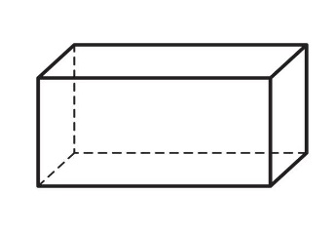  Compete the following using the above diagram.  Number of faces _________________________________________  Numbers of Edges ________________________________________ |  | (2)
QUESTION: 7 |  |  | [4]
7.1. | Convert the following measurement:  15 000 m = _______________ km |  | (1)
7.2. | Solve the following word problem.  At the start of the journey the odometer in the car read as 24 510 km. At the end of the journey the odometer read 28 467 km. What distance was travelled by the end of the journey?  __________________________________________________________________________________________________________________________________________________________________________________________________________________________________________________________________________________________________________________________________________ |  | (2)
7.3. | Calculate and complete the following  3 hours + $\frac{1}{2}$ hours = ___________ minutes |  | (1)
QUESTION: 8 |  |  | [6]
8.1. | Calculate the perimeter of the following diagram.  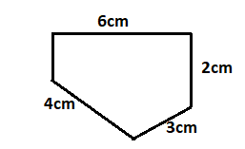  ________________________________________________________________________________________________________________________________________________________________________________________________________________________________________________________________________ |  | (2)
8.2. | Find the Area of the picture below.  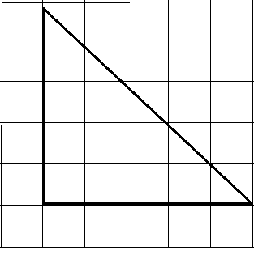  ____________________________________________________________________________________________________________________________________ |  | (1)
8.3. | Calculate the volume .  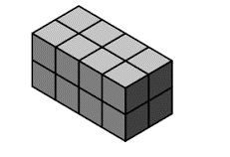  __________________________________________________________________  __________________________________________________________________ |  | (1)
8.4. | Problem solving  Phindi drank five 350 ml glasses of water and her friend drank three 500 ml bottles of water. Who drank more water?  __________________________________________________________________________________________________________________________________________________________________________________________________________________________________________________________________________________________________________________________________________ |  | (2)
 | TOTAL: 60 MARKS

