HISTORY TERM 2 GRADE 6 SPIP 2025
ACTIVITY 1 DATE _________________
REASONS FOR EUROPEAN EXPLORATION
Study the SOURCE and answer the questions that follow.
Reasons for European exploration
Trade  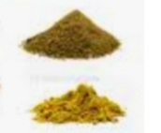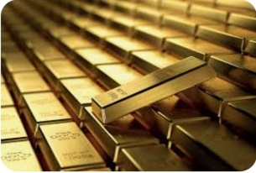  Europeans wanted to trade for spices, silk, gold and precious stones  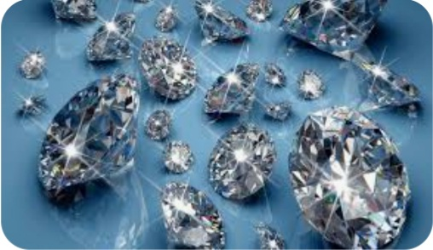 | To find a sea route to the East  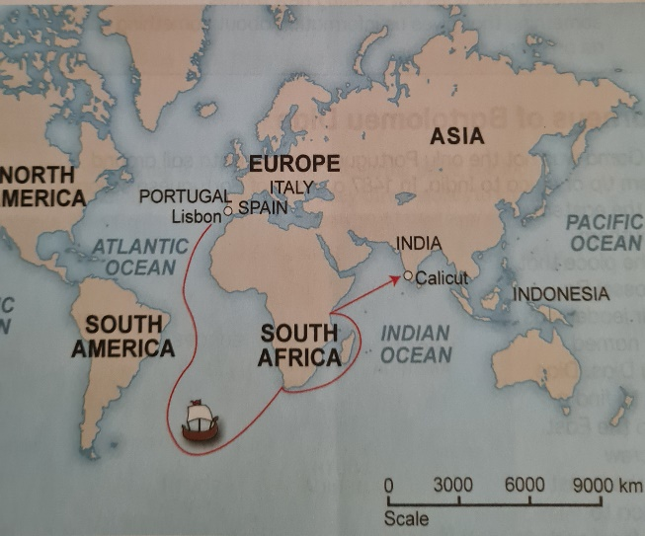  Europeans wanted to use the sea route  to buy spices in the East
To increase their knowledge of the World  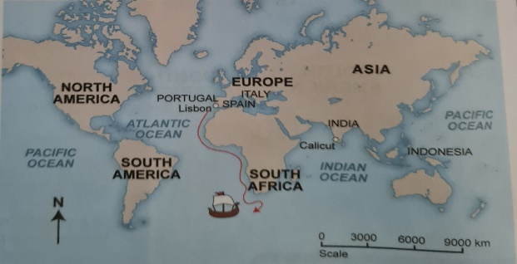  Europeans did not know much about the World they only knew Europe | To spread the Christian religion  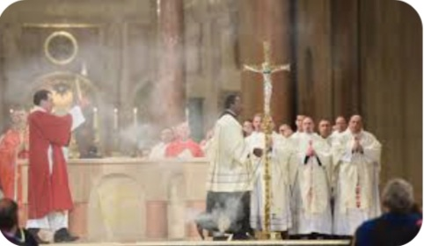  Missionaries wanted to spread the message of Christianity
Adapted from Clever Social Sciences and the internet

State whether the following statements are TRUE or FALSE
1.1 Exploration is the action of exploring an unfamiliar area. (1)
_____________________________________________________________________
1.2 Europeans wanted precious metals and spices for trade. (1)
_____________________________________________________________________
1.3 Missionaries were against Christianity. (1)
______________________________________________________________________
1.4 Europeans wanted to explore the world. (1)
______________________________________________________________________
1.5 Europeans used the sea route to the East to buy spices. (1)
______________________________________________________________________
1.6 Write a paragraph of FIVE (5) sentences about reasons for European exploration. Your
paragraph should have a topic sentence, main points and a concluding sentence. (5)
_____________________________________________________________________
_____________________________________________________________________
_____________________________________________________________________
_____________________________________________________________________
_____________________________________________________________________
Level 1 | - Uses evidence in an elementary manner e.g. shows little or no understanding. Uses evidence partially to report on topic or cannot report on topic | Marks: 0-1
Level 2 | - Evidence is mostly relevant and relates to a great extent to the topic. Uses evidence in a very basic manner. | Marks: 2-3
Level 3 | - Uses relevant evidence e.g demonstrates a thorough understanding.  - Uses evidence very effectively in an organized paragraph that shows an understanding of the topic | Marks: 4-5

(10)

ACTIVITY 2 DATE_______________
THE EUROPEAN RENAISSANCE
Study the source and answer the questions below.
The age of European Exploration

The time in history when Europeans began to explore other parts of the world is called the Age of European Exploration. This was in the 15th and 16th centuries. Portuguese, Spanish, Dutch and British ships left the shores of Europe on long Voyages to explore the seas and the continents they knew very little about.

The Renaissance brought about many changes in sciences and technology. Europeans had been trading with China and countries in the Middle East for centuries. Many new inventions were made by Europeans during the Renaissance, or were borrowed from other parts of the world they had visited.

Adapted from Platinum Social Sciences

1.1 In which centuries did European exploration begin? (1)
_______________________________
1.2 Give a reason why explorers did not use the land route from Europe to Asia? (2)
_____________________________________________________________________
_____________________________________________________________________
1.3 Explain why Europeans wanted spices from the East? (2)
_____________________________________________________________________
_____________________________________________________________________
  - Name the FOUR (4) countries that were involved in exploration. (4)
_______________________
_______________________
_______________________
_______________________
  - Define the following terms:
    - Voyage. (2)
______________________________________________________________________
______________________________________________________________________
2.2.2 Renaissance. (2)
___________________________________________________________________
2.3 In TWO (2) sentences, explain the greatest changes brought by Renaissance
around the world. (2) ______________________________________________________________________
______________________________________________________________________

2.4 Name a country that is found in Asia. (1)
_________________________________________ (11)

ACTIVITY 3 DATE __________________
CASE STUDY LEORNARDO DA VINCI
Study the SOURCE and answer the questions that follow.
Leonardo Da Vinci

Leonard da Vinci was born in Italy in 1452. He was a great man in both the arts and the sciences. He was a painter, sculptor, architect, musician, scientist, astronomer, mathematician, engineer, inventor, anatomist, geologist, cartographer, botanist, zoologist, paleontologist, and writer. Leonardo da Vinci made many important scientific discoveries, invented advanced weapons, and was one of the greatest painters of the Renaissance.
Adapted from Study and Master

3.1 Where was Leonardo da Vinci born? (1)
____________________
3.2 What is an Astronomer? (2)
_____________________________________________________________________
3.3. Mentioned any TWO (2) scientific discoveries made by Leonardo da Vinci. (2)
______________________________________________________________________
______________________________________________________________________
3.4 Name TWO (2) Leonardo da Vinci’s famous paintings. (2)
_______________________________
_____________________________
3.5 Explain why Da Vinci was skilled at many things. (2)
______________________________________________________________________
______________________________________________________________________
(9)

ACTIVITY 4 DATE_________________
CASE STUDY GALILEO GALLELEI
Study the SOURCE below and answer the questions that follow.
GALILEO GALLELI

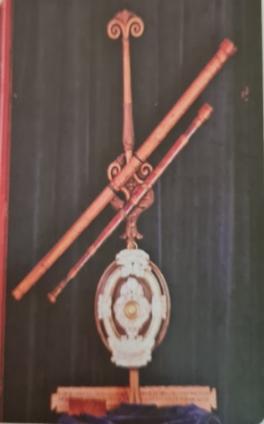Galileo telescope that he built and used to
Study the stars.
Galileo Galilei (1564 – 1642) was an Italian Scientist and astronomer. He discovered important things about science and astronomy. He is one of the fathers of modern science. Galileo built a telescope that he used to study the stars. He studied the milky way and find out that it consists of the stars and planets. He also noticed that there were moons around the planet Jupiter.
Adapted from Macmillan

4.1 What is a telescope? (2)
______________________________________________________________________
______________________________________________________________________
4.2 What did Galileo use his telescope for? (1)
4.3 What information did Galileo find out by using his telescope? Mention TWO (2)
Things from the passage. (2)
______________________________________________________________________
______________________________________________________________________
(6)

ACTIVITY 5 DATE: _______________
INVENTIONS
Study the SOURCE and answer the questions below.
Inventions
A number of inventions were very important reasons for European exploration. These inventions included the following:
- the magnetic compass
- the caravel
- gunpowder
Gunpowder
The Chinese invented gunpowder. In the 13th Century knowledge of gunpowder spread to Europe. By the time of the voyages of discovery in the 15th Century, Europeans had developed canons and firearms using gunpowder, which they put on ships. They then used these weapons to attack and conquer the people that they met on their voyages.
The Magnetic Compass
The Europeans used the magnetic compass to help them find their way on their voyages of exploration. The magnetic compass was first invented by the Chinese. The compass and the astrolabe helped sailors to figure out where they were and where they were going so that they could stay on the right course. They did not have to stay in sight of land to know where they were going. This meant that they could use the winds that blew far from land to go where they needed to go.
The Caravel
Until the 1400s (13th century) the Europeans did not have ships that were able to travel across oceans. To solve this problem, they started to build Caravels. This ship had two masts and two triangular sails. The Europeans copied the idea of the way the sails worked from the Arab trader’s ships called the dhows. The sails made it possible for the sailors to make better use of wind to get their ship to move.

Adapted from: History online

5.1 Mention THREE (3) inventions that took place during the European exploration. (3)
___________________________
__________________________
__________________________
5.2 Mention TWO (2) things that were made from gun powder. (2) ____________________________
____________________________

5.3 In THREE (3) sentences describe how the invention of magnetic compass assisted
the explorers on their voyages. (3) ______________________________________________________________________
______________________________________________________________________
______________________________________________________________________
5.4 Give a reason why the Europeans built the caravel. (2)
______________________________________________________________________
______________________________________________________________________
5.5 Write a paragraph of FIVE (5) sentences, explaining how inventions of the Caravel
and magnetic compass improved sailing. Your paragraph should have: a topic sentence,
main points and a concluding sentence. (5)
______________________________________________________________________
______________________________________________________________________
______________________________________________________________________
______________________________________________________________________
______________________________________________________________________
Level 1 | - Uses evidence in an elementary manner e.g. shows little or no understanding. Uses evidence partially to report on topic or cannot report on topic | Marks: 0-1
Level 2 | - Evidence is mostly relevant and relates to a great extent to the topic. Uses evidence in a very basic manner. | Marks: 2-3
Level 3 | - Uses relevant evidence e.g demonstrates a thorough understanding.  - Uses evidence very effectively in an organized paragraph that shows an understanding of the topic | Marks: 4-5

(15)

ACTIVITY 6 DATE: ___________________
DIAS AND HIS CREW ENCOUNTER THE KHOKHOI IN MOSSEL BAY
Study the SOURCES and answer the questions that follow
Dias and his crew encounter the Khoikhoi in Mossel Bay
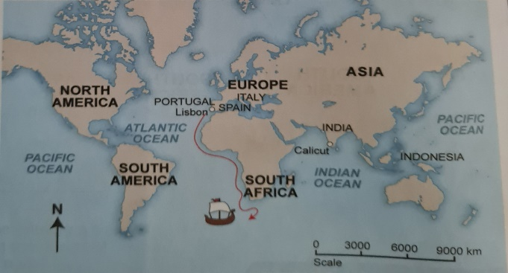
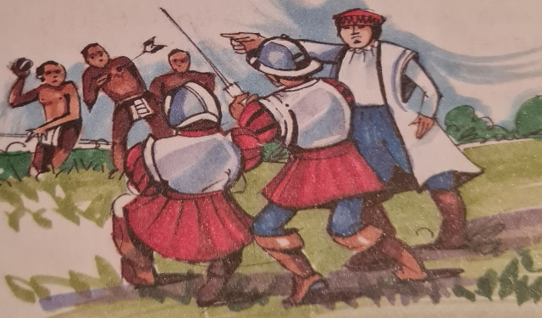
At the tip of Southern Africa, the winds currents are very strong. Dias’ ships got blown so far southwards, that they missed the tip of Africa. His ship eventually landed at Mossel Bay in 1488.
Dias and his crew went ashore to collect fresh water. They were the first white men to set foot in South Africa. The people living in Mossel Bay were the Khoi herders. When the Khoi herders saw Dias and his crew, they threw stones at them. Dias fired his crossbow at the Khoi herders and killed one of them before the Portuguese sailors got on their ships again.
This is a description of the encounter between the Portuguese and the Khoi:
“The men who landed from the boats were unlike anything the Khoikhoi had seen before…the strangers made towards a nearby stream, obviously in need of fresh water. At this the Khoikhoi reacted, and one of them picked up a stone and hurled it at the invaders. Others joined in as the strangers shouted at them in a language they did not understand. There was a sudden hissing sound, and one of the herders lay dying with a crossbow bolt protruding from his body.
Source: Readers Digest Real Story, pg 32 Readers Digest Illustrated History of South Africa, D. Oaks (ed) Cape Town, 1992

6.1 In which year did Dias’s ship land at Mossel Bay? (1)
_____________________
6.2 Give a reason why his ship landed at Mossel bay? (2)
____________________________________________________________________
6.3 Who were the people living at Mossel Bay? (1)
________________________________________

6.4 In TWO (2) sentences explain what happened when Dias encountered the
Khoikhoi herders. (2)
______________________________________________________________________
_____________________________________________________________________
6.5 What did the Khoi have that the Portuguese wanted? (1)
____________________________________________________________________
6.6 From whose point of view is the description written? (2)
______________________________________________________________________
______________________________________________________________________
(9)

ACTIVITY 7 DATE ___________________
THE JOURNEYS OF VASCO DA GAMA
Study the SOURCE and answer the questions that follow.
THE JOURNEYS OF VASCO DA GAMA

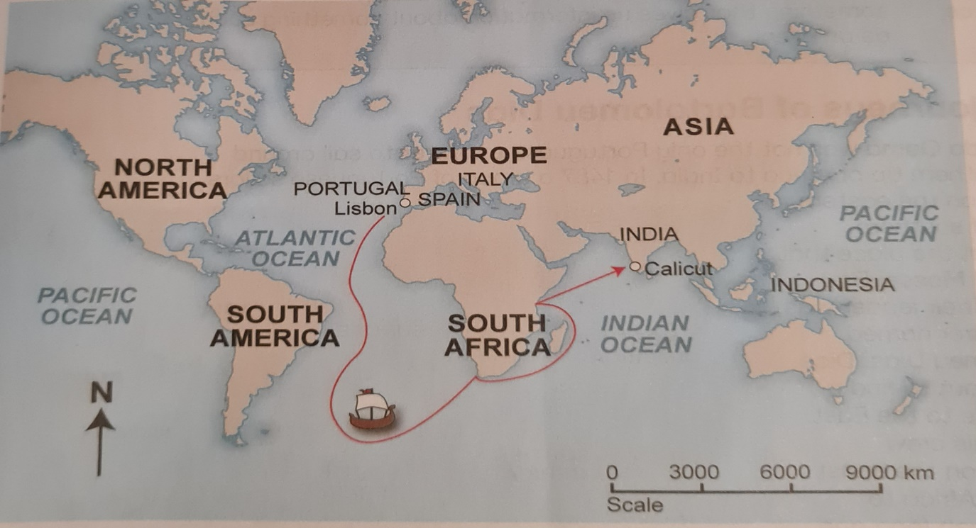

The Portuguese were the first to try to find the different route to the East. On 8 July 1497, Vasco Da Gama sailed from Portugal around the Southern tip of Africa on a journey to India. This was almost 80 years after the search for the sea route had first begun. Vasco da Gama journey took 209 days and covered nearly 20 000km.He reached Calicut, India, on 20 May 1498.Calicut was an important trading Centre in the East.

As the Da Gama sailed around Africa, he found out that trade was taking place along Africa’s east coast. It was run by African and Arab traders. They did not want Da Gama to have anything to do with their trade.

The Portuguese King sent Da Gama on a second voyage. He wanted Da Gama to take over the trade along the East coast of Africa. This would help Portugal to become powerful and prosperous. The Arab traders were very angry about this. Some of them even wanted to kill them.

(Adapted from Solutions for all)

7.1 In which year did Da Gama sail from Portugal to Southern Africa? (1)
___________________
7.2 How many days did Da Gama’s Journey take? (1)
_______________________
7.3 Why did the Portuguese king send Da Gama on a second Voyage? (2)
______________________________________________________________________
______________________________________________________________________
7.4 Why do you think the African and Arab traders in the East coast didn’t welcome
Vasco Da Gama? (2)
______________________________________________________________________
______________________________________________________________________
7.5 Write a paragraph of FIVE (5) sentences about how successful Da Gama
Was on his Journey’s? Your paragraph must be structured into a topic sentence,
supporting sentences and a concluding sentence. (5)
______________________________________________________________________
______________________________________________________________________
______________________________________________________________________
______________________________________________________________________
______________________________________________________________________
Level 1 | - Uses evidence in an elementary manner e.g. shows little or no understanding. Uses evidence partially to report on topic or cannot report on topic | Marks: 0-1
Level 2 | - Evidence is mostly relevant and relates to a great extent to the topic. Uses evidence in a very basic manner. | Marks: 2-3
Level 3 | - Uses relevant evidence e.g demonstrates a thorough understanding.  - Uses evidence very effectively in an organized paragraph that shows an understanding of the topic | Marks: 4-5

ACTIVITY 8 DATE ________________________
EUROPEAN EXPLORERS AND THEIR JOURNEYS
Study the SOURCE and answer the questions that follow.
European explorers and their journeys

In 1497 the Portuguese king sent Vasco da Gama on a voyage to India. Vasco da Gama was born in 1469. He was a Portuguese explorer. Bartholomew Diaz sailed from Portugal to the southern tip of Africa in 1488. He was the 1st explorer to sail to southern Africa. Galileo Galilei was born in 1564 in the city of Pisa in Italy.
Leonardo da Vinci was born in Italy in 1452. He was a famous Renaissance artist and scientist. The Dutch East India company started trading in 1602 in Netherlands.

8.1 Design a time line and arrange the above events in a chronological order.
Draw your timeline in the box below. (5)

