TERM 3 GEOGRAPHY GRADE 5
WEATHER, CLIMATE AND VEGETATION OF SOUTH AFRICA
WORDBANK/ NEW TERMINOLOGY/NEW CONCEPTS
Weather what happens in the air around us, including temperature, rainfall, wind and clouds.
Temperature indicates how hot or cold a place is.
Precipitation these are different forms of water that come out of the air, include snow, hail, sleet, drizzle, fog and rain.
Cloud cover is made from tiny drops of water.
Cloud is a collection of very tiny droplets of water or ice crystals.
Atmosphere is the air surrounding the earth.
Rain is the water droplets that fall from the atmosphere surrounding the earth.
Rainfall distribution is the spread of rainfall over an area.
Thermometer is an instrument used to measure the temperature (degree Celsius)
Rain gauge an instrument used to measure rainfall or any form of precipitation.
Wind is the movement of masses from high pressure areas to low pressure areas or is air that moves from one place to another.
Wind vane is used to show the direction of wind.
Anemometer is an instrument used to measure wind speed in km/h.
Observe looking at something carefully to find out more about it.
Climate is the average weather condition of a place observed over a long period.
Weather refers to the condition or atmosphere at a particular place over a short time. It is about heat, wind, rain and clouds.
Vegetation is plants such as grass, bushes and trees.
Natural vegetation are plants that have not been grown by humans or are plants that grow naturally in an area.
Exotic plants these are plants that are brought by people from another country/region.
Adaptations are ways plants change to suit the climate.

2024 - GRADE 5 GEOGRAPHY WORKSHEETS FOR TERM 3
ACTIVITY 1 DATE: _____________________
Elements of weather
Study the source below and answer the questions that follow.
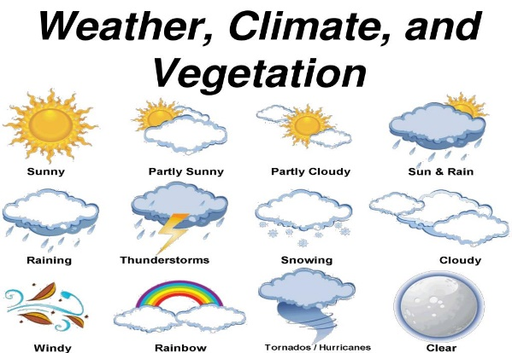 | 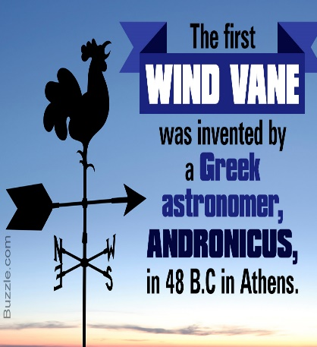
Taken from internet

Define the following terms
1.1 Weather (2)
______________________________________________________________________________________________________________________________________
1.2 Climate (2)
______________________________________________________________________________________________________________________________________
1.3 Rain gauge (2)
___________________________________________________________________
___________________________________________________________________
1.4 Wind vane (2)
___________________________________________________________________ ___________________________________________________________________

1.5 Wind sock (2)
______________________________________________________________________________________________________________________________________
1.6 Precipitation (2)
______________________________________________________________________________________________________________________________________
(12)

ACTIVITY 2 DATE: ______________________
How temperature and rain can be measured.
How weather affects the daily lives of people.
Study the source and answer the questions below
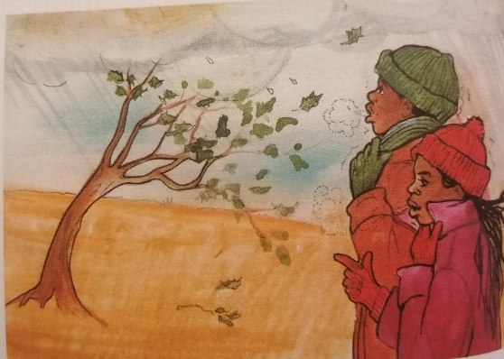
Adapted from Our World, Our Society

2.1 Name any THREE (3) elements of weather that you can see in the source. (3)
2.2 What kind of temperature is in the source? Give 2 reasons for your answer. (2)
______________________________________________________________________________________________________________________________________
2.3 Name the season that is shown in the picture. (2)
___________________________________________________________________

2.4 Which instrument can we use to measure the following: (3)
2.4.1 Temperature _______________________
2.4.2 Wind _____________________________
2.4.3 Rainfall ___________________________
2.5 Which instrument can we use to measure the speed of wind in Kilometres. (1)
______________________________________
2.6 In a paragraph of FIVE (5) sentences, explain how cold weather affects the daily lives of people. Your paragraph must be structured into topic sentence, supporting sentences and a concluding sentence. (5) _________________________________________________________________
__________________________________________________________________
__________________________________________________________________
__________________________________________________________________
__________________________________________________________________
_________________________________________________________________
Level 1 | - Uses evidence in an elementary manner e.g. shows little or no understanding. Uses evidence partially to report on topic or cannot report on topic. | Marks: 0 - 1
Level 2 | - Evidence is mostly relevant and relates to a great extent to the topic. Uses evidence in a very basic manner. | Marks: 2 - 3
Level 3 | - Uses relevant evidence e.g. demonstrates a thorough understanding.  - Uses evidence very effectively in an organised paragraph that shows an understanding of the topic | Marks: 4 - 5
(16)

ACTIVITY 3 DATE: ___________________
Wind direction and weather maps in the media.
Study the source and answer the questions below
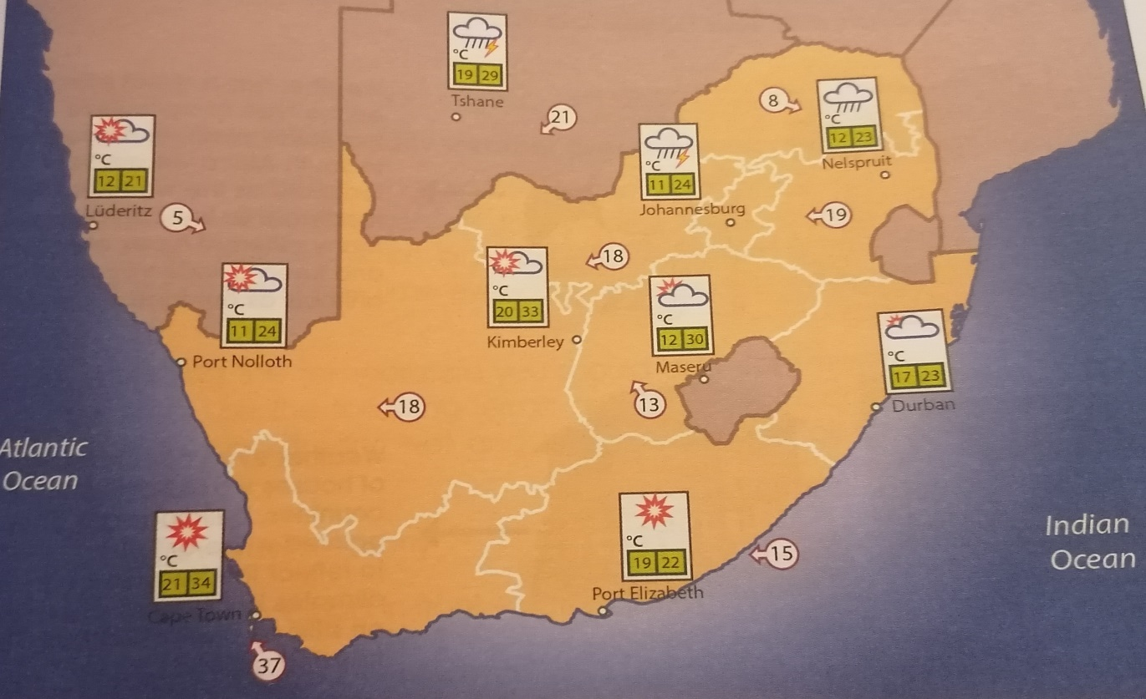 Adapted from Viva Social Sciences

3.1 Give the maximum temperature for Durban? (1)
______________________________________________________________
3.2 Which city has the highest temperature? (1)
______________________________________________________________
3.3 Is rain expected in Port Elizabeth, explain your answer. (2)
______________________________________________________________
______________________________________________________________
3.4 What will be the weather condition in Nelspruit? (2)
______________________________________________________________
______________________________________________________________
3.5 Name two cities where there will be rain. (2)
______________________________________________________________
3.6 How do we name the wind direction? (2)
______________________________________________________________
______________________________________________________________
3.7 What is the wind direction for Port Elizabeth? (1)
______________________________________________________________
3.8 In a paragraph FIVE (5) sentences, describe what type of clothing would you wear if you were in Cape Town. Your paragraph must be structured into topic sentence, supporting sentences and a concluding sentence (5)
_______________________________________________________________
_______________________________________________________________
_______________________________________________________________
_______________________________________________________________
_______________________________________________________________
_______________________________________________________________
Level 1 | - Uses evidence in an elementary manner e.g. shows little or no understanding. Uses evidence partially to report on topic or cannot report on topic. | Marks: 0 - 1
Level 2 | - Evidence is mostly relevant and relates to a great extent to the topic. Uses evidence in a very basic manner. | Marks: 2 - 3
Level 3 | - Uses relevant evidence e.g. demonstrates a thorough understanding.  - Uses evidence very effectively in an organised paragraph that shows an understanding of the topic | Marks: 4 - 5
(14)

ACTIVITY 4 DATE: ____________________
RAINFALL AND CLIMATE
Study the two climate graphs and answer the questions below
SOURCE A
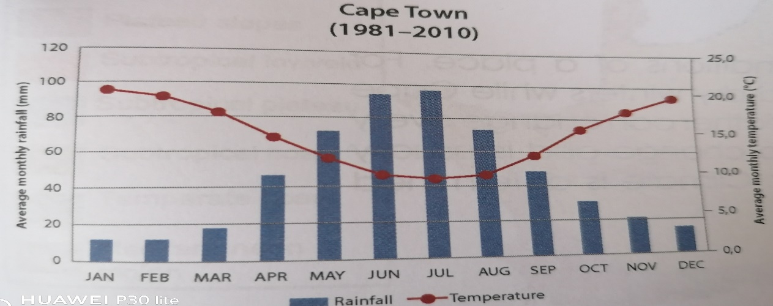
SOURCE B
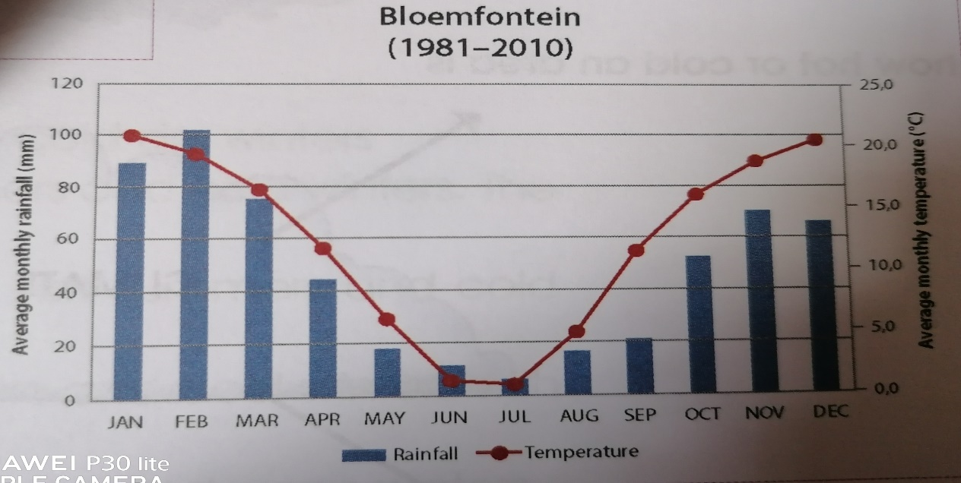 Adapted from Viva Social Sciences
NB. BLUE BARS indicates the average rainfall AND RED DOTS indicates average temperature.
4.1 Name the place that receives winter rain? (1)
_____________________________________________________________
4.2 Which place has lower temperatures during winter? (1)
_____________________________________________________________

4.3 What is Bloemfontein’s lowest average temperature? (1)
_____________________________________________________________
4.4 Which place gets more yearly rainfall? (1)
_____________________________________________________________
4.5 Continue to look at SOURCE B above to answer the following questions:
4.5.1 How much rain usually falls in January? (1)
_____________________________________________________________
4.5.2 How much rain usually falls in July? (1)
_____________________________________________________________
4.5.3 Which is the driest month? (1)
_____________________________________________________________
4.5.4 Does it get most of its rain in summer or in winter? (1)
_____________________________________________________________
(8)

ACTIVITY 5 DATE: ________________
Different kinds of climate in South Africa.
Study the source and answer the questions that follow.
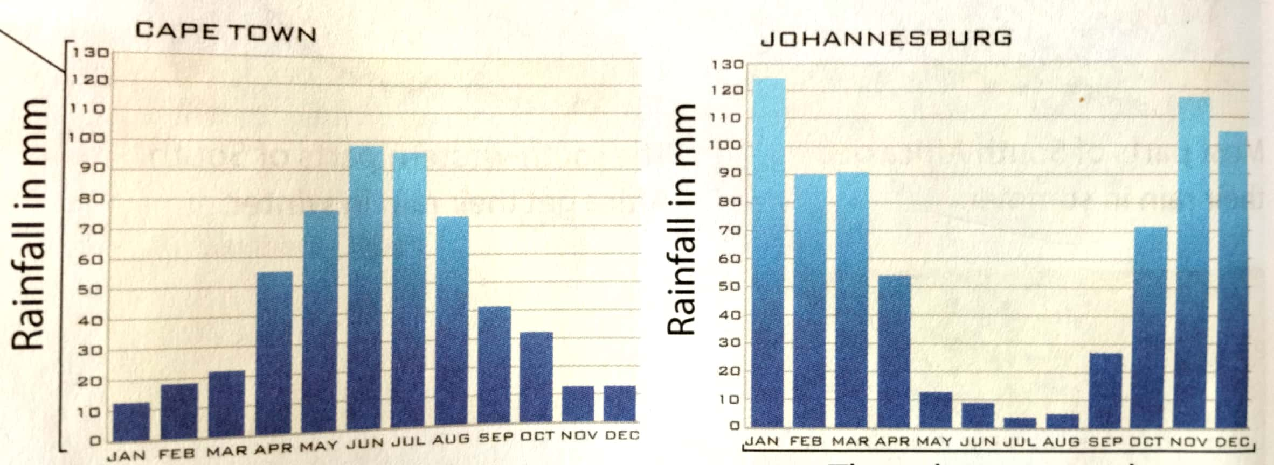 Adapted from Platinum Social Sciences
5.1 In which month does Cape Town receive the more rainfall? (1)
________________________________________________________________
5.2 In which month does Johannesburg receive the less rainfall? (1)
________________________________________________________________
5.3 Explain why Cape Town receives less rainfall in November, Johannesburg
receives more rainfall. (2) ___________________________________________________________________
___________________________________________________________________
5.4 Which city receives rain throughout the year? (1)
_______________________________________________________________
5.5 Which city receives winter rainfall? (1)
________________________________________________________________
5.6 Explain why Cape Town receives more rainfall than Johannesburg. (2)
___________________________________________________________________ ______________________________________________________________________________________________________________________________________
(10)

ACTIVITY 6 DATE: __________________
Natural vegetation
Study the source below and answer the questions that follow.
Natural vegetation means plants that grow naturally in an area. People did not bring these plants to the area. They are indigenous to the area. These plants are best suited to the soil and climate of that area. Plants have a way of adapting to the climate just like people do, eg. deciduous trees, fynbos, coniferous trees.
Adapted from Viva Social Sciences

Match COLUMN A and COLUMN B by writing the correct answer in COLUMN C. eg. 6.1 D
COLUMN A | COLUMN B | COLUMN C
6.1 Natural vegetation | A. is when plants are able to grow in a new place | 6.1 _________
6.2 Exotic plants | B. survive hot, dry summers, but need winter rain. | 6.2 _________
6.3 Adapted | C. survive dry climate by storing water in their leaves. | 6.3 _________
6.4 Baobab trees | D. are plants that people brought from another area/country. | 6.4 _________
6.5 Proteas | E. are plants that grow naturally in an area. | 6.5 _________
 | F. they survive dry climate by storing water in their trunks.
 | G. is when plants cannot grow in a new place

ACTIVITY 7 Date: _____________________
Links between natural vegetation and climate.
Study the source below and answer the questions that follow.
Some natural vegetation regions
Fynbos grows in the Western Cape. Fynbos includes proteas, ericas and restios. The plants are suited and adapted to dry hot summers with fires, and winters that are cold and wet. Their leaves are waxy or spiky, with hairs and tiny spikes. This stops them losing water when there is a drought or high temperatures. Smoke from summer fires often makes the seeds start growing. The Northern Cape has desert conditions. Most of the year, it is dry and only small bushes and succulent plants survive the cold winters and hot summers. For example, succulent plants in the Karoo store water in their fleshy leaves. A lot of the ground is stony and sandy.
Adapted from Study and Master Social Sciences
7.1. Define natural vegetation. (2)
_________________________________________________________________
_________________________________________________________________
7.2. Name three examples of fynbos plants. (3)
_________________________________________________________________
_________________________________________________________________
_________________________________________________________________
7.3. In which province do fynbos plants grow? (1)
_________________________________________________________________
7.4. Explain the leaves of fynbos plants (2)
_________________________________________________________________
_________________________________________________________________
7.5 Why are the fynbos leaves spiky with hairs? (2)
_________________________________________________________________
_________________________________________________________________
7.6. In which province do we find the succulent plants? (1)
_________________________________________________________________

7.7. Where do succulent plants store their water? (1)
_________________________________________________________________
7.8. State the differences between the succulent plant and the fynbos plants. (4)
Fynbos plants | Succulent plants

(16)

