Grade 6 History Term 4 Worksheets

Types of medicine

Indigenous medicine
- It was used long ago by the hunter-gatherers, herders and African farmers.
- Also sometimes called traditional healing.
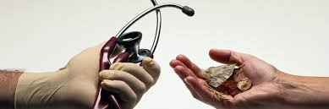
- It is passed from one generation to the next.

Western medicine
- It treats diseases of the body.
- It is based on science and is studied in universities.
- It is used by most South Africans today, but it has not replaced indigenous healing practices and beliefs.
- Most people use western and traditional medicine.

SOURCE A: Indigenous healing in South Africa Date: _________________

Indigenous healing is based on African traditional belief that the whole person, body, mind and spirit has to be kept healthy. This would involve having good relationships within the family, community as well as with the ancestors. Many people believe that illness occurs when people do not follow the traditions practised by their ancestors.

Indigenous healers include diviner, herbalist and faith healers who treat illness through communication with the ancestors, herbal remedies, indigenous medicine and Christian prayer and have a vast knowledge of plants that can be used as herbal remedies.

Traditional healing is based on the belief that illness has more than just physical causes and focuses on the healing of the whole person body, mind and spirit. The training is a spiritual experience, whereby initiates are trained to use herbs remedies and plants as part of the healing process.

Western medicine if often contrasted with the approach taken by practitioners of indigenous medicine. Western medicine is associated with diseases of the physical body and is based on the principles of science, technology and knowledge developed mainly in Western Europe and Northern America. Western medicine has in the past often neglected the link between the spiritual and the physical, but a more holistic approach is not commonly part of the teaching in most Western Medical Schools.

Make use of SOURCE A and your own knowledge to answer the following questions:

Write the word Western or Indigenous in Column B next to the statement in Column A to indicate your choice:

COLUMN A | COLUMN B
Statement | Western or Indigenous
These people believe that herbal medicines can help heal you.
A vaccine is given to young children to prevent them from getting ill later in life.
We use x-ray machines to check if bones have been broken.
We use bones to help us diagnose a person’s illnesses.
When you are feeling very sick you may visit a hospital.
These people are called to their positions by their ancestors.
These people generally attend school for many years in order to qualify.

Holistic healing
• Traditional healers treat the whole person and not just the physical illness.
• It is therefore also called holistic healing.
• Ancestors are important in the practice of indigenous medicine.
• The ancestors are seen as an extended family.
• There is a strong relationship between the living and the dead.

Holistic healing: Date: _________________

SOURCE B:

Practitioners that most often practice holistic healing are Diviners and Herbalists. In South Africa, the most common type of diviner is a sangoma. A sangoma is a traditional healer or indigenous healer. Sangomas are also called shamans (North American culture).
Herbalists specialise in handling herbs for medicinal purposes. These herbs should always be of the highest quality, and often herbalists grow their own. Herbalists are able to receive formal training through various organisations and others learn from experienced herbalists.
An important part of herbalism is the identification of various herbs and what they can be used for. An herbalist also needs to be skilled in collecting and storing herbs properly to ensure that they will work as intended. Many herbalists also know the different interactions between various herbs and with mainstream pharmaceuticals, and he or she will carefully discuss a patient’s situation before offering a prescription. Herbal medicine is widely practiced in Asia, especially China.

Name of plant | What is this plant used for? | Scientific proof of  healing agents
Pennywort / Varkoortjies | It is used to treat wounds and fever. It is also used to treat acne and allergies. | Yes
Coral Tree / Umsinsi | The bark is used to treat toothache and arthritis. It is also used on swelling and wounds. | Yes
Madagascar periwinkle /  Isisushlungu | The roots are used to treat diabetes and rheumatism. Liquid from the leaf is used in chemotherapy to treat several types of cancer. | Yes
Kouterie / Pig’s ears / Imphewula | The warmed leaf is used for earache and inflammation. It is also used to soften and remove arts and corns. | Yes
Hoodia / Bitterghaap | The stems are dried and used to stop people wanting to eat. It is also used for indigestion and stomach ache | Yes

Make use of SOURCE A, SOURCE B and your own knowledge to answer the following questions:

1. What does the word holistic mean? ________________________________________________________________________
_______________________________________________________________________________________________________

2. What is the main difference between a sangoma and an inyanga?
Sangoma: ___________________________________________________________________________________________
Inyanga : ____________________________________________________________________________________________

3.Which plant would you use for wounds and fever?_____________________________________

4. Which picture matches which explanation?

Picture | Explanation | Answer
1 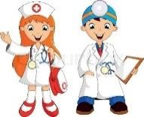 | - A. It allows you to get inside someone's body to  look at their bone structure. | 1.
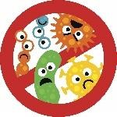  2 | - These people use plants to cure diseases. This is called herbal medicine. | 2.
3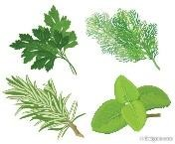 | - Doctors perform operations to cure certain diseases. They use scientific methods | 3.
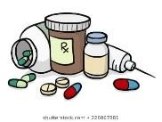  4 | - Germs can be spread through the air and the water. | 4.
5 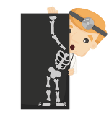 | - Western doctors give their patients pills  or injections to cure them. | 5.
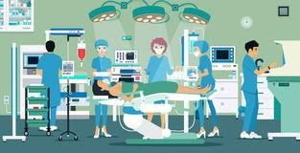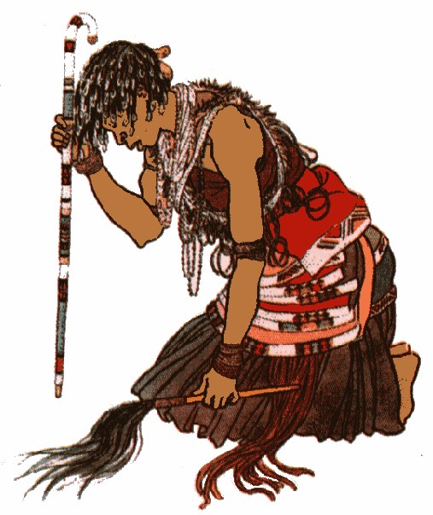
‘

Google images
5. What is the difference between western medication/treatment and Indigenous medication/treatment?

Western medication and treatment | Indigenous medication and treatment

Western scientific medical discoveries Date: _________________
Word bank:
Disease: _______________________________________________________________
Germ: A very small living organism that causes __________________________________________
Laboratory: A workplace where scientists conduct experiments.
Experiment: Perform a scientific procedure, especially in a laboratory
Microscope: An instrument for viewing very small objects, especially in a ______________________________________
Bacteria: Very small living organisms, some of which can cause disease.
Tuberculosis: A serious infectious disease that affects the _______________________
Identify: Discover and give a name to something.
Contagious: If a disease is easily ___________________________________ from one person to another.
Smallpox: People who had smallpox had a fever and a distinctive, progressive skin rash. deadly infectious disease.
Immune: When your body is able to ________________________an infectious disease.
Antibiotic: A substance used in medicine to ____________________________ bacteria and cure infections.
Penicillin: An antibiotic that stops _______________________________ from growing.

SOURCE C: Infectious diseases
Infectious diseases are disorders caused by bacteria, viruses, fungi or parasites. Many organisms, such as these, live in and on our bodies. They are normally harmless or even helpful, but under certain conditions, some organisms may cause disease. Some of these diseases are infectious and are also contagious.
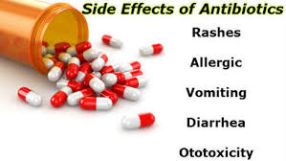

In the fight against infectious diseases, some important discoveries have been made:

- The vaccination against small pox – Edward Jenner
- The connection between germs and disease – Louis Pasteur
- Tuberculosis (TB) – Robert Koch

Small Pox:
Its a serious infectious disease caused by the variola virus. It was contagious—meaning, it spread from one person to another. People who had smallpox had a fever and a distinctive, progressive skin rash.
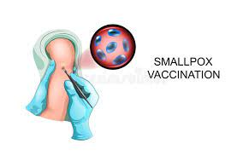

The Role of Edward Jenner:
Edward Jenner, FRS FRCPE (17 May 1749 – 26 January 1823) was an English physician and
scientist who pioneered the concept of vaccines including creating the smallpox vaccine,
the world's first ever vaccine
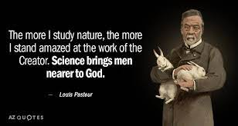

Louis Pasteur:
Louis Pasteur was a French scientist who focused on biology, chemistry, and microbiology,
and is world-renowned for his work on disease prevention and the reduction of
bacterial contamination in milk

Robert Koch: Tuberculosis (TB) in South Africa Date: _________________

SOURCE D: Tuberculosis (TB)

Robert Koch was a German born physician who lived between the years 1843 and 1910. Through his research, Robert Koch was able to demonstrate how specific germs caused specific diseases.

Koch began studying bits of material through a magnifying glass. He received a microscope from his wife for his 28th birthday end then began his study of anthrax, a deadly disease of warm-blooded animals. He infected healthy animals in order to demonstrate which germs produced each type of infection. He demonstrated to the world the first definite proof that a particular microbe causes a particular disease.

In 1882 Koch identified the tubercle bacillus, the bacterium that causes tuberculosis. He announced the discovery of the cholera germ in 1883. We mostly find cholera in water.
South Africa is one of the countries with the highest rates of TB, according to World Health Organisation (WHO) statistics.
TB is a serious disease the affects the lungs. TB is also infectious, and so when someone with TB coughs or sneezes, the air is filled with droplets containing the bacteria. If a person breathes in the infected droplets, he or she has a very high chance of getting TB. With medical advances in Western medicine, TB can be cured. However, many people in South Africa still die from TB because they do get the correct treatment and medicine. A person who has TB must take the medication the doctor prescribes, every day, for as long as needed to get rid of the disease.

The highest prevalence of TB, estimated at 88% has been found among people in the age group 30 to 39 years old living in townships and informal settlements.
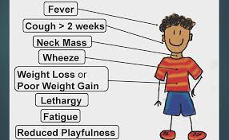

SOURCE E: Incidence rate per province per 100 000 people:
 | 2015 | 2014 | 2013 | 2012 | 2011 | 2010 | 2009 | 2008 | 2007
Free State | 575 | 632 | 721 | 761 | 842 | 837 | 860 | 890 | 844
Gauteng | 330 | 378 | 403 | 418 | 454 | 114 | 517 | 490 | 174
KZN | 685 | 814 | 953 | 1060 | 1185 | 1162 | 1216 | 928 | 881
North West | 528 | 631 | 658 | 705 | 817 | 894 | 904 | 815 | 767
Western Cape | 681 | 710 | 743 | 777 | 827 | 910 | 930 | 948 | 938

Study SOURCE D and E to answer the following questions:

1. In what year was the rate of incidence for TB the highest? ____________________________

2. Describe the trend of incidence for TB from 2007 to 2015. ____________________________________________________
______________________________________________________________________________________________________
3. Why do you think the cure rate for TB has changed over the years? ____________________________________________
___________________________________________________________________________________________________
4. Who was the main person involved in finding a cure for TB? __________________________________

5. What age is TB most prevalent / wide spread and what is percentage? _____________________ _____________________

William Morton

Father of anaesthetics

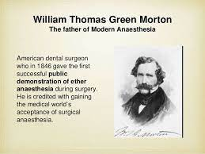
6.Name seven symptoms of the possibility of TB: ____________________
_________________________ __________________________
___________________________ ___________________________
7.Can TB be cured if the patient go early to the doctor? _______________ 8.Where do we mostly find Cholera? In ________

Study SOURCE D and write a paragraph of 6-7 lines about TB. Pay attention to:
• Who identified TB?
• When did he discover it and
• Symptoms of TB and can it be cured?
________________________________________________________________________________________________________________________________________________________________________________________________________________________________________________________________________________________________________________________________________________________________________________________________________________________________________________________________________________________________________________________________________________________________________________________________________________________________________________________________________________________________________________________________________________________________________________________________________________________________________________________________

Discoveries that which made surgeries possible:
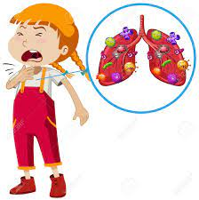
SOURCE F:
Louise Pasteur
Father of germ theory
1. Anaesthetics: a substance that induces insensitivity
to pain and induce sleep
2. Infection: The attack and growth of ________________________
in the body
3. Germ: A very small organism which causes disease. ___________________________
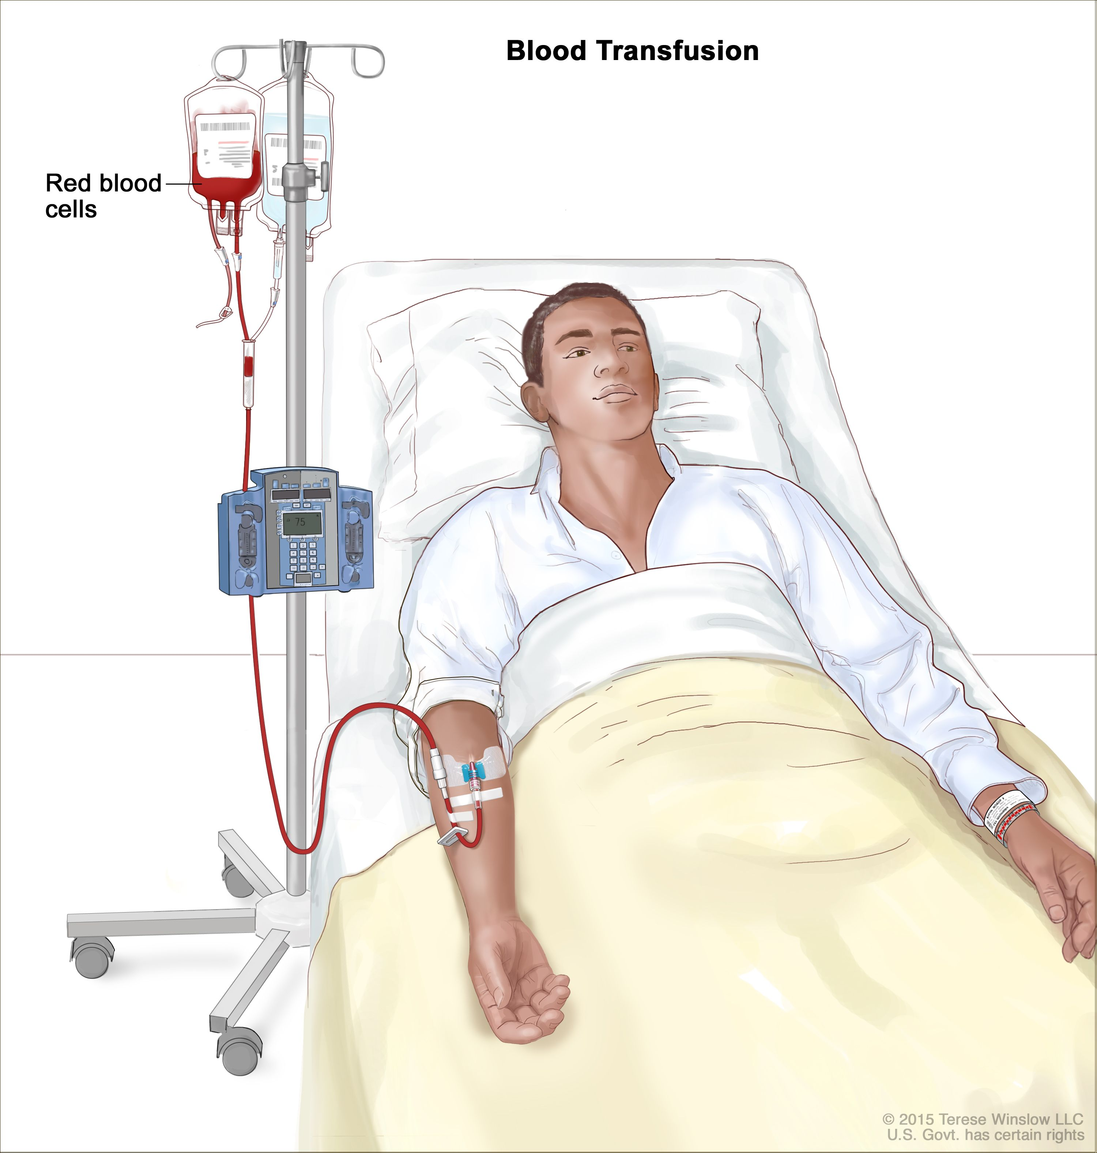
is regarded as one of the fathers of germ theory of diseases.

Karl Landsteiner:

Father of blood transfusions
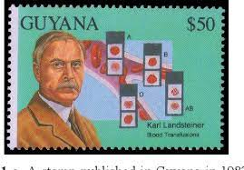
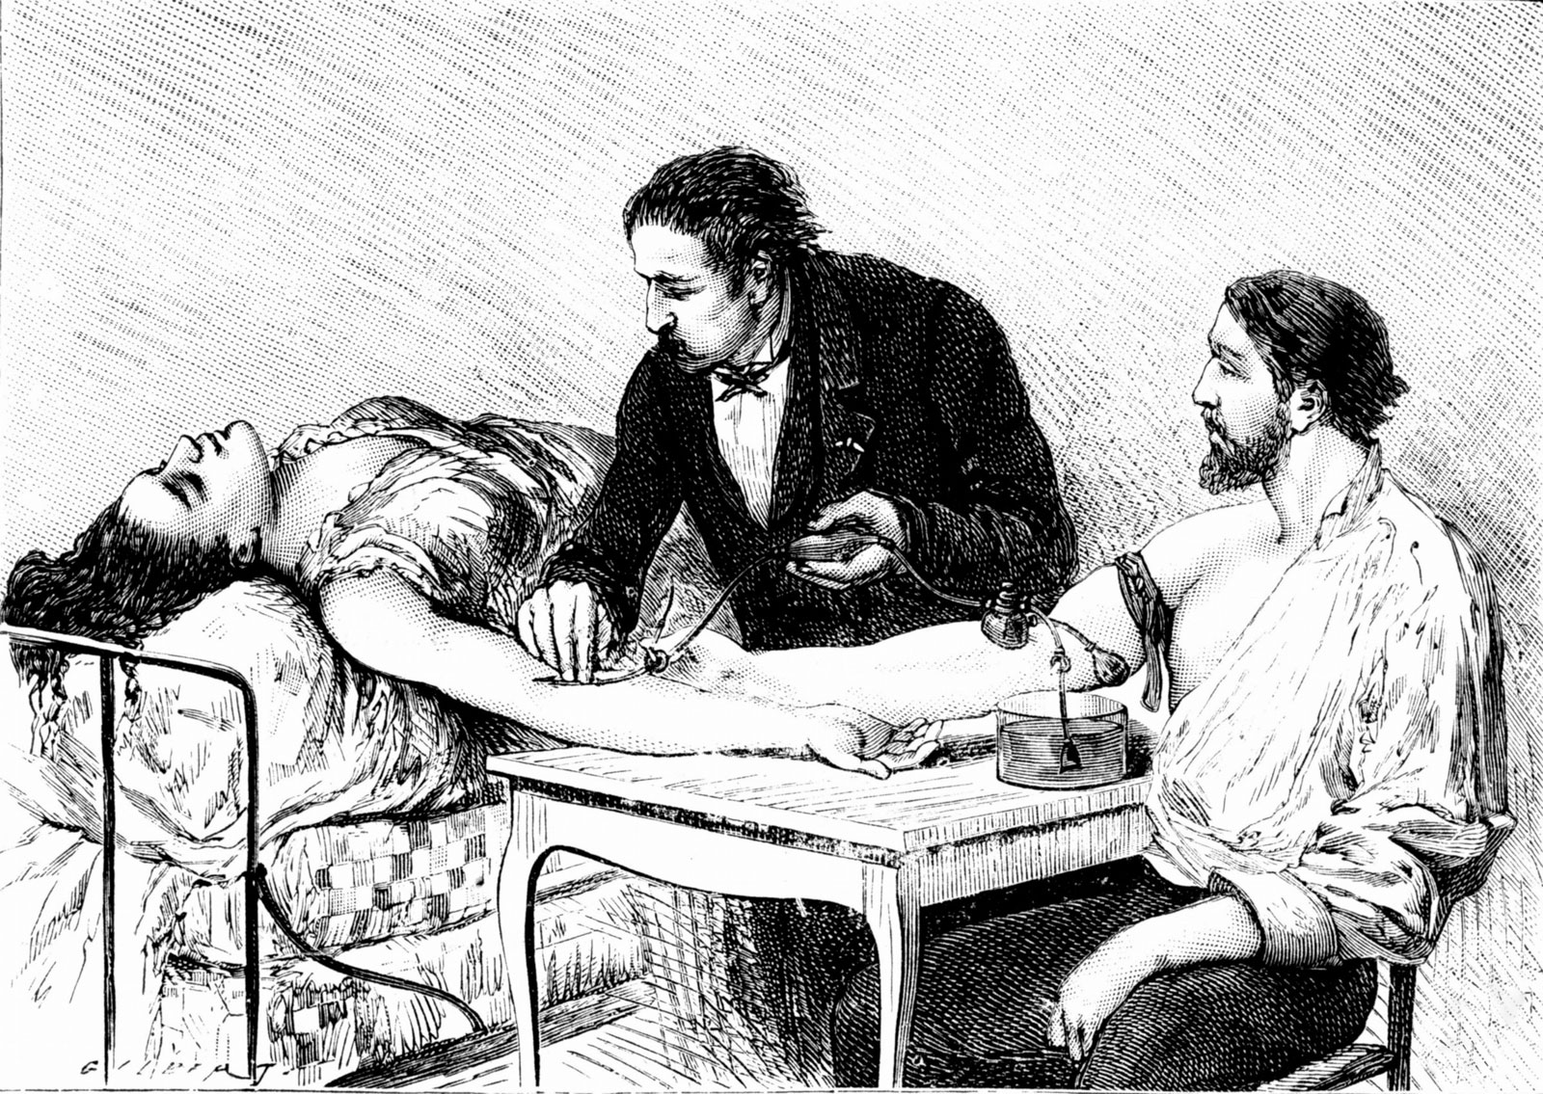

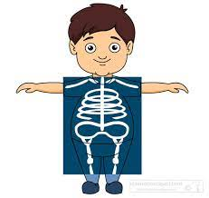

Father of…..
Person discover…..

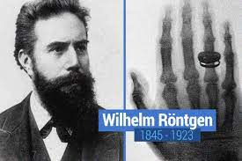
4. 4.Blood transfusions: A procedure in which whole blood or parts
of blood are put into a patient's bloodstream through a _______________. The
blood may be donated by another person or it may have been taken
from the patient and stored until needed. Also called transfusion.

5. X-rays: X-rays are a type of radiation called electromagnetic waves. X-ray imaging creates pictures of the inside of your body. The images show the parts of your body in different shades of black and white. The most familiar use of x-rays is checking for fractures , __________________________________

1. Match column A with column B: Just write the correct letter next to the correct number in column C.

Column A | Column B | Column C
1. X-rays | A. Louise Pasteur | 1.
2. Karl Landsteiner | B. Broken bones | 2.
3. Germ | C.X-rays | 3.
4.Fractures | D. Wiliam Röntgen | 4.
5.Father of germ theory | E. Anaesthetics | 5.
6.Induces sleep | F. Causes disease | 6.
7.Picture of the inside of body | G. Blood transfusions | 7.

2. Write a paragraph of 6-7 lines about covid, give attention to prevention and symptoms (6x1) (6)

___________________________________________________________________________________________________________________________________________________________________________________________________________________________________________________________________________________________________________________________________________________________________________________________________________________________________________________________________________________________
_______________________________________________________________________________________________
Chris Barnard Date: _________________

SOURCE G: First successful human-to-human heart transplant
Christiaan Neethling Barnard (8 November 1922 – 2 September 2001) was a South African cardiac (heart) surgeon who performed the world’s first successful human-to-human heart transplant. Over time, Barnard became known as a brilliant surgeon. He was promoted to Professor of Surgical Science in the Department of Surgery at the University of Cape Town in 1972. Barnard experimented for several years with animal heart transplants. More than 50 dogs received transplanted hearts. Barnard had a patient willing to undergo the procedure, but as with other transplants, he needed a suitable donor. He performed the world’s first human heart transplant operation on 3 December 1967, in an operation assisted by his brother, Marius Barnard. The operation lasted nine hours and used a team of thirty people. The patient, Louis Washkansky, was a 54-year-old grocer, suffering from diabetes and incurable heart disease. Barnard later wrote, “For a dying man it is not a difficult decision because he knows he is at the end. The donor heart came from a young woman, Denise Darvall, who had been rendered brain damaged in an accident on 2 December 1967, while crossing a street in Cape Town. Washkansky survived the operation and lived for 18 days. However, he died from pneumonia. Pneumonia is a lung inflammation caused by bacterial or viral infection Though the first patient with the heart of another human being survived for only a little more than two weeks, Barnard had passed a milestone in a new field of life-extending surgery. Barnard retired as Head of the Department of Cardiothoracic Surgery in Cape Town in 1983 after developing rheumatoid arthritis in his hands which ended his surgical career.
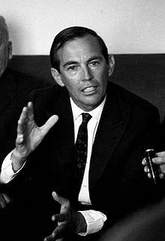 | 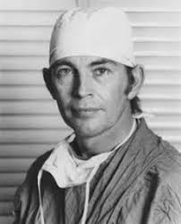 | 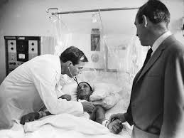 | 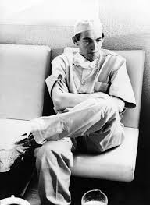

Make use of SOURCE G to answer the following questions:

1. What do the following words mean?

Transplant: __________________________________________________________________________________

Cardiothoracic: ______________________________________________________________________________
____________________________________________________________________________________________

Recipient: ________________________________________________________________________________

2. In what year did the first human heart transplant operation take place? ______________________________

3. How did Barnard practice heart transplants before attempting one on a human? ___________________________________

___________________________________________________________________________________________________

___________________________________________________________________________________________________

4. Discuss why Barnard’s first human-to-human transplant was considered a success despite that the patient
died after 18 days.

__________________________________________________________________________________________________

__________________________________________________________________________________________________

