Creative Arts
Learner Activity Book
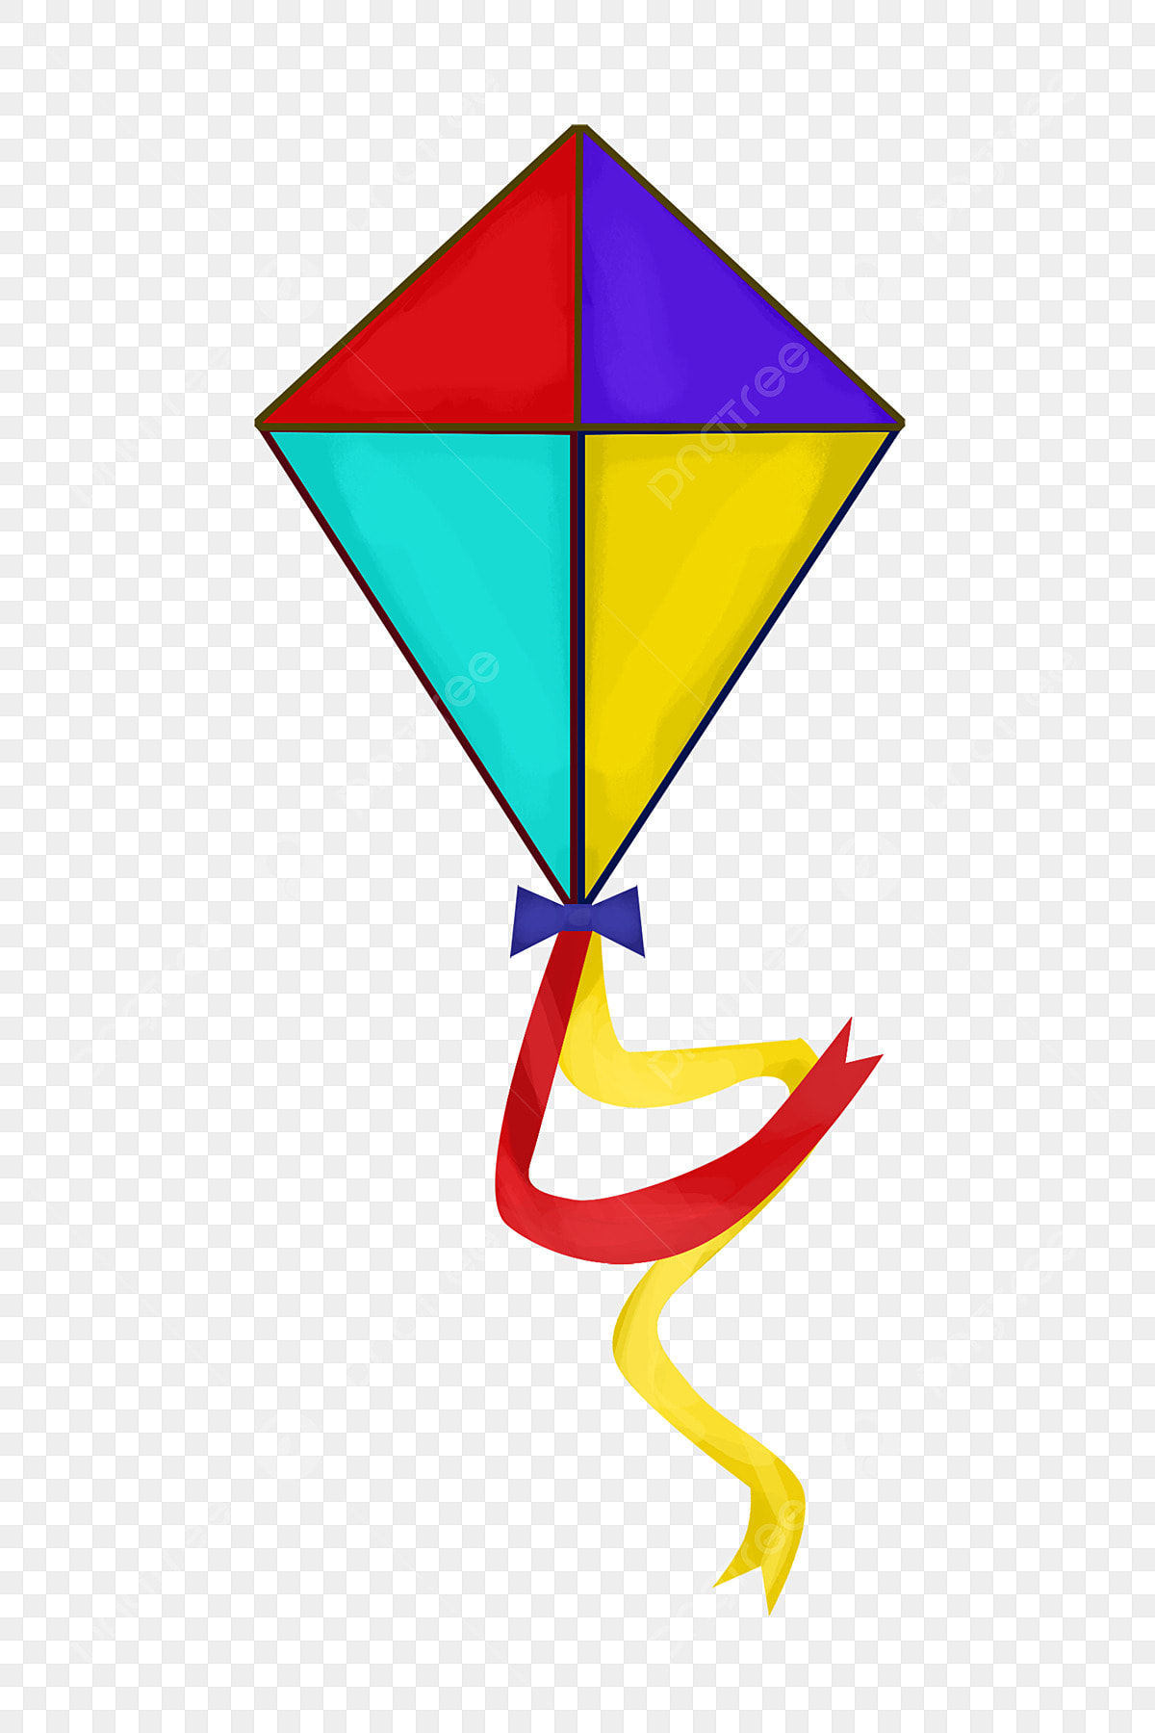
GRADE 4
TERM 4
2025
WEEK 1 The natural world. WORKSHEET NO 1
Look at the picture of the natural world and answer the questions:
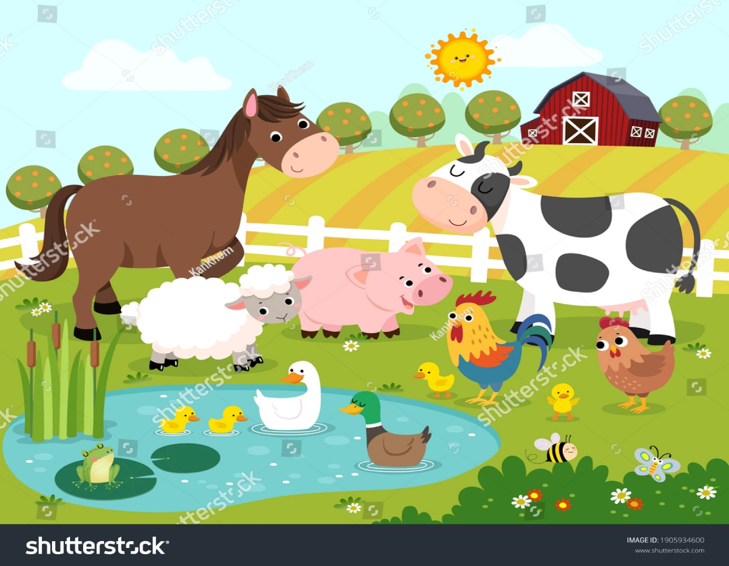

- How many animals can you identify? Circle the correct answers.
A cow | A horse | An elephant | A chicken | A Sheep | A Snake
Can you see any plants in this picture? Circle the correct answers.
Trees | flowers | a snake | A house | A bee

- Can you identify any shapes in this picture? Circle the correct answers.
circles | rectangle | oval | star

WEEK 2 PRACTICAL NO 1
Draw your own natural world in the space provided. Make sure you include the following:
A mountain
Trees
Plants / Flowers
Animals
WEEK 2 WORKSHEET NO 2
Look at the following shapes and identify them:
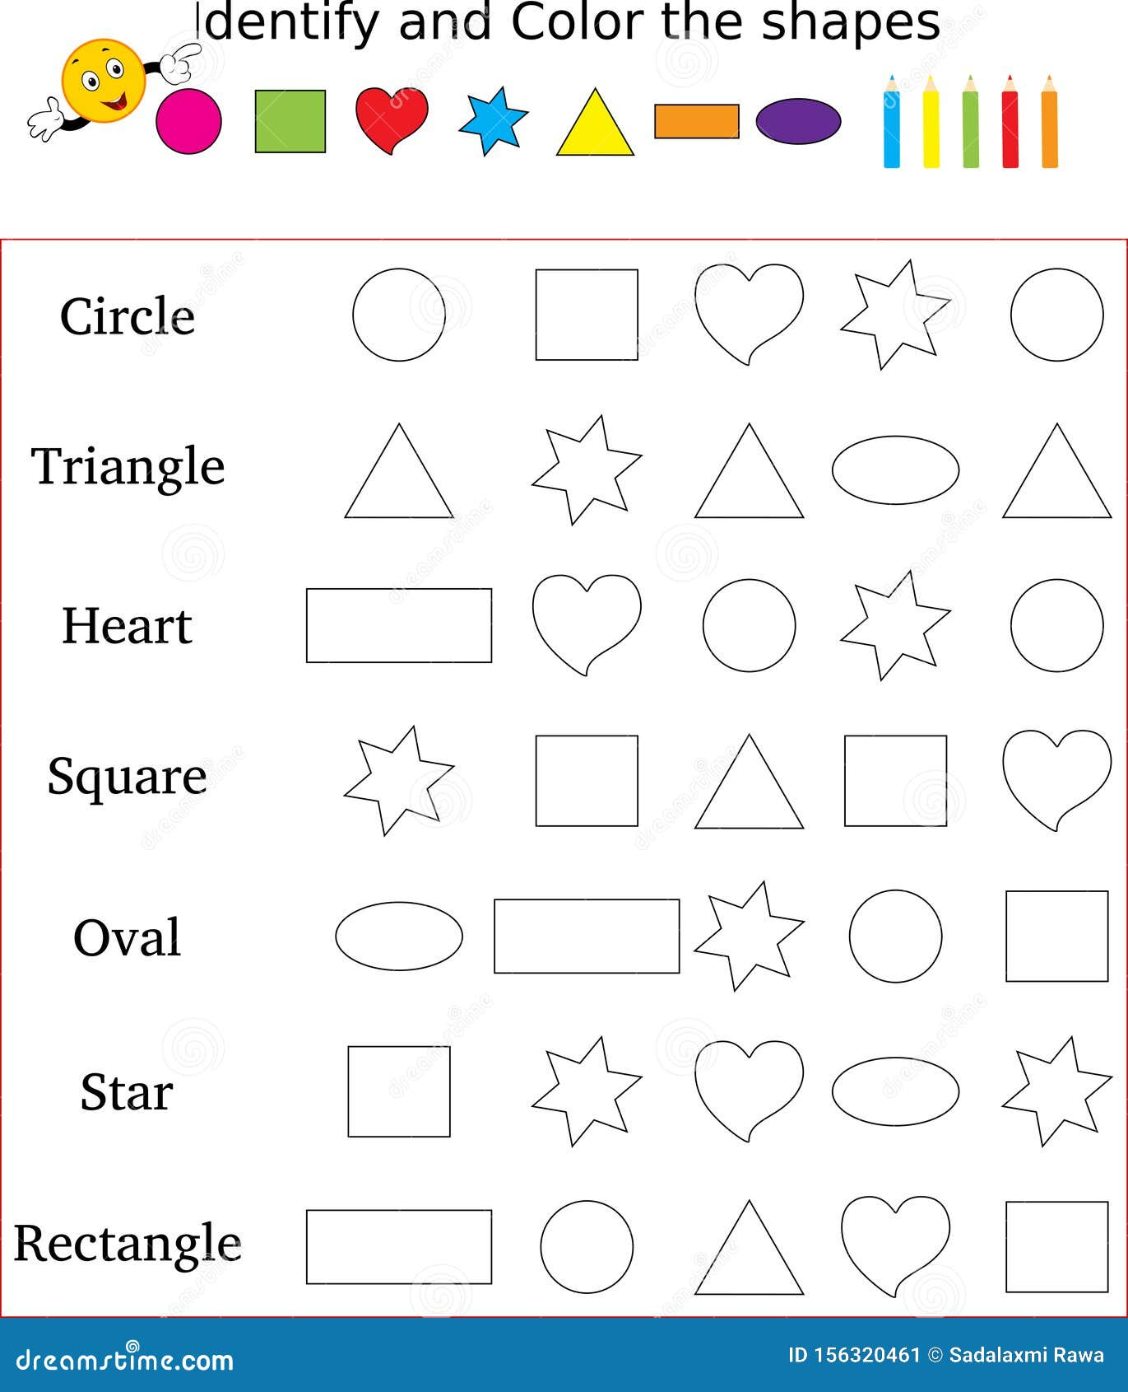

WEEK 3 Elements of Art: Line WORKSHEET NO 3
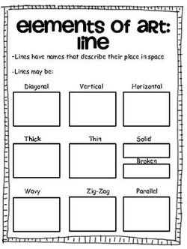
WEEK 4 PRACTICAL NO 2
Create your own pattern by using geometric OR organic shapes. Use the whole page.

WEEK 5 FORMAL PRACTICAL ASSESSMENT
NOTES TO THE TEACHER:
- Learners can make a kite, a bird feeder OR a dream catcher.
- If you do not have materials for a 3D product, then learners van make a drawing of one of the three. (2d)
- PLEASE CHOOSE BETWEEN 2D OR 3D
3D : Simple Instructions for Making a Kite, Bird Feeder, and Dream Catcher

1. How to Make a Kite
Materials Needed:
- 1 large sheet of paper or plastic
- 2 wooden dowels or sturdy sticks
- String
- Tape or glue
- Scissors
Instructions:
- Shape the Kite: Cut the paper into a diamond shape.
- Create the Frame: Use the dowels to make a cross. Tape them together in the centre.
- Attach the Paper: Lay the diamond shape over the frame and tape the edges down.
- Add String: Tie a long piece of string to the bottom of the kite.
- Decorate: Use markers or stickers to decorate your kite.
- Fly Your Kite: Find an open space, hold the string tight, and let it fly!

2. How to Make a Bird Feeder
Materials Needed:
- 1 empty plastic bottle or milk carton
- String or yarn
- Birdseed
- Scissors
Instructions:
- Prepare the Bottle: Cut holes on opposite sides of the bottle, about 1/3 of the way up.
- Fill with Birdseed: Pour birdseed into the bottle.
- Add Perches: If using a carton, you can insert small sticks through the holes for birds to land on.
- Hang It Up: Tie string around the bottle or carton and hang it from a tree branch.
- Watch the Birds: Enjoy watching birds come to eat!

3. How to Make a Dream Catcher
Materials Needed:
- A hoop (can be made from a wire or a sturdy twig)
- Yarn or string
- Beads (optional)
- Feathers (optional)
- Scissors
Instructions:
- Wrap the Hoop: Take yarn and wrap it around the hoop until it’s covered.
- Create the Web: Tie a piece of string across the hoop, making a web pattern. Start from the top and go down to the sides.
- Add Beads: Thread beads onto the string if you like, and tie them into the web.
- Decorate with Feathers: Attach feathers to the bottom by tying them to the hoop.
- Hang It Up: Find a special place to hang your dream catcher!

RUBRIC FOR ASSESSMENT (3D) 20 MARKS. (20 X 2 = 40)
CRITERIA | 4-5 | 2-3 | 1
PLANNING | Detailed plan with sketches and materials listed; clear understanding of project goals. | Basic plan, some materials listed; minimal understanding of project goals. | Incomplete plan; few materials listed; unclear project goals.
PROCESS | Followed most steps; organized; adapted to some challenges | Followed some steps; minimal organization; struggled with challenges | Inconsistently followed steps; disorganized; did not adapt.
CRAFTMAN SHIP | Good attention to detail; mostly clean edges and connections; good finish. | Some attention to detail; uneven edges or connections; acceptable finish. | Minimal attention to detail; rough edges or weak connections; poor finish.
END PRODUCT | Creative and original. | Some creativity; basic understanding; functions but has flaws. | Limited creativity; lacks understanding; does not function as intended.

INSTRUCTIONS FOR A DRAWING OF A KITE. (2D)

Istructions to Draw a Kite on A4 Paper
Materials Needed:
- A4 paper
- Pencil
- Eraser (optional)
- Colored pencils or markers (for decorating)

Step-by-Step Guide:
- Draw the Kite Shape:
  - Start by drawing a large diamond shape in the center of the paper. The top point should be near the top edge of the paper, and the bottom point should be a little above the bottom edge.
- Add the Tail:
  - Draw a wavy line starting from the bottom point of the diamond to create the kite's tail. You can make the tail long and add small bows or loops along the way.
- Divide the Kite:
  - Lightly draw two diagonal lines from the top point to the bottom corners of the diamond to divide the kite into four sections.
- Create Patterns:
  - In each section, draw different patterns. Here are some ideas:
    - Stripes (zigzag or straight)
    - Dots or circles
    - Stars or flowers
    - Waves or spirals
  - Fill the sections with a mix of these patterns.
- Decorate the Tail:
  - Add patterns to the tail as well. You can use triangles, diamonds, or any other shapes.
- Final Touches:
  - Erase any unnecessary pencil lines that are still visible

RUBRIC FOR 2D DRAWING 20 Marks (20 x 2 = 40)
CRITERIA | 4-5 | 2-3 | 1
PLANNING | Well-planned with most aspects outlined | Some planning evident but lacks clarity in execution | Almost no planning done
USE OF SPACE | Good use of space; mostly balanced | Average use of space | Poor use of space
PATTERNS | Interesting patterns that add to the design; some originality. | Basic patterns used | Limited patterns that do not contribute significantly to design
END PRODUCT | Final drawing is neat with minor flaws; shows good skill. | Final drawing is adequate but lacks refinement; some noticeable flaws. | Final drawing is messy or poorly executed; lacks effort.

WEEK 6 MIME WORKSHEET NO 4
- Facial Expressions
sad | happy | confused | angry | excited

 |  | 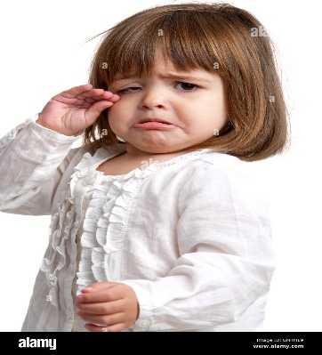

- Underline the correct answers:
  - Mime refers to (dancing / acting without speaking)
  - In mime, (you are allowed to speak / you are not allowed to speak)
- Look at the following pictures, and figure out what is happening in the picture. Choose the correct answer.
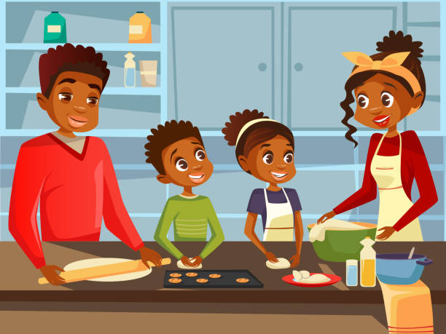 | 
- This family is (walking / cooking)  - The family seems ( happy / sad) | - This is a (nurse / policeman)  - The man seems (happy / angry)
WEEK 7 Mime using objects PRACTICAL NO 4
Examples of objects that can be used to do mime. There are many other objects that can be used – umbrellas, scarves, books, boxes, glasses, a toothbrush, a hairbrush, etc.
ACTIVITY
Learners use an object and improvise a mime. They can use the object, facial expressions and movement. Encourage them to be creative!
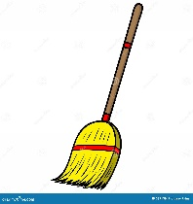  A Broom  Examples :  - Use the broom as a dancing partner  - Use the broom as a microphone when you sing.  - Use it for it’s original purpose | 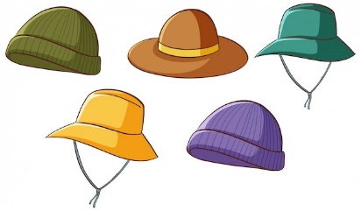  Hats  Use different hats to play different characters.

WEEK 7 Body part isolation WORKSHEET NO 5

WEEK 8 - 9 PRACTICAL NO 5
DRAMA & MUSIC
Elephant | “All animals in my valley. Listen carefully. We have a problem here.”
Fox | “What is the problem, mr. Elephant? How can we help?”
Lion | “Yes. Please tell us. What is the matter?”
Elephant | “We did not get rain. We are almost out of water.”
Rabbit | “I saw the water level in the dam was very low”
Lion | “I think we must search for another water whole.”
Fox | “That seems like a very good plan mr. Lion.”
Elephant | “Thank you my dear friends. Now we must find someone who will go and look for water.”
Rabbit | “I will go my dear friends. I can run very fast.
Fox | “Thank you mr. Rabbit. Then off you go. Come back soon!”

The whole class will sing this song after their performances. The learners can use body percussion. (Clapping hands / clicking fingers etc.)
Melody : The wheels of the bus go round and round.
The animals walk to the waterhole,
Splash, splash, splash, splash, splash splash
With their noses high, searching for a flow,
Splash, splash, splash, splash splash!
(Chorus)
The water’s low, the sun beats down,
Oh, where can we find water now?
The animals roam, looking all around,
Hoping for the rain to please come down!

