School Logo

School Name

NATURAL SCIENCES SUBJECT POLICY

Vision
Every learner feels valued and inspired in our innovative education system.
Mission
We are committed to provide functional and modern schools that enable quality teaching and learning to protect and promote the right of every learner to quality, equitable and relevant education.
Scope
This policy applies to all Natural Sciences educators within Senior Phase (Grade 7-9)
Review
This policy will be reviewed and amended annually.
1.1 Background
The National Curriculum Statement Grades R-12 (NCS) stipulates policy on curriculum and assessment in the schooling sector.
To improve implementation, the National Curriculum Statement was amended, with the amendments coming into effect in January 2012. A single comprehensive Curriculum and Assessment Policy document was developed for each subject to replace Subject Statements, Learning Programme Guidelines and Subject Assessment Guidelines in Grades R-12.

1.2 Overview
(a) The National Curriculum Statement Grades R-12 (January 2012) represents a policy statement for learning and teaching in South African schools and comprises the following:
(i) Curriculum and Assessment Policy Statements for each approved school subject;
(ii) The policy document, National policy pertaining to the programme and promotion requirements of the National Curriculum Statement Grades R-12; and
(iii) The policy document, National Protocol for Assessment Grades R-12 (January 2012).
(b) The National Curriculum Statement Grades R-12 (January 2012) replaces the two current national curricula statements, namely the
(i) Revised National Curriculum Statement Grades R-9, Government Gazette No. 23406 of 31 May 2002, and
(ii) National Curriculum Statement Grades 10-12 Government Gazettes, No. 25545 of 6 October 2003 and No. 27594 of 17 May 2005.
(c) The national curriculum statements contemplated in subparagraphs b(i) and (ii) comprise the following policy documents which will be incrementally repealed by the National Curriculum Statement Grades R-12 (January 2012) during the period 2012-2014:
(i) The Learning Area/Subject Statements, Learning Programme Guidelines and Subject Assessment
Guidelines for Grades R-9 and Grades 10-12;
(ii) The policy document, National Policy on assessment and qualifications for schools in the General
Education and Training Band, promulgated in Government Notice No. 124 in Government Gazette No. 29626 of 12 February 2007;
(iii) The policy document, the National Senior Certificate: A qualification at Level 4 on the National
Qualifications Framework (NQF), promulgated in Government Gazette No.27819 of 20 July 2005;
(iv) The policy document, An addendum to the policy document, the National Senior Certificate: A
qualification at Level 4 on the National Qualifications Framework (NQF), regarding learners with special needs, published in Government Gazette, No.29466 of 11 December 2006, is incorporated in the policy document, National policy pertaining to the programme and promotion requirements of the National Curriculum Statement Grades R-12; and
(v) The policy document, An addendum to the policy document, the National Senior Certificate: A
qualification at Level 4 on the National Qualifications Framework (NQF), regarding the National Protocol for Assessment (Grades R-12), promulgated in Government Notice No.1267 in Government Gazette No. 29467 of 11 December 2006.
(d) The policy document, National policy pertaining to the programme and promotion requirements of the National Curriculum Statement Grades R-12, and the sections on the Curriculum and Assessment Policy as contemplated in Chapters 2, 3 and 4 of this document constitute the norms and standards of the National Curriculum Statement Grades R-12. It will therefore, in terms of section 6A of the South African Schools Act, 1996 (Act No. 84 of 1996,)form the basis for the Minister of Basic Education to determine minimum outcomes and standards, as well as the processes and procedures for the assessment of learner achievement to be applicable to public and independent schools.
1.3 General aims of the South African Curriculum
(a) The National Curriculum Statement Grades R-12 gives expression to the knowledge, skills and values worth learning in South African schools. This curriculum aims to ensure that children acquire and apply knowledge and skills in ways that are meaningful to their own lives. In this regard, the curriculum promotes knowledge in local contexts, while being sensitive to global imperatives.
(b) The National Curriculum Statement Grades R-12 serves the purposes of:
• equipping learners, irrespective of their socio-economic background, race, gender, physical ability or intellectual ability, with the knowledge, skills and values necessary for self-fulfilment, and meaningful participation in society as citizens of a free country;
• providing access to higher education;
• facilitating the transition of learners from education institutions to the workplace; and
• providing employers with a sufficient profile of a learner’s competences.
(c) The National Curriculum Statement Grades R-12 is based on the following principles:
• Social transformation: ensuring that the educational imbalances of the past are redressed, and that equal educational opportunities are provided for all sections of the population;
• Active and critical learning: encouraging an active and critical approach to learning, rather than rote and uncritical learning of given truths;
• High knowledge and high skills: the minimum standards of knowledge and skills to be achieved at each grade are specified and set high, achievable standards in all subjects;
• Progression: content and context of each grade shows progression from simple to complex;
• Human rights, inclusivity, environmental and social justice: infusing the principles and practices of social and environmental justice and human rights as defined in the Constitution of the Republic of South Africa. The National Curriculum Statement Grades R-12 is sensitive to issues of diversity such as poverty, inequality, race, gender, language, age, disability and other factors;
• Valuing indigenous knowledge systems: acknowledging the rich history and heritage of this country as important contributors to nurturing the values contained in the Constitution; and
• Credibility, quality and efficiency: providing an education that is comparable in quality, breadth and depth to those of other countries.
(d) The National Curriculum Statement Grades R-12 aims to produce learners that are able to:
• identify and solve problems and make decisions using critical and creative thinking;
• work effectively as individuals and with others as members of a team;
• organise and manage themselves and their activities responsibly and effectively;
• collect, analyse, organise and critically evaluate information;
• communicate effectively using visual, symbolic and/or language skills in various modes;
• use science and technology effectively and critically showing responsibility towards the environment and the health of others; and
• demonstrate an understanding of the world as a set of related systems by recognising that problem solving contexts do not exist in isolation.
(e) Inclusivity should become a central part of the organisation, planning and teaching at each school. This can only happen if all teachers have a sound understanding of how to recognise and address barriers to learning, and how to plan for diversity.
The key to managing inclusivity is ensuring that barriers are identified and addressed by all the relevant support structures within the school community, including teachers, District-Based Support Teams, Institutional-Level Support Teams, parents and Special Schools as Resource Centres. To address barriers in the classroom, teachers should use various curriculum differentiation strategies such as those included in the Department of Basic Education’s Guidelines for Inclusive Teaching and Learning (2010).

2.1 Introduction
Science as we know it today has roots in African, Arabic, Asian, European and American cultures. It has been shaped by the search to understand the natural world through observation, testing and proving of ideas, and has evolved to become part of the cultural heritage of all nations. In all cultures and in all times people have wanted to understand how the physical world works and have needed explanations that satisfy them.

What is Science?
Science is a systematic way of looking for explanations and connecting the ideas we have. In Science certain methods of inquiry and investigation are generally used. These methods lend themselves to replication and a systematic approach to scientific inquiry that attempts at objectivity. The methods include formulating hypotheses, and designing and carrying out experiments to test the hypotheses. Repeated investigations are undertaken, and the methods and results are carefully examined and debated before they are accepted as valid. The science knowledge we teach at school is not in doubt – most of it has been tested and known since the 1800s – but a good teacher will tell the learners something of the arguments and confusion among the people who were the first to investigate this knowledge. Science also explores the frontiers of the unknown. There are many unanswered questions such as: Why is climate changing around the world? What is making the universe expand? What causes the earth’s magnetic field to change? As with all knowledge, scientific knowledge changes over time as scientists acquire new information and people
change their ways of viewing the world.

2.2 Indigenous knowledge systems and Natural Sciences
Our forebears would not have survived if they had not been able to learn about the natural world they depended on. They made careful observations, recognised regular patterns in seasons, the life cycles of plants, and the behaviour of animals.
They had theories about cause and effect too, and understood many of the relationships in the environment where they lived. These sets of knowledge, each woven into the history and place of people, are known as indigenous knowledge systems.
Indigenous knowledge includes knowledge about agriculture and food production, pastoral practices and animal production, forestry, plant classification, medicinal plants, management of biodiversity, food preservation, management of soil and water, iron smelting, brewing, making dwellings and understanding astronomy. As society changes, some of that knowledge is being lost. People such as biologists, pharmacists and archaeologists are seeking it out and writing it down before it is gone.

2.3 Teaching Natural Sciences
Careful selection of content, and use of a variety of approaches to teaching and learning Science, should promote understanding of:
• Science as a discipline that sustains enjoyment and curiosity about the world and natural phenomena
• the history of Science and the relationship between Natural Sciences and other subjects
• the different cultural contexts in which indigenous knowledge systems have developed
• the contribution of Science to social justice and societal development
• the need for using scientific knowledge responsibly in the interest of ourselves, of society and the environment
• the practical and ethical consequences of decisions based on Science.
Natural Sciences at the Senior Phase level lays the basis of further studies in more specific Science disciplines, such as Life Sciences, Physical Sciences, Earth Sciences or Agricultural Sciences. It prepares learners for active participation in a democratic society that values human rights and promotes responsibility towards the environment.
Natural Sciences can also prepare learners for economic activity and self-expression.
2.4 Organisation of the Natural Sciences Curriculum
In this curriculum, the knowledge strands below are used as a tool for organising the content of the subject Natural Sciences.

Natural Sciences Knowledge Strands
Life and Living
Matter and Materials
Energy and Change
Planet Earth and Beyond

Each Knowledge Strand is developed progressively across the three years of the Senior Phase. The Knowledge Strands are a tool for organising the subject content. When teaching Natural Sciences, it is important to emphasise the links learners need to make with related topics to help them achieve a thorough understanding of the nature of and the connectedness in Natural Sciences. Links must also be made progressively, across grades to all Knowledge Strands.

The time allocations given to the different topics provide an indication of the weighting of each topic.
In all Grades, a significant amount of time should be spent on doing practical tasks and investigations which are an integral part of the teaching and learning process.

2.5 Allocation of teaching time
Time for Natural Sciences has been allocated in the following way:
• 10 weeks per term, with 3 hours per week
• Grades 7, 8 and 9 have been designed to be completed within 34 weeks
• 6 hours have been included for assessment in terms 1 and 3
• Terms 2 and 4 work will cover 8 weeks each, plus 2 weeks for revision and examinations
The time allocated per topic is a guideline and should be applied flexibly according to circumstances in the classroom and to accommodate the interests of the learners.

2.6 Specific aims
This curriculum aims to provide learners with opportunities to make sense of ideas they have about nature. It also encourages learners to ask questions that could lead to further research and investigation. There are three specific aims in Natural Sciences

Specific Aim 1: ‘Doing Science’
Learners should be able to complete investigations, analyse problems and use practical processes and skills in evaluating solutions.
Learners plan and do simple investigations and solve problems that need some practical ability. Attitudes and values underpin this ability. Respect for living things is an example – learners should not damage plants; if they examine small animals they should care for them and release them in the place where they found them.

Specific Aim 2: ‘Knowing the subject content and making connections’
Learners should have a grasp of scientific, technological and environmental knowledge and be able to apply it in new contexts.
The main task of teaching is to build a framework of knowledge for learners and to help them make connections between the ideas and concepts in their minds – this is different to learners just knowing facts. When learners do an activity, questions and discussion must follow and relate to previously acquired knowledge and experience, and connections must be made.

Specific Aim 3: ‘Understanding the uses of Science ’
Learners should understand the uses of Natural Sciences and indigenous knowledge in society and the environment.

Science learnt at school should produce learners who understand that school science can be relevant to everyday life. Issues such as improving water quality, growing food without damaging the land and building energy-efficient houses are examples of applications.
An appreciation of the history of scientific discoveries, and their relationship to indigenous knowledge and different world views, enriches our understanding of the connections between Science and Society.

2.7 Process Skills
The teaching and learning of Natural Sciences involves the development of a range of process skills that may be used in everyday life, in the community and in the workplace. Learners also develop the ability to think objectively and use a variety of forms of reasoning while they use these skills. Learners can gain these skills in an environment that taps into their curiosity about the world, and that supports creativity, responsibility and growing confidence.
The following are the cognitive and practical process skills that learners will be able to develop in Natural Sciences
1. Accessing and recalling information – being able to use a variety of sources to acquire information, and to remember relevant facts and key ideas, and to build a conceptual framework
2. Observing – noting in detail objects, organisms and events
3. Comparing – noting similarities and differences between things
4. Measuring – using measuring instruments such as rulers, thermometers, clocks and syringes (for volume)
5. Sorting and classifying – applying criteria in order to sort items into a table, mind-map, key, list or other format
6. Identifying problems and issues – being able to articulate the needs and wants of people in society
7. Raising questions – being able to think of, and articulate relevant questions about problems, issues, and natural phenomena
8. Predicting – stating, before an investigation, what you think the results will be for that particular investigation
9. Hypothesizing – putting forward a suggestion or possible explanation to account for certain facts. A hypothesis is used as a basis for further investigation which will prove or disprove the hypothesis
10. Planning investigations – thinking through the method for an activity or investigation in advance. Identifying the need to make an investigation a fair test by keeping some things (variables) the same whilst other things will vary
11. Doing investigations – this involves carrying out methods using appropriate apparatus and equipment, and collecting data by observing and comparing, measuring and estimating, sequencing, or sorting and classifying. Sometimes an investigation has to be repeated to verify the results.
12. Recording information – recording data from an investigation in a systematic way, including drawings, descriptions, tables and graphs
13. Interpreting information – explaining what the results of an activity or investigation mean (this includes reading and understanding maps, tables, graphs). A Translation Task requires learners to make sense of information and convert the information into a different format e.g. from information captured on a table into a graph format and or written format.
14. Communicating – using written, oral, visual, graphic and other forms of communication to make information available to other people.

15. The Scientific Process is a way of investigating things about the world. Scientists use this process to find out about the world and to solve problems. The steps that make up the scientific process are not necessarily in order (sequential), and may include:
Step 1: Identify a problem and develop a question. What is it you want to find out?
Step 2: Form a hypothesis. A hypothesis is your idea, answer, or prediction about what will happen and why.
Step 3: Design an activity or experiment. Do something that will help you test your idea or prediction to see if you were right.
Step 4: Observe/note changes/reactions (e.g. through measuring), and record your observations (e.g. onto a table). What were the results of your activity or experiment? Write about what happened.
Step 5: Make inferences about the observations recorded in the tables, graphs, drawings, photographs. Make some conclusions. What did you find

Developing Language Skills: Reading and Writing
The ability to read well is central to successful learning across the curriculum. Writing is also a powerful instrument of communication. Writing allows learners to construct and communicate thoughts and ideas coherently. Frequent reading and writing practice across a variety of tasks and subjects enables learners to communicate functionally and creatively.
Learners are required to read and write particular genres of texts (including instructions, reports and explanations) during Natural Sciences lessons. Learners need regular opportunities to read and write a range of genres in order to improve their reading and writing skills. The ability to read and write well is also critical when learners are assessed, both informally and formally.

2.8 Resources
The resources needed for teaching Natural Sciences are listed against each topic in order to assist teachers with planning and preparation. The list is a guide and suitable alternative tools and materials may be used. Every learner must have his/her own textbook. Teachers should ensure that a system is in place for recovering textbooks at the end of every year. Schools must provide secure storage space where textbooks, and other equipment, can be stored safely.
Every learner should have access to sufficient workspace and equipment to carry out investigations. For safety and educational reasons it is recommended that no more than three learners share space and equipment. Teachers should ensure that learners are familiar with rules regarding the safe use of equipment. Schools must make every effort to ensure that the essential equipment is provided. Tools, apparatus, materials
and consumables must be acquired through a planned budgeting process. Secure storage for equipment must be provided by the school.
While it is acknowledged that it is not ideal to have to improvise equipment, teachers should remember that it is more important for learners to have the experience of carrying out a variety of investigations than to depend on the availability of equipment. In instances where equipment is limited, teachers should be encouraged to improvise. The
same knowledge and skills can be developed using improvised equipment.
In instances where there is no alternative, it is more effective for teachers to demonstrate an investigation than not to do investigations due to a lack of equipment.

2.9 Detailed summary of Natural Sciences concepts and content, and time allocations
Each term focuses on one Natural Sciences knowledge strand
• The strands are organised to show clear progression of concepts across the Grades and in the phase.

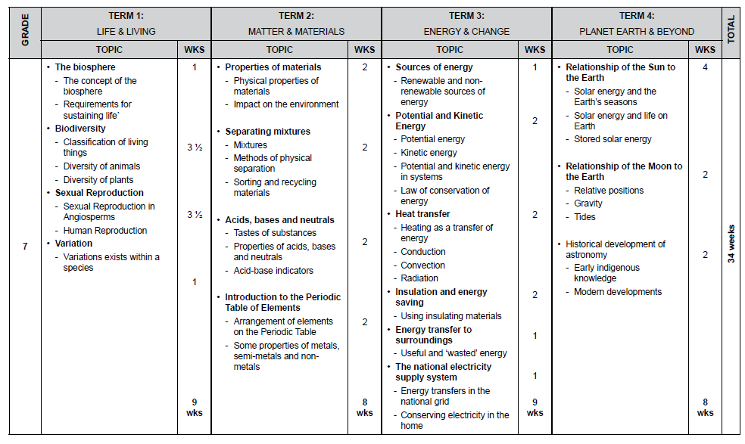

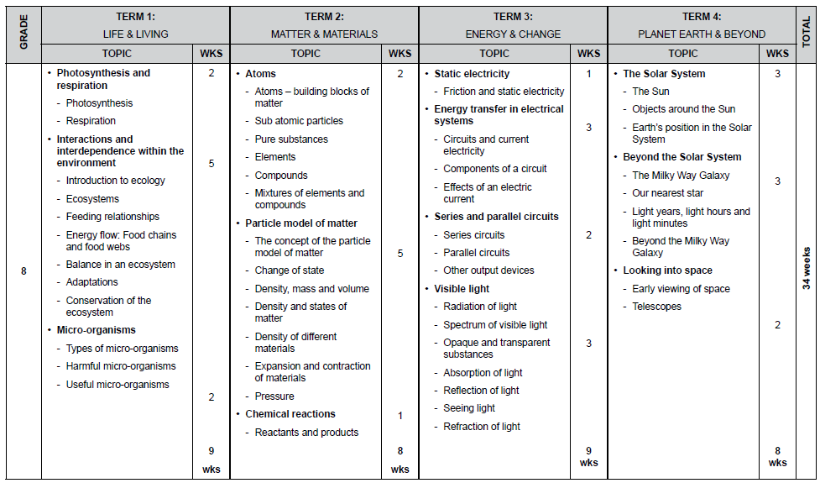

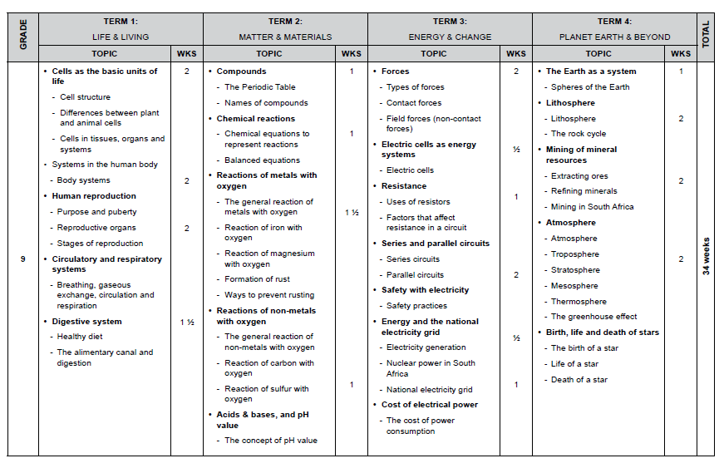

Teachers have the freedom to expand concepts and to design and organise learning experiences according to their own local circumstances.
Examples of indigenous knowledge that teachers select for study should, as far as possible, reflect different South African cultural groupings. They should also link directly to specific content in the Natural Sciences curriculum.
Notes: * These totals include the 6 hours per term for school-based assessment but exclude the 2 weeks set aside for the mid-year and the end of year examinations
General: Time spent on each topic should serve as a guideline for weighting of marks in Tests and Exams. The purpose of using times as guidelines is to ensure that all
topics are assessed.
3. Organisation, Administration processes.
3.1 Planning
3.1.1 Lesson Plans
- Utilise the provincial lesson plan provided.
3.1.2 Teacher’s files
Teacher’s files must be available at all times. File should be professionally organised and easy manageable. The Natural Sciences file remain the property of the school. The HOD should ensure that the educator’s in Natural Sciences are provided with the required documents.
Any relevant documents in the subject needed should be referred to the HOD, who will then inform the Subject Advisor.
Teacher Focus File should contain the following documents.
- PERSONAL TIME TABLE
- CLASS TIME TABLE
- Natural SCIENCES Caps pOLICY
- NATIONAL POLICY PERTAINING TO THE PROGRAMME AND PROMOTION REQUIREMENTS
- NATIONAL PROTOCOL FOR ASSESSMENT
- subject POLICY
- ASSESSMENT POLICY
- Annual teacher plan
- LESSON PLANS
- Programme of assessmenT
- SCHOOL ASSESSMENT PLAN
- MONITORING TOOLS
- MODERATION TOOLS
- MEMO’S
- DEPARTMENTAL MINUTES
- MARKSHEETS
- ANALYSIS OF RESULTS
- GDE SUPPORT FORMS
- GDE CIRCULARS

4. ASSESSMENT

4.1 Programme of assessment per grade.
JOHANNESBURG CENTRAL DISTRICT NATURAL SCIENCES PROGRAMME OF ASSESSMENT GRADE 7
TERM | STRAND | TOPIC | DURATION | DATE | MINIMUM MARKS | TOOLS
1 | Life and living | Practical investigation | Dependent on the nature of the task. |  | 20 | Rubric/ Memo/Checklist
1 | Life and living | Test | 90 Min |  | 60 | Memo
2 | Matter and materials | Practical investigation | Dependent on the nature of the task. |  | 20 | Rubric/ Memo/Checklist
2 | Matter and materials | June Exam [T1(40%)+T2(60%)] | 120 Minutes |  | 80 | Memo
3 | Energy and change | Project | Dependent on the nature of the task. |  | 30 | Rubric/ Memo/Checklist
3 | Energy and change | Test | 90 Min |  | 60 | Memo
4 | Planet earth and beyond | November Exam [T3(60%)+T4(40%)] | 120 Minutes |  | 80 | Memo

JOHANNESBURG CENTRAL DISTRICT NATURAL SCIENCES PROGRAMME OF ASSESSMENT GRADE 8
TERM | STRAND | TOPIC | DURATION | DATE | MINIMUM MARKS | TOOLS
1 | Life and living | Practical investigation | Dependent on the nature of the task and context |  | 20 | Rubric/Memo/ Checklist
1 | Life and living | Test | 90 minutes |  | 60 | Memo
2 | Matter and materials | Practical investigation | Dependent on the nature of the task and context |  | 20 | Rubric/Memo/ Checklist
2 | Matter and materials | Examination  [T1 (40%)+T2 (60%)] | 120 minutes |  | 90 | Memo
3 | Energy and change | Project | Dependent on the nature of the task and context |  | 30 | Rubric/Memo/  Checklist
3 | Energy and change | Test | 90 minutes |  | 60 | Memo
4 | Planet earth and beyond | Examination [T3(60%)+T4 (40%)] | 120 minutes |  | 90 | Memo

JOHANNESBURG CENTRAL DISTRICT PROGRAMME OF ASSESSMENT GRADE 9
TERM | STRAND | TOPIC | DURATION | DATE | MINIMUM MARKS | TOOLS
1 | Life and living | Practical investigation | Dependent on the nature of the task and context |  | 20 | Rubric/Memo/  Checklist
1 | Life and living | Test | 90 minutes |  | 70 | Memo
2 | Matter and materials | Practical investigation | Dependent on the nature of the task and context |  | 20 | Rubric/Memo/Checklist
2 | Matter and materials | Examination  [T1 (40%)+T2 (60%)] | 120 minutes |  | 100 | Memo
3 | Energy and change | Project | Dependent on the nature of the task and context |  | 30 | Rubric/Memo/Checklist
3 | Energy and change | Test | 90 minutes |  | 70 | Memo
4 | Planet earth and beyond | Examination [T3(60%)+T4 (40%)] | 120 minutes |  | 100 | Memo

4.2 FORMS OF ASSESSMENT
FORM & DEFINITION | GUIDELINE FOR QUESTIONING
Practical:  - In carrying out practical tasks learners are required to demonstrate a skill or proficiency. Learners use materials, tools and equipment to create, produce or do something. | - Minimum mark must be 20.  - It should cover the following elements:  -Aim/Objective  -Hypothesis  -Apparatus/Resources  -Method  -Observation (Use of Questioning technique)  -Results (Graphs-Clarifying Variables, Tables, Data)  -Conclusions  - Use of Rubric and Memorandum for marking  - Process skills must be taught and emphasized:  -Accessing & Recalling information  -Observing  -Comparing  -Measuring  -Sorting & Classifying  -Identifying problems & Issues  -Raising Questions  -Predicting  -Hypothesizing  -Planning Investigations  -Doing investigation  -Recording Information  -Interpreting Information  -Communicating  - The teacher observes the learner demonstrate specific practical skills (e.g. measure the voltage of a cell, use a thermometer to measure temperature, etc.). Practical tasks can be very useful for assessing how learners draw on knowledge and values to carry out practical skills (manual and/or behavioral, e.g. safety and handling of equipment).  - Any practical task should provide opportunities for learners to demonstrate the skills listed under Specific Aim 1. These may or may not include design/plan investigations skills. However, there are some circumstances in which only some of these skills would apply and not every skill can be assessed in every practical task.  - Assessment of practical tasks: The assessment may be based on the end-result of the activity (the product), or the carrying-out of the activity (the process), or a combination of both. Assessment tools could be a combination of rubric, memorandum, checklist, etc.
Tests  - Tests consist of a range of questions that cover the different cognitive levels – knowledge recall, understanding, application, evaluation, analysis and synthesis. | - Learners are required to respond to questions within a specified time under controlled conditions. Since they are generally easy to mark, reliably they are a good way to conduct formal assessment, however, they can be a very useful informal tool too.  - Minimum Mark: Grade 7 – 60, Grade 8 – 60 and Grade 9 – 70  - Test should consist of two Sections (Section A & B)  - Section A –  Multiple Choice: General instructions to the question should be given at the start of this question type (once off):  Various options are provided as possible answers to the following questions. There must be FOUR possible answers ‘. All of the above’ is not a good answer and should be avoided. Each question should be awarded 1 mark. Do not shuffle the possible answers – especially using ‘All of the above’  Matching column, A with B:  These are matching column A with Column B by selecting the correct item to match the statement. Selecting answers using a key in columns. General instructions to the question should be given at the start of this question type (once off): Indicate whether each of the terms in COLUMN A applies to the definition in COLUMN B.  Format of the question:  Scientific terms: A format for this question type must be created to enable teachers to specifically test learners on terminology  - 1 mark each  - All these items are definitions and therefore classified as level 1 questions on Blooms taxonomy  - Section B –  Case Study:  - Case studies (extract) should not be more than 10 lines and language should be easy to follow  - The questions based on these are scaffolded from easy to more difficult  - The system should be able to scaffold the questions  Translation Questions (Graphs, Tables, Diagrams)  - The graph/diagram/table is given and questions asked on these  - These are an interpretation of the specific source given  - The questions based on these are scaffolded from easy to more difficult  - The system should be able to scaffold the questions  Investigative Questions (Based on practical experiments)  - There must be scientific investigations based on every topic included in the item bank  - This type of question provides the higher order questions on Blooms taxonomy and tests scientific method skills:  - Hypothesis  - Aim  - Planning  - Identification of the variables (independent, dependent and controlled)  - Methodology  - Gathering and recording results  - Drawing conclusions  Learners must also be able to evaluate the investigation and comment on the reliability of the results and the validity of the method.  General Information:  - It must be made possible to do SBA tasks which are skilled based on the system.  - This include  - practical investigations where the learners physically have to do the experiments,  - projects where the learners have to do fieldwork and make observations, gather their own data and interpret the data by drawing graphs and tables.  - Informal assignments (translation) where learners have to present data in another form, e.g. table to graph, text to table, etc.  The assessment items must be inclusive of the latest trends and developments in Natural Sciences.  Formative assessment  - All question types should be included  - These should be on all cognitive levels  - There should be a video, voice clip or written explanation given in the feedback to learners of the correct answer and why.
  COLUMN A | COLUMN B | Answer
  1.3.1 Photosynthesis | A. Energy released from food by series of chemical reactions | B
  1.3.2 Respiration | B. Use of radiant energy to make food | A
Examinations  - Examinations are similar to tests, the only difference is that they cover more content. | - Learners are required to respond to questions within a specified time under controlled conditions. Since they are generally easy to mark, reliably they are a good way to conduct formal assessment, however, they can be a very useful informal tool too.  - Minimum Mark: Grade 7 – 80, Grade 8 – 90 and Grade 9 – 100  - Test should consist of two Sections (Section A & B)  - Section A – Multiple Choice  - Matching column A with B  - Scientific terms  - Section B – Case Study  - Translation Questions (Graphs, Tables, Diagrams)  - Investigative Questions (Based on practical experiments)  ( same as test above)
Investigation  - The investigation activities are about “Doing Science”. They are about investigating relationships and solving problems in the natural world. These usually start off with a question that is followed by a hypothesis (a speculative answer to the question), the validity of which will be tested.  - Investigation activities are one type of performance activity that engage learners in some form of systematic inquiry of a phenomenon.  - Learners can investigate and solve: problems of making, problems of observing, surveying and measuring, problems of comparing, and problems of determining the effect of certain factors. | Assessment of investigation activities  - Each stage of an investigation activity involves a range of thinking skills, therefore it is important to assess each stages of an investigation activity (process), as well as the end-result (the product).  - Assessment tools can be a combination of rubric, memorandum, checklist, observation sheet etc.  - Minimum mark must be 20.  - It should cover the following elements:  -Aim/Objective  -Hypothesis  -Apparatus/Resources  -Method  -Observation (Use of Questioning technique)  -Results (Graphs-Clarifying Variables, Tables, Data)  -Conclusions  - Use of Rubric and Memorandum for marking  - Process skills must be taught and emphasized:  -Accessing & Recalling information  -Observing  -Comparing  -Measuring  -Sorting & Classifying  -Identifying problems & Issues  -Raising Questions  -Predicting  -Hypothesizing  -Planning Investigations  -Doing investigation  -Recording Information  -Interpreting Information  -Communicating  - The teacher observes the learner demonstrate specific practical skills (e.g. measure the voltage of a cell, use a thermometer to measure temperature, etc.). Practical tasks can be very useful for assessing how learners draw on knowledge and values to carry out practical skills (manual and/or behavioral, e.g. safety and handling of equipment).  Any practical task should provide opportunities for learners to demonstrate the skills listed under Specific Aim 1. These may or may not include design/plan investigations skills. However, there are some circumstances in which only some of these skills would apply and not every skill can be assessed in every practical task.
Projects  - Projects are tasks in which learners illustrate or apply knowledge that they have gained in class. Projects may involve aspects of investigation and/or design. Learners may collect data to solve a problem or to understand a particular set of circumstances and/or phenomena. In doing this, they can build models, compile reports, essays or posters and even give presentations. | Projects Guidelines  - Learners can do projects individually or in groups; working alone but with some support and guidance from the teacher. The teacher directs the choice of the project, usually by providing the learner with a topic or brief for the investigation.  - Minimum mark 20.  - Projects can be done for any topic area within the grade.  Assessment of projects  - Teachers can assess different stages of projects separately, or the entire project. Assessment of projects should be based on the understanding of content, application of skills and values applicable in a relevant context. Assessment tools of projects could be a combination of rubric, memorandum, checklist, etc.

4. 3 Moderation of Assessment Tasks
- The educator must submit all formal assessments with the memorandum and cognitive grid to the HoD for pre-moderation.
- 10% of the total learner’s scripts must be post-moderated by the HoD for quality assurance.
- Pre and post moderation reports must be provided to the educators for evidence of moderation done at school level.
Analysis of results
- All educators must analyse the term results of all learners.

Intervention strategies
- Educators should have a list of learners at risk.
- Learners should be identified during contact time and based on the learner performance.
- Intervention strategies/ Intervention programmes must be developed to support the learners at risk.
- Individual meetings can also be arranged with the parent of the learner.
- Subject HOD should monitor the implementation of the intervention strategy.

5. Written work
A minimum of three written activities will be given to learners per week. If the teacher is doing a demonstration, explaining a topic, using ICT such as a video to explain a concept or using a diagram or picture from a resource, it must be referenced in learner books. The format of all work in the learners should follow the following format: date, topic, short summary, activity and page number.

6. Classroom management.
Learners are expected to fully participate in the subject.
Educators are responsible for his/her classroom equipment.
Faulty or broken equipment must be reported to the Head of the Department.
Discipline should be encouraged at all time. Referrals will be made to SBST or Head of Department /SMT of the school in terms of extreme cases.

7. Book control
All class work should be marked by the Educator.
Positive constructive feedback/comments in learner’s books should be encouraged.
HOD should monitor learner’s books to verify curriculum coverage as per Annual Teaching Plan.

8. Subject Meetings
One Subject meetings should be held per month
All Natural Sciences Educators in the school should meet to plan, prepare curriculum activities and to discuss curriculum challenges.

The above policy was accepted by the educators in a meeting held on the __________________ at ___________________(school).
Educators/ HoD Name and surname Signature
1_____________________________ _______________________
2_____________________________ _______________________
3_____________________________ _______________________
4_____________________________ _______________________
5_____________________________ _______________________

Deputy Name and Surname Signature
1_____________________________ ___________________
2_____________________________ ___________________

Principal Name and Surname Signature
1______________________________ ___________________

SCHOOL STAMP

