

Teacher
Guideline:
How to develop a
Rubric
SECTION | TABLE OF CONTENTS |  | PAGE
1 |  | RATIONALE | 3
2 |  | When do you use a rubric? | 4
3 |  | TYPES OF RUBRICS | 9
3.1  3.2  3.3  3.4  3.5 |  | ANALYTICAL RUBRIC  HOLISTIC RUBRIC  DEVELOPMENTAL RUBRIC  CHECKLIST  GRID | 10
 |  |  | 12
 |  |  | 13
 |  |  | 14
 |  |  | 16
4 |  | HOW TO DEVELOP A RUBRIC | 18
5 |  | A CLOSER LOOK AT RUBRIC DEVELOPMENT | 19
6 |  | COMPONENTS OF A RUBRIC | 21
7 |  | COGNITIVE LEVELS IN RUBRICS | 22
8 |  | RUBRIC DEVELOPMENT USING A LESSON PLAN | 26
9 |  | APPLYING DIFFERENTIATED WEIGHTING | 26
10 |  | THE HAZARDS OF A 7-LEVEL RUBRIC | 29
11 |  | RESOURCES | 31

- RATIONALE
WHAT IS A RUBRIC?
A rubric is a marking tool that clearly indicates achievement criteria across all the components of any kind of learners’ work, from written, to oral, to visual. It can be used for marking assignments, class participation, etc. It is usually presented in the form of a grid and aims to simplify the assessment process.
A marking tool for assessing learner performance that:
- Describes a continuum of performance quality that ranges from highest to lowest/beginner performance levels.
- Consists of a set of criteria that defines a task in its entirety and by which a task will be evaluated.
- Level descriptors are used to assess the quality of the learners’ performances that are clear and concise written sets of expectations.
- Clearly show learners how their work is being evaluated as it communicates detailed explanations of what constitutes excellence.

Why Are Rubrics Important?
Rubrics are important because they clarify for learners the qualities their work should have. This point is often expressed in terms of learners understanding the learning target and criteria for success. For this reason, rubrics help teachers to teach, they help coordinate instruction and assessment, and they help learners learn.
Rubrics help teachers to teach
To write or select rubrics, teachers need to focus on the criteria by which learning will be assessed. This focus on what you intend learners to learn rather than what you intend to teach actually helps improve instruction. Without clarity on outcomes, it is hard to know how much of various aspects of the content to teach. Rubrics help with clarity of both content and outcomes.
Really good rubrics help teachers avoid confusing the task or activity with the learning goal, and therefore confusing completion of the task with learning. Rubrics help maintain a focus on criteria, not tasks.
Rubrics help coordinate instruction and assessment
Most rubrics should be designed for repeated use, over time, on several tasks. Learners are given a rubric at the beginning of new content of instruction or an episode of work. They tackle the work, receive feedback, practice, revise or do another task, continue to practice, and receive a mark, all using the same rubric as their description of the criteria and the quality levels that will demonstrate learning. This path to learning may be much more cohesive than a string of assignments with related but different criteria.

Rubrics help learners to learn
The criteria and performance-level descriptions in rubrics help learners understand what the desired performance is and what it looks like. Effective rubrics show learners how they will know to what extent their performance has achieved on each criterion of importance, and if used formatively can also show learners what their next steps should be to enhance the quality of their performance.
https://cole2.uconline.edu/courses/333119/pages/why-are-rubrics-important

- WHERE DO YOU USE THE RUBRIC?
Rubrics are used to mark open ended questions. They are used not only for languages activities but all the content subjects as well. They have many other uses:
- They can be used for oral presentations, etc.
- They are a great tool to evaluate teamwork and individual contribution to group tasks.
- Rubrics facilitate peer-review by setting evaluation standards.
Sentence introducing table:

SUBJECT | ACTIVITIES THAT REQUIRE AN INFORMAL OR FORMAL MARKING TOOL
Languages | LISTENING & SEAPKING  - Public Speaking,  - Unprepared/Prepared speech  - Conversations/Discussions  - Role play,  - Dialogue,  - Interview/Interviewee,  - Debate  - Listening  - Practical demonstrations  - Presentations  READING & VIEWING:  - Demonstrations (such as retelling a story, matching)  - Prepared/unprepared reading aloud  - Reading comprehension (cognitive level 4 and 5)  WRITING & PRESENTING:  - Summary writing (open ended questions/level 4 and 5 questions)  - Paraphrasing  - Paragraphing  - Essays  - Transactional / functional texts  - Creative writing project
Mathematics | - Practical demonstrations  - Performance assessment  - Short investigations  - Open-response questions  - Portfolios  - Self-assessment
Natural Sciences & Technology | - Practical demonstrations  - Presentations  - Investigations  - Summary writing (open ended questions/level 4 and 5 questions)  - Paraphrasing  - Discussions
Social Science | - Role play,  - Dialogue  - Interview/Interviewee,  - Debate  - Conversations/Discussions  - Unprepared/Prepared speech  - Group projects  - Presentations  - Portfolios  - Demonstrations (such as retelling a story, matching)  - Summary writing (open ended questions/level 4 and 5 questions)  - Paraphrasing
Life Skills | - Conversations/Discussions  - Role play  - Dialogue  - Interview/Interviewee  - Presentations  - Group work  - Self-evaluation  - Case studies  - Demonstrations (such as retelling a story, matching)  - Summary writing (open ended questions/level 4 and 5 questions)  - Paraphrasing
Technology | - Practical demonstrations  - Presentations  - Investigations  - Summary writing (open ended questions/level 4 and 5 questions)  - Group work  - Self-evaluation
Economic Management Sciences | - Interview/Interviewee  - Conversations/Discussions  - Role play  - Presentation  - Case studies  - Summary writing (open ended questions/level 4 and 5 questions)
Life Orientation | - Role play  - Dialogue  - Debate  - Case studies  - Conversations/Discussions  - Practical demonstrations  - Presentations

Assessment tools that could be used in Languages for Grades 4-6
 | Task | Grade 4 | Grade 5 | Grade 6
Term one | Task one | Oral (to be recorded in Term 2)  Continuous task  Rubric to assess Informal Reading Aloud/Oral | Oral (to be recorded in Term 2)  Continuous task  Rubric to assess Informal Reading Aloud/Oral | Oral (to be recorded in Term 2)  Continuous task  Rubric to assess Informal Reading Aloud/Oral
Term one | Task two | Essay writing  Rubric to assess Creative/Narrative Writing | Essay writing  Rubric to assess Creative/Narrative Writing | Essay  Rubric to assess Creative/Narrative Writing
Term one | Task three | Response to Text | Response to Text | Response to text
Term two | Task one | Oral (to be recorded in Term 2)  Rubric to assess Formal Reading  Aloud/Oral | Oral (to be recorded in Term 2)  Rubric to assess Formal Reading  Aloud/Oral | Oral (to be recorded in Term 2)  Rubric to assess Formal Reading  Aloud/Oral
Term two | Task four | Transactional writing  Rubric to assess transactional  writing | Transactional writing  Rubric to assess transactional  writing | Transactional writing  Rubric to assess transactional  writing
Term two | Task five | Response to Text  Question 3: Rubric to assess a  summary | Response to Text  Question 3: Rubric to assess a  summary | Response to Text  Question 3: Rubric to assess a  summary
Term three | Task six | Creative writing project  Stage 1: Rubric to assess research  Stage 2: Rubric to assess  writing | Creative writing project  Stage 1: Rubric to assess research  Stage 2: Rubric to assess writing | Creative writing project  Stage 1: Rubric to assess research  Stage 2: Rubric to assess writing
Term three | Task seven | Oral (to be recorded in Term 4)  Continuous task  Stage 3:Rubric to assess oral | Oral (to be recorded in Term 4)  Stage 3:Rubric to assess oral | Oral (to be recorded in Term 4)  Stage 3:Rubric to assess oral
Term four | Task seven | Oral (to be recorded in Term 4)  Stage 3:Rubric to assess oral | Oral (to be recorded in Term 4)  Stage 3:Rubric to assess oral | Oral (to be recorded in Term 4)  Stage 3:Rubric to assess oral
Term four | Task eight | Transactional writing  Rubric to assess transactional writing | Transactional writing  Rubric to assess transactional  writing | Transactional writing  Rubric to assess transactional  writing
Term four | Task nine | Response to text  Question 3: Rubric to assess a  summary | Response to text  Question 3: Rubric to assess a  summary | Response to text  Question 3: Rubric to assess a  summary

Assessment tools that could be used in Languages for Grades 7-9
 | Task | Grade 7 | Grade 8 | Grade 9
Term one | Task one | Oral (to be recorded in Term 2)  Rubric to assess informal  Reading Aloud/Oral | Oral (to be recorded in Term 2)  Rubric to assess informal  Reading Aloud/Oral | Oral (to be recorded in Term 2)  Rubric to assess informal  Reading Aloud/Oral
Term one | Task two | Essay  Rubric to assess Narrative/Reflective essay | Essay  Rubric to assess Narrative/Reflective essay | Essay  Rubric to assess Narrative/Reflective essay
Term one | Task three | Response to text | Response to text | Response to text
Term two | Task one | Oral (to be recorded in Term 2)  Rubric to assess formal Reading  Aloud/Oral | Oral (to be recorded in Term 2)  Rubric to assess formal Reading  Aloud/Oral | Oral (to be recorded in Term 2)  Rubric to assess formal Reading  Aloud/Oral
Term two | Task four | Transactional writing - two short or one long  Rubric to assess transactional writing | Transactional writing - two short  or one long  Rubric to assess transactional writing | Transactional writing - two short  or one long  Rubric to assess transactional writing
Term two | Task five | Response to text  Question 3: Rubric to assess a  summary | Response to text  Question 3: Rubric to assess a  summary | Response to text  Question 3: Rubric to assess a  summary
Term three | Task six | Creative writing project  Stage 1: Rubric to assess research  Stage 2: Rubric to assess writing | Creative writing project  Stage 1: Rubric to assess research  Stage 2: Rubric to assess writing | Creative writing project  Stage 1: Rubric to assess research  Stage 2: Rubric to assess writing
Term three | Task seven | Oral (to be recorded in Term 4)  Stage 3: Rubric to assess formal oral | Oral (to be recorded in Term 4)  Stage 3: Rubric to assess formal oral | Oral (to be recorded in Term 4)  Stage 3: Rubric to assess formal oral
Term three | Task eight | Response to Literature | Response to Literature | Response to Literature
Term four | Task seven | Oral (to be recorded in Term 4)  Stage 3: Rubric to assess formal  oral | Oral (to be recorded in Term 4)  Stage 3: Rubric to assess formal  oral | Oral (to be recorded in Term 4)  Stage 3: Rubric to assess formal  oral
Term four | Task nine | Transactional writing - two short or one long  Rubric to assess transactional writing | Transactional writing - two short or one long  Rubric to assess transactional writing | Transactional writing - two short or one long  Rubric to assess transactional writing
Term four | Task ten | Response to text  Question 3: Rubric to assess a  summary | Response to text  Question 3: Rubric to assess a  summary | Response to text  Question 3: Rubric to assess a  summary

At what point during a lesson should the rubric for a task be given to learners?
Yes, rubrics can be given to learners. Rubrics given to learners before the learning activity starts, helps them get a clear sense of what knowledge and skills they need in order to achieve a given mark. In their book Learner-Centred Assessment on College Campuses, Hubba and Freed (2000) point out that Scoring rubrics usually contain the following elements:
- Clear statements of the level of knowledge you expect the learner to achieve for them to receive a given mark.
- The dimensions of the quality of work you expect the learner to achieve.
- Commentaries describing your expectations of knowledge and quality that distinguishes each level.

- TYPES OF RUBRICS
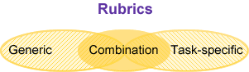

https://images.app.goo.gl/fbAo3phgeqVUGgtMA

3.1 Analytical Rubric
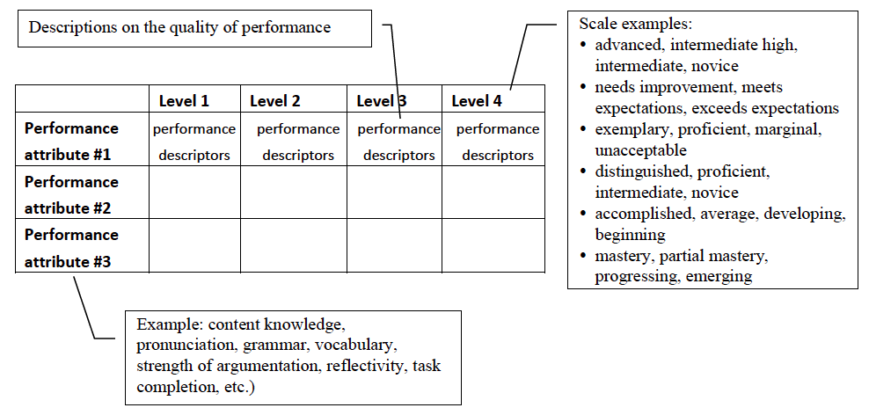
- This is the optimal rubric for providing clear, detailed feedback.
- Selected criteria for the learners' work is listed in the left column and performance levels are listed across the top.
- The squares inside the grid will typically contain the specs for each level
- A rubric for an essay, for example, might contain criteria like "Organization, Support, and Focus," and may contain performance levels like "(4) Exceptional, (3) Satisfactory, (2) Developing, and (1) Unsatisfactory
- The performance levels are typically given percentage points (marks), or letter grades(weightings) and a final grade (mark) is typically calculated at the end.
- Provide feedback on strengths and weaknesses and criterion can be weighted and scored.

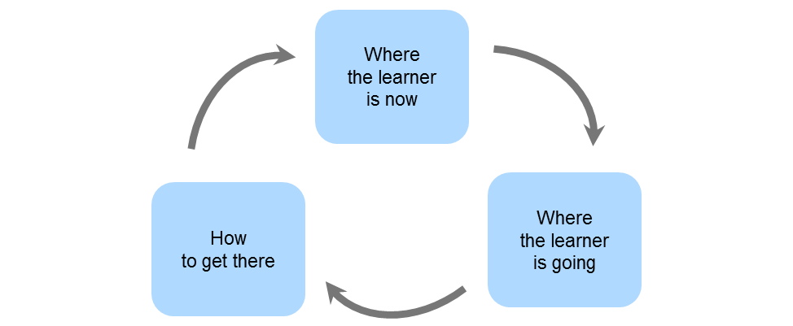

https://images.app.goo.gl/pwbQxV5PTmKeW7ej7

EXEMPLAR RUBRIC (ASSESSMENT GUIDELINES) FOR REFLECTIVE ESSAY (30 marks)

CRITERIA | LEVEL 4 | LEVEL 3 | LEVEL 2 | LEVEL 1
Writer’s view on the selected topic | Thorough understanding of the chosen topic.  Story line is convincing and personal, give emotional reactions and feelings | Some understanding of the chosen topic  Story line make sense and has some personal reactions and feelings in | Limited understanding of the chosen topic  Story line loosely arranged and limited personal reactions and feelings | Do not understand the chosen topic.  Story line has no sense and no personal reactions and feelings
Mark | 5 | 4 | 3-2 | 1-0
Planning | Exceptional planning done around the main and supporting ideas per paragraph. | Good planning done around the main and supporting ideas per paragraph. | Weak planning done around the main and supporting ideas per paragraph. | Exceptional planning done around the main and supporting ideas per paragraph.
Mark | 5 | 4 | 3-2 | 1-0
Process writing | Very effective use of the drafting end editing process, making a lot of corrections and improvements | Quite effective use of the drafting end editing process, picking up a lot but not all corrections and improvements | Very limited use of the drafting end editing process, leaving a lot of corrections and improvements | Limited or no use of the drafting end editing process, missing most corrections and improvements
Mark | 5 | 4 | 3-2 | 1-0
Language used in the essay | No mistakes or so few that they do not detract from the meaning.  Used enough adverbs and adjectives effectively to describe the feelings and emotions of the learner. | Few mistakes, but they do not detract from the meaning.  Use some adverbs and adjectives to describe the feelings and emotions of the learner. | Mistakes that detract from the meaning.  Adverbs and adjectives used in the essay do not convey the feelings and emotions of the learner. | Mistakes that make the meaning difficult to follow.  Limited adverbs and adjectives used to describe the emotions and feelings of the learner.
Mark | 5 | 4 | 3-2 | 1-0
Features:  Reflective | Presented the writer’s views, ideas, thoughts and feelings excellently. | Presented the writer’s views, ideas, thoughts and feelings adequately | Express very little ideas, thoughts or feelings. Very little evidence of their own reflections | Essay is in story telling mode.  Does not reflect at all.
Mark | 5 | 4 | 3-2 | 1-0
Conclusion | Effective ending  Do make use of an unusually interesting ending | An attempt at an effective ending | Ending does not follow the requirements of explaining the conclusion of the story | Very weak ending
Mark | 5 | 4 | 3-2 | 1-0
Total: |  |  |  | /30

3.2 Holistic rubric
This is the type of rubric that is much easier to create, but much more difficult to use accurately. Typically, a teacher provides a series of letter grades or a range of numbers (1-4 or 1-6, for example) and then assigns expectations for each of those scores. When grading, the teacher matches the student work in its entirety to a single description on the scale. This is useful for grading multiple essays, but it does not leave room for detailed feedback on student work.

Holistic Writing Rubric
1 | - Some incomplete sentences  - Little or no evidence of punctuation and capitalization  - Limited vocabulary and few, if any, details or descriptive words  - Story hard to understand and read
2 | - Uses only simple sentence structure  - Many errors in spelling, punctuation, and capitalization  - Only a few descriptive words and phrases  - Lacks a clear sequence of beginning, middle and end
3 | - Some variety in sentence beginnings and structure  - Some errors in spelling, punctuation, and capitalization, but they do not interfere with meaning  - Effective word choice  - Logical organization, flows smoothly and holds the reader’s attention
4 | - Variety of sentence structures and length, includes some compound sentences  - Generally accurate spelling, punctuation, and capitalization  - Uses engaging and effective word choice  - Well organized, flows well and has a clearly stated main idea and ample supporting details

3.3 Developmental rubric

A developmental rubric communicates that you expect all learners to achieve the highest level as they develop a certain skill. It utilizes clear descriptions to convey the desired learning or performance objective or competency and how well the learners achieved against the level performances. The main distinction between developmental rubrics and other analytic trait rubrics is that the purpose of developmental rubrics is not to evaluate an end product or performance.
Reading Fluency Rubric
This rubric is to be used as an informal marking tool
CRITERIA | 4  Awesome! | 3  Very Good! | 2  Developing | 1-0  Needs practice
Speed (Rate):
Not too slow and not too fast!
Accurate (correct)
Few words were skipped and few mistake were made.
Expression:
Interesting, your voice changes and sounds like talking
Smoothness:
Not choppy, No robot reading.
Total: |  |  |  | /15
FEEDBACK:

Character Sketch Writing Rubric
This rubric is to be used as an informal marking tool
CRITERIA | 4 | 3 | 2 | 1-0
Use of correct grammar and vocabulary | Excellent use of grammar and vocabulary | Good use of grammar and vocabulary | Fair use of grammar and vocabulary | Grammar and vocabulary needs more support
Use of descriptive characterization | Excellent use of descriptive language | Good use of descriptive language | Fair use of descriptive language | Descriptive language needs support
Use of imagery |  |  | Good and creative imagery used that is about text | No Imagery found  Imagery not about the text
Total: |  |  |  | /10
FEEDBACK:

Independent Reading Rubric
This rubric is to be used as an informal marking tool
CITERIA | 4 | 3 | 2 | 1-0
On task |  |  | I was off task more than I read | I pretended to read
Book choice | I read a just right book that I have been reading | I left my just right book at home and chose another just right book | I read a book that is not on my level, too easy or too hard | I did not select a just right book
Respect | I respected the readers around me the whole time | I respected the readers around me most of the time | I respected the readers around me some of the time | I distracted readers around me
Fix-up  Strategies | I realized something did not make sense and used this strategy | I sometimes reread when something did not make sense | I skipped over the tricky parts | I did not understand what I read
Thinking | I paid attention to my inner voice and mental movie | I paid attention to my inner voice | I usually did not pay attention to my thinking | I did not pay attention to my thinking
Tracking |  |  | I tracked my thinking. | I did not track my thinking
Total: |  |  |  | /20
FEEDBACK:

3.4 Checklist

A checklist is a list of items required, things to be done, or points to consider, used as a reminder. It offers a yes/no format in relation to student demonstration of specific criteria. Checklists may be used to record observations of an individual, a group or a whole class.
- The administration uses a checklist to monitor the consistent use of procedures and discipline during classroom visits.
- Each month, professional development revisits the schoolwide procedures and allows teachers a chance to self-assess their effectiveness with the one-page checklist.
- The information is gathered and used to plan additional training and support.

EXAMPLES:
Recount writing checklist:

Features | Yes | No
My introduction briefly covers the 5 W (who, what, when and why) the event happened.
I write the piece in the first person or third person.
My piece was written in the past tense.
I named specific places and people
I used time connectives
I wrote the recount in the chronological order

Paragraph checklist
Features | No | Sometimes | Yes
The paragraph starts with a topic sentence that states an opinion.
The paragraph includes adequate details supporting the opinion
The paragraph ends with a concluding sentence that states the opinion in different words.
Linking words are used to show how the ideas connect.
All of the sentences have a subject and verb.
Most words are spelled correctly
Comments: _________________________________________________________________

3.5 Grid (Scoring guide):

Grid rubrics are made up of rows and columns. The rows correspond to the various criteria of an assignment. The columns correspond to the level of achievement expressed for each criterion. A criterion and a mark for each cell in the rubric defines the evaluation and score of an assignment.
Typically designed as a grid-type structure, a grid includes criteria and mark allocations. This is also typically used for formative assessments.

Grid Rubric Template
- Determine your components and their associated worth (e.g., points), as well as how many grading levels you want to define.
- Be sure to include a description of criteria for what is required to attain a particular rating for each component.
- You can add or eliminate columns and rows to best fit the needs of your assignment.
- You can also choose different labels for your grading levels.
- Examples to get you started.

Oral Presentation Grid Rubric

CRITERIA | 4 | 3 | 2 | 1
Delivery |  |  | - Holds attention of entire audience with the use of direct eye contact, seldom looking at notes  Speaks with fluctuation in volume and inflection to maintain audience interest and emphasize key points | - Holds no eye contact with audience, as entire report is read from notes  - Speaks in low volume and/ or monotonous tone, which causes audience to disengage
Content/  Organization | - Demonstrates full knowledge by answering all class questions with explanations and elaboration  - Provides clear purpose and subject; pertinent examples, facts, and/or statistics; supports conclusions/ideas with evidence | - Is at ease with expected answers to all questions, without elaboration  - Has clear purpose and subject; some examples, facts, and/or statistics that support the subject; includes some data or evidence that supports conclusions | - Is uncomfortable with information and is able to answer only rudimentary questions  - Attempts to define purpose and subject; provides weak examples, facts, and/ or statistics, which do not support the subject; includes very thin data or evidence | - Does not have grasp of information and cannot answer questions about subject  - Does not clearly define subject and purpose; provides weak or no support of subject; gives insufficient support for ideas or conclusions
Enthusiasm/  Audience  Awareness | - Demonstrates strong enthusiasm about topic during entire presentation  - Significantly increases audience understanding and knowledge of topic; convinces an audience to recognize the validity and importance of the subject | - Shows some enthusiastic feelings about topic  - Raises audience understanding and awareness of most points | - Shows little or mixed feelings about the topic being presented  - Raises audience understanding and knowledge of some points | - Shows no interest in topic presented  - Fails to increase audience understanding of knowledge of topic
Comments |  |  |  | Total: /10

- HOW TO DEVELOP A RUBRIC:
STEP 1: Identify and list the subject area and outcomes (skills) learners should demonstrate competencies in.
STEP 7: Use the rubric to rate performance. Provide constructive feedback to learners. Ensure that the rubric is dated and signed by the teacher.
STEP 5: Develop differentiated performance descriptors.
Use action words (verbs) and describing words (adjectives) when writing the descriptors per level, per criterion. Include taxonomy levels.
STEP 3: Identify the type of assessment activity and the assessment tool to be used
STEP 6: Discuss the criteria and descriptors prior to assessment.
STEP 4: Identify the level descriptors like excellent, good, fair and poor.
STEP 2: Identify and list the performance criteria

- A CLOSER LOOK AT RUBRIC DEVELOPMENT:

CRITERIA
What are criteria?
- Assessment Criteria means the clear and transparent expression of requirements
- Select from the criteria the most relevant to be placed in the rubric, grid or checklist.
- What secondary skills are important for learners to demonstrate in this assessment? (for example, critical thinking, public speaking, creative writing, summarising, paragraphing etc.)
- Do not over complicate the assessment criteria
- Keep in mind that certain criteria may have a greater weighting than others. This is dependent on the lesson objectives before assessment.
Good assessment criteria:
- Clear and easy to understand as a guide for learners.
- Attainable rather than beyond learners’ ability.
- Significant in terms of the learning and what learners should demonstrate.
- Relevant in that they assess learners learning towards task objectives related to that assessment.
How to select criteria?
- The overview of content, skills, and strategies table and Annual Teaching Plan provides the knowledge, content, and skills to be assessed. Use this to develop the criteria.
- Assessment principles dictate that assessment must always be transparent, fair, valid and reliable.
- The rubric cannot succeed more than five different criteria.
- The weighting of the rubric is determined by the criterion.

Example:

- Activity:
Each learner will do a 5-minute presentation on the changes in their community over
the past 3 years. The learner may focus on the presentation in any way he or she wishes, but there needs to be a theory of some sort, not just a chronological exposition. The presentation should include appropriate photographs, maps, graphs, and other visual aids for the audience.

CRITERIA | Excellent | Good | Satisfactory
CRITERIA | 3 Marks | 2 Marks | 1 Mark
Knowledge/Understanding
LEVEL 2 (20%)
Thinking/Inquiry
LEVEL 4 (30%)
Communication
LEVEL 5 (20%)
Use of visual aids
LEVEL 5 (20%)
Presentation skills
LEVEL 3 (10%)
Total: |  |  | /10
COMMENTS / FEEDBACK

LEVEL DESCRIPTORS
- The level descriptors will describe to the learner and the teacher how well the learner
performed the task / activity.
- Positive terms should be used so that the learner is not disheartened if they did not attain the level well.: “Outstanding,” “Meritorious” “Adequate,” “Moderate”,” Elementary”
- Non-judgmental or non-competitive language must be used when feedback is given to the learners. “High level,” “Middle level,” “Beginner level”

Commonly used labels can include:

- Competent or not yet competent
- Exemplary, proficient, marginal or unacceptable
- Advanced, intermediate high, intermediate low or novice
- Distinguished, proficient, intermediate or novice
- Accomplished, average, developing or beginner

3-5 levels are typically used:
- The more levels descriptors there are, the more difficult it becomes to differentiate between them and to articulate precisely why one learner’s work falls into the scale level it does.
- More specific levels make the task clearer for the learner and they reduce the teacher’s time needed to furnish detailed comments or notes.

3 : PERFORMANCE / TASK DESCRIPTORS (What the learner must do?)
- Involves a “performance” of some sort by the learner
- The task can take the form of a specific assignment, e.g., a paper, a poster, a presentation
- The task can take the form of overall behaviour, e.g., participation, application of the
writing process, delivering a speech, etc.

- COMPONENTS OF A RUBRIC:

CRITERIA | Outstanding achievement level | Meritorious achievement level | Adequate achievement level | Moderate achievement level | Elementary achievement level
CRITERIA | Level 5 | Level 4 | Level 3 | Level 2 | Level 1
CRITERIA | Mark | Mark | Mark | Mark | Mark
1. | Descriptors | Descriptors | Descriptors | Descriptors | Descriptors
2. | Descriptors | Descriptors | Descriptors | Descriptors | Descriptors
Descriptions (Descriptors) of dimensions from highest to lowest performing level: Explains each Level against the Criteria.

Add a list of Criteria:
identified expectations
or aims of the task.

Add a mark per descriptor per achievement level:
This enables
the criteria
to be allocated
a mark.

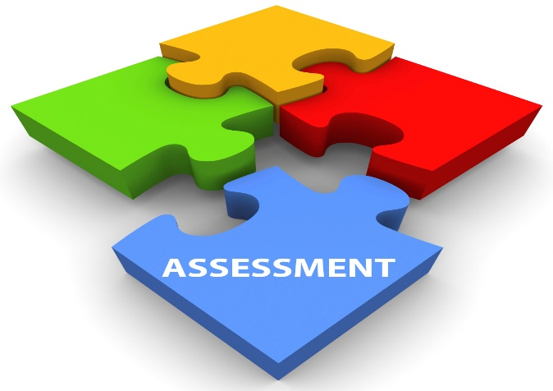

https://images.app.goo.gl/HsK3UGkeTwtUTMoGA
- COGNITIVE LEVELS IN RUBRICS

Why Cognitive levels?
Cognitive skills allow learners to understand the relationships between ideas, to comprehend the development of cause and effect and to improve their analytical skills. Cognitive skill development not only can benefits learners in the classroom but outside of class as well. In the interim teachers are able to see and understand complex cognitive development and how lower-level skills build into higher-order thinking.

Bloom’s Taxonomy

- There are six levels of cognitive learning according to the revised version of Bloom's Taxonomy.
- Bloom's taxonomy is a set of three hierarchical models used for classification of educational learning objectives into levels of complexity and specificity.
- The goal of an educator's using Bloom's taxonomy is to encourage higher-order thought in their learners by building up from lower-level cognitive skills.
- The classification begins at the basic level that is simple recall skills and progresses to the perceived highest level of cognitive processing.
- Blooms Taxonomy has six levels which are conceptually different, namely:
remembering, understanding, applying, analyzing, evaluating, and creating.

Barrett’s Taxonomy

- The Barrett Taxonomy was designed originally to assist classroom teachers in developing comprehension questions and / or test questions for reading.
- Levels of The Barrett Taxonomy
  - LEVEL 1: Literal Comprehension;
  - LEVEL 2: Reorganization;
  - LEVEL 3: Inferential Comprehension;
  - LEVEL 4: Evaluation;
  - LEVEL 5: Appreciation

- A rubric should contain at the very least a description or the highest level of performance in that dimension
- Scoring levels appear from high to low: Excellent – Good - Satisfactory

Cognitive Levels table

In selecting the appropriate criteria to develop your marking tool rubric. You need to identify the performance criteria that needs to be assessed. The activities in the various cognitive levels can be selected as criteria:
COGNITIVE LEVELS | ACTIVITY | PERCENTAGE OF TASK
Literal  (Level 1)  Reorganisation  (Level 2) | Questions that deal with information explicitly stated in the text.  - Name the things/people/places/elements …  - State the facts/reasons/points/ideas …  - Identify the reasons/persons/causes …  - List the points/facts/names/reasons …  - Describe the place/person/character ...  - Relate the incident/episode/experience …  Questions that require analysis, synthesis or organisation of information explicitly stated in the text.  - Summarize the main points/ideas/pros/cons/ …  - Group the common elements/factors …  - State the similarities/differences …  - Give an outline of … | Levels 1 and 2: 40%
Inference  (Level 3) | Questions that require a candidate’s engagement with information explicitly stated in the text in terms of his/her personal experience.  - Explain the main idea …  - Compare the ideas/attitudes/actions …  - What is the writer’s (or character’s) intention / attitude/motivation/reason …  - Explain the cause/effect of …  - What does an action/comment/attitude (etc.) reveal about the narrator/ writer/character …  - How does the metaphor/simile/image affect your understanding …  - What, do you think, will be the outcome/effect (etc.) of an action/a situation … | Level 3: 40%

COGNITIVE LEVELS | ACTIVITY | PERCENTAGE OF TASK
Evaluation  (Level 4)  Appreciation  (Level 5) | These questions deal with judgments concerning value and worth. These include judgments regarding reality, credibility, facts and opinions, validity, logic and reasoning, and issues such as the desirability and acceptability of decisions and actions in terms of moral values.  - Do you think that what transpires is credible/ realistic/ possible …?  - Is the writer’s argument valid/logical/conclusive  …  - Discuss/Comment critically on the action/ intention/ motive/ attitude/suggestion/ implication …  - Do you agree with the view/statement/ observation/ interpretation that…  - In your view, is the writer/narrator/character justified in suggesting/ advocating that … (Substantiate your response/Give reasons for your answer.)  - Is the character’s attitude/behaviour/action justifiable or acceptable to you? Give a reason for your answer.  - What does a character’s actions/attitude(s)/ motives … show about him/her in the context of universal values?  - Discuss critically/Comment on the value judgments made in the text.  These questions are intended to assess the psychological and aesthetic impact of the text on the candidate. They focus on emotional responses to the content, identification with characters or incidents, and reactions to the writer’s use of language (such as word choice and imagery).  - Discuss your response to the text/incident/ situation/ conflict/dilemma.  - Do you empathize with the character? What action/decision would you have taken if you had been in the same situation?  - Discuss/Comment on the writer’s use of language …  - Discuss the effectiveness of the writer’s style/ introduction/ conclusion/imagery/metaphors/use of poetic techniques/ literary devices … | Levels 4 and 5: 20%
SOURCE: CAPS LANGUAGES (IP & SP)

EXAMPLE - Activity:
Each learner will do a 5-minute presentation on the changes in their community over
the past 3 years. The learner may focus on the presentation in any way he or she wishes, but
there needs to be a theory of some sort, not just a chronological exposition. The presentation
should include appropriate photographs, maps, graphs, and other visual aids for the audience.

Cognitive Levels | EXCELLENT | COMPETENT | NEEDS WORK
Knowledge/  Understanding  LEVEL 2 | The presentation  demonstrates a depth of understanding by using relevant and accurate detail.  Research is thorough and goes beyond what was presented in class or in the assigned texts. | The presentation uses  knowledge that is generally accurate with only minor inaccuracies and that is relevant.  Research is adequate but does not go much beyond what was presented in  class or in the assigned text. | The presentation uses  little relevant or accurate information, not even that which was presented in class or in the assigned texts.  Little or no research is apparent.
Thinking/Inquiry  LEVEL 4 | The presentation is  centred around the topic, which shows a high level of conceptual ability. | The presentation shows an analytical structure and a central view, but the analysis is not always fully developed or linked to the topic. | The presentation shows  no analytical structure and no central theme.
Communication  LEVEL 5 | The presentation is  imaginative and effective in conveying ideas to the  audience.  The presenter responds effectively to audience reactions and questions. | Presentation techniques  used are effective in  conveying main ideas, but they are a bit  unimaginative.  Some questions from the audience remain unanswered. | The presentation fails to capture the interest of the audience and/or is confusing in what is to be communicated
Use of visual aids  LEVEL 5 | The presentation includes  appropriate and easily  understood visual aids,  which the presenter refers to and explains at appropriate moments in the presentation. | The presentation includes  appropriate visual aids, but these are too few, are in a format that makes it  difficult to use or  understand, or the  presenter does not refer to  or explain them in the presentation. | The presentation  includes no visual aids  or includes visual aids  that are inappropriate or too small or messy to be understood.  The presenter makes no mention of them in the presentation.
Presentation skills  LEVEL 3 | The presenter speaks  clearly and loudly enough to be heard, using eye contact, a lively tone, gestures, and body language to engage the audience. | The presenter speaks  clearly and loudly enough to be heard but tends to drone or fails to use eye contact, gestures, and body language consistently or effectively at times. | The presenter cannot be heard or speaks so  unclearly that she or he cannot be understood.  There is no attempt to  engage the audience  through eye contact,  gestures, or body language.

8. RUBRIC DEVELOPMENT USING A LESSON PLAN
Mboni Primary School
LESSON PLAN
Grade: 4 |  |  | Topic: Creative Writing Project |  | Subject: English HL
Term: 3 |  |  | Duration: Weeks 3-4
Lesson Topic: | Research a literature genre (CWP - Stage 1)
Learning Objectives/Outcomes:  - Research the research topic using the research process.  - Gather relevant information in a learner portfolio.  - Using reliable sources  - Cite sources correctly in a bibliography  - Select text features to organize information in written and visual form  - Present research in chosen form e.g., poster, portfolio, infographic etc. |  |  | LTSM (Teaching Resources) required:  - Research questions  - Information resources:  Libraries, including virtual libraries,  newspapers, magazines, television etc.  Surveys and questionnaires, the internet.  - Research rubric  - Presentation checklist  - Exemplar Bibliography
LESSON PROCEDURE
The criterion for this lesson’s rubric must be linked to your learning objectives/outcomes that is evident in the lesson taught. |  | What the teacher will do |  | What the learners will do
 |  | - Teacher will conduct a whole class discussion with learners to discuss the research topics.  - Research topics will be decided upon and allocated to individuals or groups.  - Teaching on how to do research information about topics will be conducted by the teacher.  - Teacher provides the learners with various options of search engines to students.  - Teacher demonstrates how to identify a hypothesis or driving question related to literature.  - Learners are guided as to how to analyse sources so that their findings respond to the hypothesis or driving question.  - Teacher shares and explains the criteria and descriptors in the assessment rubric and provides each learner with a copy of the rubric.  - (Refer to the DBE CWP Guideline for more information). |  | - Learners participate in the discussion and pose questions.  - Class decide to work individually or in groups.  - Learners then will select one question to research and explain why they selected it.  - Learners could select their own resources and bring it to class the following day or Teacher could provide the research resources.  - Learners will research reliable sources and gather information in written and visual form.  - Learners will analyse the information gathered so that it connects with their research topic or driving question.  - Learners will make notes.  - Learners will place their notes and research sources in their ‘Learner Portfolio’ for informal assessment purposes.  - Refer to DBE CWP Guideline for further guidance.
ASSESSMENT:
- Learners must do research on their selected topic.
- They work in groups or individually.
- They use a range of sources (visual and written).
- They analyse the information gathered and respond to research questions agreed upon during the lesson.
- Learners note their findings clearly.
- Sources and notes are filed in a Portfolio of Evidence with the assessment rubric provided by the teacher.

FIGURE 1
EXEMPLAR RESEARCH RUBRIC: 1
LEVEL DESCRIPTORS (DIFFERENTIATED WEIGHTING)

Criteria | 5 Marks | 4 Marks | 3 Marks | 2 Marks | 1-0 Mark
Research  (The topic is clearly stated.) |  | The topic is clearly stated. Research is collected logically and brainstorming – ready for the writing process. | The topic is stated.  Research is collected but in a disorganized way. There is some notetaking and brainstorming. | The topic is not clear. The research  is insufficient.  Some analysis notes but no brainstorming of the topic is evident. | Not attempted.  The research is insufficient—with no notes.
Variety of resources used  (Print and Visuals used.) |  |  |  | A variety of creative visual resources to enable analysis of information – either printed or drawn (or both). | Some visual sources used to support research.  No sources were used.
Bibliography (Evidence of a bibliography is presented.) |  |  |  | A comprehensive bibliography is presented. | The bibliography lacks structure.  Bibliography not added.
Adherence to submission date | When developing an assessment rubric:  - Do not have too many criteria.  - Descriptors must be simple.  - In a rubric that has differentiated weighting (as is in Figure 1), level descriptors will only be indicated in selected blocks.  - The teacher uses their discretion when allocating weighting to criterion and descriptors. This will link to what was taught.  - Note that the total marks equates to 10 (as per the IP PoA for CWP Research) with the second rubric exemplar (Figure 2 ) equals a total mark allocation of 20 which is then converted to 10 marks.  - Remember it is not advisable to multiply the total marks allocated in a rubric, but marks can be divided as was done in the second rubric (Figure 2). |  |  | Research analysis is handed in on or before the due date –for comment. | Not handed in on time.
Comments / Feedback |  |  |  | Teacher’s signature
Total: /10

CRITERIA | FIGURE 2  When developing a rubric:  - You do not have to have seven level descriptors but a maximum of five as in Figure 2 or less than five as in figure 1.  EXEMPLAR RESEARCH RUBRIC: 2  LEVEL DESCRIPTORS (EQUALLY WEIGHTED)
TOTAL MARKS: 20/2=10 | 4 | 3 |  | 2 | 1
Use of language | Learner shows excellent use of vocabulary, correct sentence structure; language usage mainly correct.  Correct spelling and punctuation. | Learner shows a wide range of vocabulary, mostly correct sentence and language structure, spelling and punctuation. |  | Learner shows limited use of vocabulary, generally correct sentence and language structure, spelling and punctuation. | Learner shows poor use of vocabulary, incorrect sentence and language structure, spelling and punctuation.
 | 4 | 3 |  | 2 | 1
Locating, accessing information, evidence of a bibliography | Learner is able to locate and access a number of different types of media. Evidence of a bibliography is provided. | Learner is able to locate and access information independently. Evidence of a bibliography is provided. |  | Learner is able to locate a limited amount of information. Evidence of a bibliography is provided. | Learner is unable to locate and access information independently. Evidence of a bibliography is not provided.
 | 4 | 3 |  | 2 | 1
Accuracy and relevance of selected information | Learner is able to select information that displays a high degree of accuracy and relevance. | Learner is able to select information that displays an accuracy and relevance. |  | Learner is able to select information that displays limited accuracy and relevance. | Information is inaccurate and irrelevant.
 | 4 | 3 |  | 2 | 1
Organization of information and development of argument | Learner is able to synthesize/integrate information showing a high degree of coherence and logical development of a reasoned argument. | Learner is able to synthesize/integrate information showing coherence and logical development of a reasoned argument. |  | Learner is able to produce a product that shows synthesis of information but is not always coherent and logical. The argument is not always reasoned. | Learner is unable to provide any information. The product is  Incoherent and illogical, lacking a reasoned argument.
 | 4 | 3 |  | 2 | 1
Presentation of results/findings | Learner is able to present results in a very clear, structured and concise manner using a variety of appropriate formats. | Learner is able to present results in a clear, fairly structured and concise manner using different formats. |  | Learner is able to present the results in a limited number of formats, but clarity and structure are weak. | Learner is not able to present the results in a structured or logical manner.
COMMENTS |  |  | MARKS: | SIGNATURE: | DATE:

9. APPLYING DIFFERENTIATED WEIGHTING
The criteria of a rubric and level descriptors/marks differ according to the type of activity or skill being assessed. The criteria needs to be based on the objectives or outcomes of the content taught. However, the criteria in the rubric do not have to weigh the same. The teacher should apply professional discretion when allocating weighting to the criteria and descriptors. They should be guided by the objectives in the lesson plan as well as the contextual features, they find themselves in. The table below demonstrates how criteria can be weighted in a differentiated manner:
EXEMPLER WEIGHTING OF CRITERIA
Criteria |  | Criteria |  | Criteria |  | Criteria
1 | 4 | 1 | 5 | 1 | 4 | 1 | 6
2 | 4 | 2 | 5 | 2 | 5 | 2 | 5
3 | 4 | 3 | 5 | 3 | 3 | 3 | 7
4 | 4 | 4 | 5 | 4 | 4 | 4 | 2
5 | 4 |  |  | 5 | 2
Total marks | 20 | Total marks | 20 | Total marks | 20 | Total marks | 20

10. THE HAZARDS OF A 7-LEVEL RUBRIC
- In the General Education and Training (GET) Band, standardised rubrics are not recommended due to the developmental nature of teaching approaches across all skills.
- A 7-level rubric is criteria and descriptor dense, and learners may be confused by the number of assessment outcomes they may be required to meet.
- The feedback for each criterion is not detailed as there may be too many to address.
- It can be difficult to understand how each criterion is weighted/carries significance.
- The final grade may not reflect the value of the work as a whole.
- There is the potential to cause learner confusion, if criteria across similar assessment types on a programme are weighted differently/different scales are used.
- It may not be transparent how the final mark has/had been attained.
- Difficulties can arise in assigning the same grade for equivalent qualities of learner work.
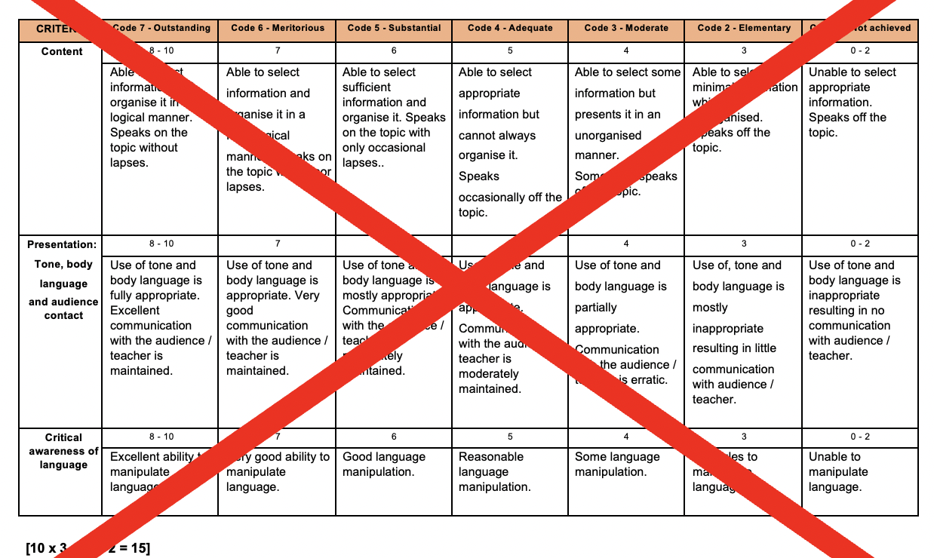

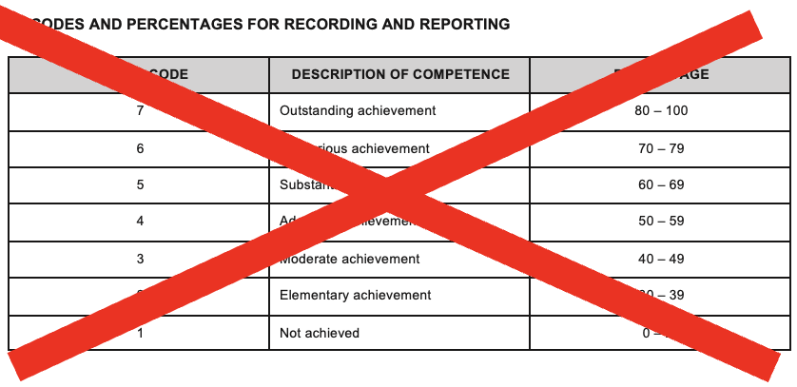

11. RESOURCES

eRubric Generators:

1. iRubric – Free rubric building tools plus options for analyzing data and sharing rubrics with other teachers around the world.
2. Teach-nology- A comprehensive list of rubric building tools arranged by subject.
3. Digi-tales – Create a scoring rubric for evaluating media projects.
4. The Canadian Teacher – A rubric builder that allows you to build weighted rubrics, checklists, and rating scales.
5. Rubistar- Register for an account and have access to a variety of rubric tools, plus the ability to edit, save, and access online.
6. Scholastic – A simple and fast rubric tool. Fill in the fields and it will arrange it in a matrix for you.

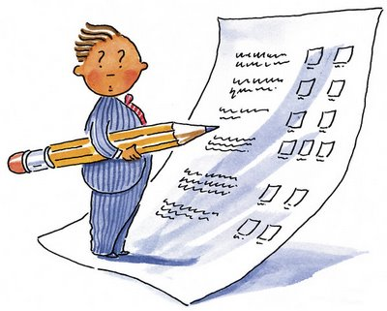

https://images.app.goo.gl/mpoKiKzjbN4g4hZ37

